The Official Publication of ALOA—An International Association of Security Professionals

LAS VEGAS, NEVADA

ALOA 2003

♦ ♦ * **i**

Breck H. Camp CML PO Box 47070 Atlanta GA 30362-0070

11 ■ ■ I ■ i ■ I ■ 111 ■ 111111111 ■ 1111M, |,,, 1111,,,, |, 11

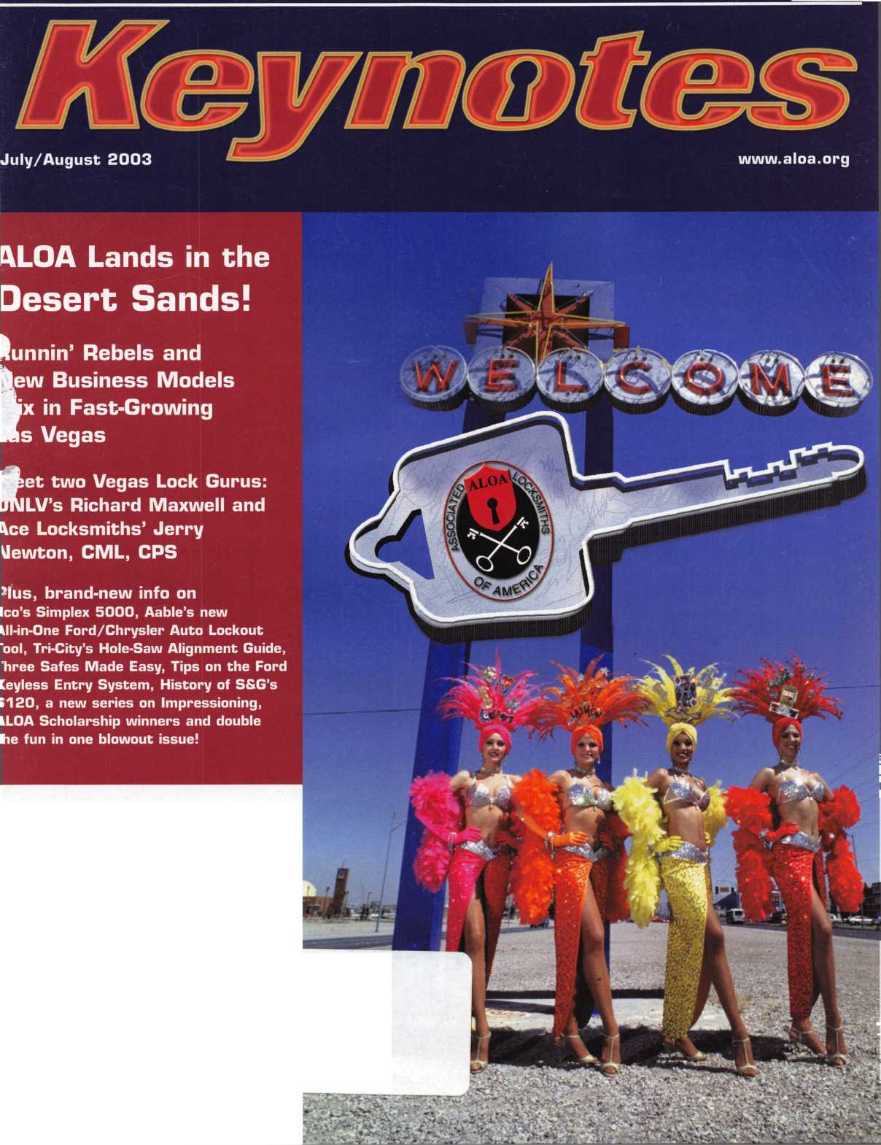

**OUR NEW TECHNOLOGY GIVES YOU A GLIMPSE OF THE FUTURE**

OUR NEW TRANSPONDER KEYS ARE THE LATEST ADVANCEMENT

IN THE INDUSTRY. AS A TRUSTED OEM SOURCE, WE ENSURE YOUR

FUTURE IS BRIO HT AND PROF I TABLE

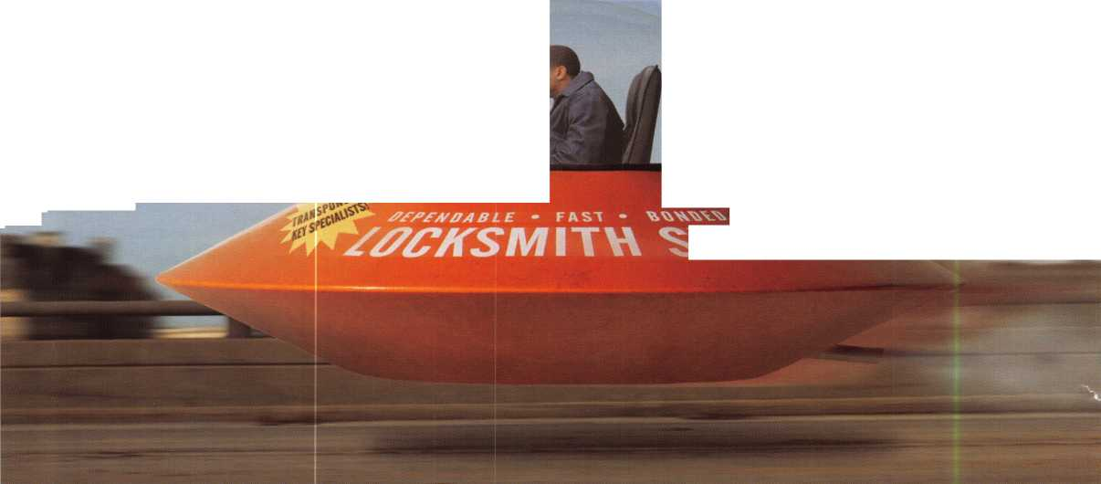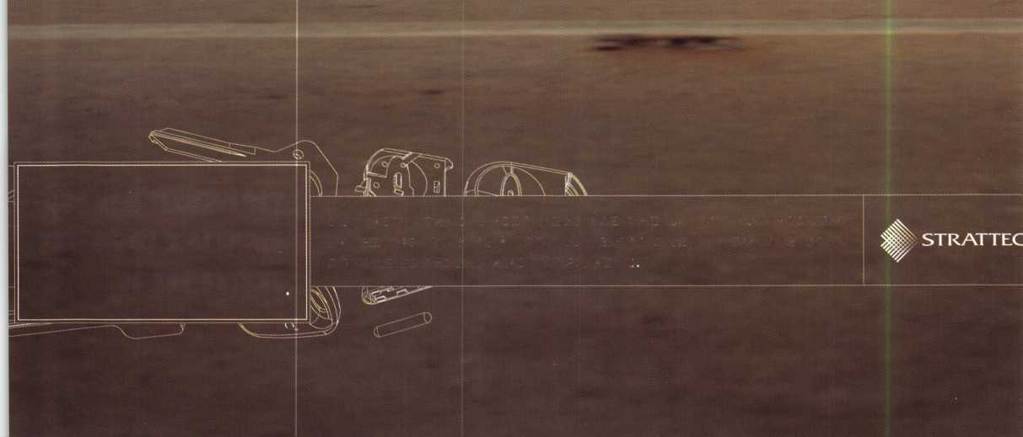

Attention Current Members! As the best security pros in  
the world, you play a vital role in' making ALOA what it  
is. You make our industry hum, and we’re going to  
prove it this year by offering you more benefits than  
ever. For the entire calendar year of 2002, those who  
recruit new members will receive special gifts from  
ALOA. We're asking you to prove you're a pro by sup-  
porting the only professional organization that exists to  
help educate, protect and promote security profession-  
als in America and beyond. Here are some of the  
details of our campaign:

**For Chapters and Affiliates Who Recruit!**

If your chapter gets 15 new members: ALOA will send instructors out to your site for two free days of ACE classes FREE OF CHARGE! Plus, the chap­ter or affiliate that recruits the most new members gets three free convention packages for our blowout show in sparkling Las Vegas in July of 2003!

Don't pass up this fantas­tic chance for these grtet free giveaways, an ™ expanded group of peers with whom to learn and grow, and the same fantastic education, protection and promotion ALOA has been providing for our great profession for almost 50 years! Call us today at 800/532-ALOA (2562) for more informa­tion, or visit us on the web at [www.aloa.org](http://www.aloa.org).

ALUA Locksmiths Secure America

**For New Members!**

All newly recruited members receive a useful ALOA  
11-piece pick set from LAB, plus our stirring "ALOA  
Locksmiths Secure America" decal for the shop or van

**For Current Members Who Recruit!**

1 new member: The useful ALOA 11-piece pick set  
from LAB.

5 new members: A handsome ALOA Polo Shirt (w/  
stitched logo)

10 new members: LAB's great Schlage/Kwikset  
Combination pin kit -- plus membership in the ALOA  
President’s Club, with your choice of a dazzling ALOA  
ring or a classic ALOA blazer (plus a periodic listing  
in Keynotes).

**Hew**

**ALOA Membership. Prove You're a Pro,**

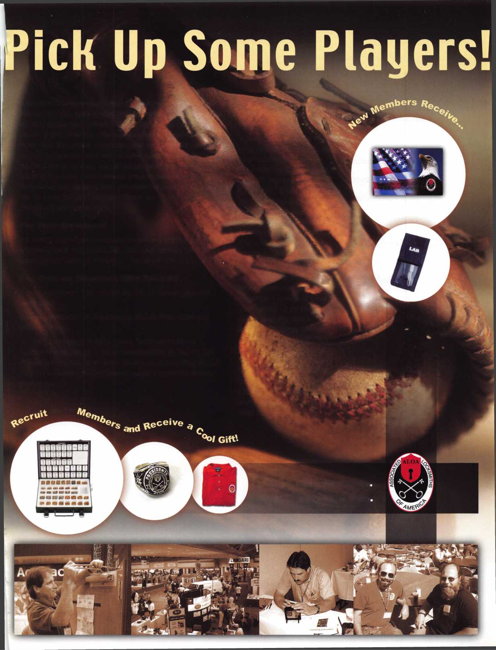

Here we are at the end of my term as President of ALOA. I have had an inspiring journey over the last two years. This convention in Las Vegas marks 10 years that I have served on the board. I can say I have learned a lot of history. I also have had the privilege of working with many of the finest in our industry.

The ALOA Board is, I believe, the best it's ever been. It has written and is learn­ing how to operate under governance policies. It has created a set of predeter­mined ends, for our staff to follow, with the good of our members as its goal.

How grateful I am to all of my fiends and family. I have had so much support from so many of you. I have always said the thing I like most about our associa­tion is belonging. By association, I am one of the professionals of our industry. Thanks to everyone for your help and support over the last two years.

I look forward now to Bill Young, CML, taking over and continuing to assure the future for ALOA. The best is yet to come.

Thanks,

Randy Simpson, CML

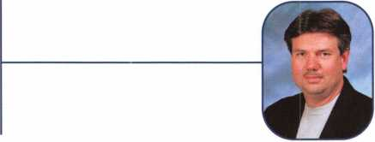

4

Keynotes • July/August 2003

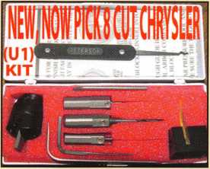

Universal Ford Flush-Mounted/Chrysler 8-Cut Ignition Removal Kit #U1 (patented)

Use this tool on all Ford flush mount ignitions, with or without side bar, large and small diameter face, all types of focus locks. With adapter, you can do virtually all Chrysler, Dodge, and Jeep 8-cut ignitions with no damage to lock. Similar kits sell for over $100.00 and only do Chrysler. Fit key and replace. In less than 5 minutes, you will have them out. Kit includes: 1 force tool (to remove face); 3 drill & arbors; 3 drill guides for all access holes; side B AR pressure tool; turn wrench; tumbler holding tool (to assemble and disassemble). No other tool needed with this kit. SHOW SPECIAL: get free adapter for Chrysler, Dodge and Jeep with each kit. $155.00 +$6.00 S&H

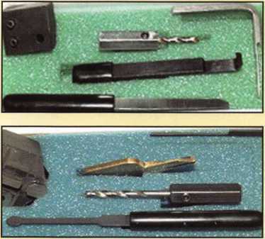

1998 Up G.M. In-Dash Ignition Removal Kit (patent 5454245)

Remove plastic ring and chrome cap in seconds. Make access hole to pick side bar. Turns cylinder to ACC position to remove lock in less than 5 minutes with no damage to lock. Your first job will pay for this kit. $70.00 + $6.00 S&H

1996 Up Ford 8 Tumbler Ignition Removal Kit and Side Bar Breaker Tool

(patent 5701773)

Use force tool to turn ignition to “on” position in less than 60 seconds. To start car or for fast ignition lock removal or use kit to push side bar in, turn cylinder to “on” position for fast removal without any damage. Fit key, replace same lock. $90.00 + $6.00 S&H

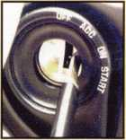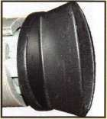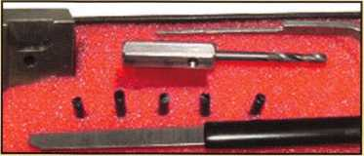

1994 Up G.M. 9 Tumbler Ignition Removal Kit (patent 5454245)

The locks have longer side bars than the older type and must be in the “on” position to remove. This kit will do that with no damage to the lock. Fit key and install same lock. Does all types, vats, mrd, top hat, module, etc. Your first job will more than pay for this kit. New with update to do module locks, blazers, suburbans, pick-ups, etc. $80.00 +$6.00 S&H

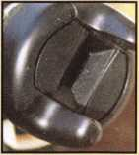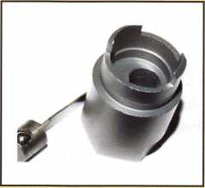

Ford “Quick-On” (patent 5454245)

Now turn all 10-cut ignition cylinders to the “on” position for fast removal-in less than 60 seconds. Sable, Taurus, all styles even those with airbags. No damage to housing.

$65.00 + $6.00 S&H

No-Nonsense Squeeze Lock Plug Remover

(patent 5165158)

Now you can remove all squeeze lock plugs in 15 seconds or less from all GM, Ford, Chrysler, AMC, and Jeep. No more fumbling, gadgets, cut fingers, broken tabs, or the need for 3 hands! It’s so easy you can do it in the dark while it’s still in the glove box.

$50.00 + $6.00 S&H

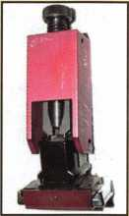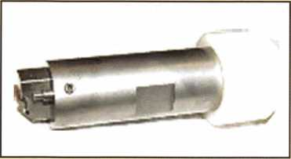

The G.M. Trunk & Door Persuader

The unique tool will open virtually all GM trunks and doors through the current year when tool fits into the cylinder core cavity in less than 50 seconds. No drilling, pulling, picking, special tools or electricity needed. When customer’s key does not open trunk because: Problem 1: spring retainer popped up into outer shell; Problem 2: One side of side bar sprung off. Side bar does not retract; Problem 3: key or cylinder worn. Side bar does not retract; Problem 4: Key jammed in lock at “turned” position, etc. With The Persuader you will open these locks in less than 50 seconds with no damage to lock. Just repair and replace. There is nothing to wear out. Yes, if needed, it will open with no key. Note: Because of The Persuader’s capabilities, it will be sold to locksmith only. $45.00 + $6.00 S&H

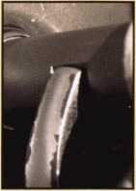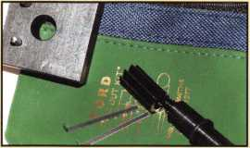

Ford “Disc-Out” Kit (patent 4682308)

This kit will remove those stubborn Ford pin ignitions from 1976 to present in less than 5 minutes. These locks incorpo­rate 2 locking devices and a hard steel disc across the shear line. They must be turned to “on” position to release both locking devices so as not to damage the housing. $60.00 + $6.00 S&H

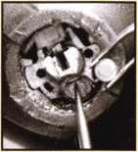

Frank Markisello guarantees all his products to do as stated.

[www.aablelocksmiths.com](http://www.aablelocksmiths.com) • 8619 97th Ave. • Ozone Park, NY 11416 • (718)848-8000

Visit us at Booth #1321!

**12**

**34**



The Institutional Runnin' Rebel: Q&A with ALOA Member Richard Maxwell, Head of Housing Security for UNLV

The first time we spoke with Richard Maxwell, we were impressed: He'd learned locksmithing on the fly, and was opportunistic enough to work his way into a high profile institutional locksmithing gig at UNLV. Not bad for a guy who only moved to Vegas for the dry air, huh? As we spoke with him over time, though, it became clear that we had a special member on our hands, one who values knowledge and one who stresses keeping an open mind. Interview by Jim DeSimone, Keynotes Editor

Biz Models - Vegas Style:

Behind the scenes at Las Vegas' Ace Locksmiths & Security Alarms

It starts with a solid foundation, long-standing traditions, and good people. But Ace is not a company that intends to rest on its laurels, and they were gracious enough to pull back the curtain and show us how they keep excelling in today's security industry - and even their plans for the future.

**20**

By Jerry Newton, CML, CPS, Owner

Tools: Hole Saw Alignment Guides from Tri-City Lock

I'm sure you've all been there: trying to put a jig on a door that has trim around the edge, putting plywood on the door with "C" clamps, measuring centers, and even using a small hole saw inside a large hole saw. Here's a guide that saves the day.

**22**

Basic Impressioning, Part 1: Tools

Impressioning in locksmithing is much like the Latin language to scholars; it is either a dead or dying art form. But in more than a few cases, impressioning can help you out of a jam, and save you lots of time. If I can save 10 to 30 minutes per call, that's an extra two or three calls I can accomplish in the day. That is money.

By Jim Hancock, CRL

**28**

En-Aable Yourself! Aable Releases the All-New, All-in-One Ford Universal Flush-Mount and Chrysler 8-cut Ignition Removal Kit

As you all know, the Ford Focus has been a popular car; how­ever, the ignition locks have been a big problem. So at many of the conventions, locksmiths have came over to me and asked me to come up with a simple solution to remove these locks. Well, as always I've done that - and gone even farther.

By Frank Markisello, CRL

**40**

**46**

**48**

**54**

**60**

Easy Safes Made Even Easier

This month, I'm cleaning off my desk of these pesky safe pictures. Each safe is interesting, but not enough for an article on their own. The first two barely qualify as safes, although their manufacturers call them safes. The next one is an Amsec electronic safe I worked on several years ago with a disconnected wire.

Greg Perry, CML, CPS

Keyless Entry System (Explorer)

If the vehicle is so equipped, in the owner's manual under "Controls and Features" you will find how to use the key­less entry. (See illustrations.) I have selected a 2000 Explorer with the keyless entry system. Let's dive in!

By Jeff Trepanier, RL

Locksmith Liability, Part 2

In Part I of this article, the author examined general liabili­ty questions that can confront the locksmith or security pro­fessional. In this second and final installment, we will examine specific problems relating to master key systems, and related legal issues.

By Marc Tobias

Simplex 5000 is Actually SIMPLE!!

From the initial opening of the box, I was on edge: Here was something new from the folks who have given us reli­able push-button locks for ages! I was intrigued and giddy, somewhat like a kid in a candy store.

By Eric Costley, CRL

Brief History of S&G's 6120

The Sargent & Greenleaf Model 61 20 was born in mid- 1994 and, like a child fast approaching his ninth birth­day, it has gone through many changes. It hasn't grown any larger, but it has definitely become more mature, and no longer embarrasses its parents in restaurants.

By Brian Costley, CML, CMST

Meet the Winners! Up close with this year's ALOA Scholarship winners.

**64**

**66**

**68**

Member Milestones State of the Association Financial Report

**departments**

|  |  |  |  |  |  |
| --- | --- | --- | --- | --- | --- |
| Executive | 5 | Calendar | 8 | Legislative Update 70 | Associate Members74 |
| Applicants | 6 | Core | 10 | Classifieds 72 | Back Page 76 |

executive

Volume 49, Issue 7



Additional contact information for the ALOA Board and most Keynotes authors is  
available through "Locksmith Search'" on the ALOA Web site- [www.aloa.org](http://www.aloa.org) or by  
contacting the ALOA office at 3003 Live Oak Street; Dallas, TX 75204; (800)532-2562;  
FAX (214)827-1810; e-mail [aloa@aloa.org](mailto:aloa@aloa.org).

|  |  |
| --- | --- |
| Editor  Jim DeSimone | [editor@aloa.org](mailto:editor@aloa.org) |
| Technical Editor  David Lowell, CML, CMST .... | [david@aloa.org](mailto:david@aloa.org) |
| Editorial Advisor  John D. Cannon, CML | [jdcannon@worldnet.att.net](mailto:jdcannon@worldnet.att.net) |
| Art Director  Betty Henderson | [betty@aloa.org](mailto:betty@aloa.org) |
| Advertising Sales  Kim Hammond | voice: 817-645-6778  Fax: 817-645-7599 e-mail: [adsales@aloa.org](mailto:adsales@aloa.org) |
| Executive Director  Charles W. Gibson, Jr., CAE | [charlie@aloa.org](mailto:charlie@aloa.org) |
| Convention & Meetings Manager  Jo Anne Mims [joanne@aloa.org](mailto:joanne@aloa.org) | |

PRP/Education Manager

David Lowell, CML, CMST [david@aloa.org](mailto:david@aloa.org)

Operations/Membership Manager

Mary May [mary@aloa.org](mailto:mary@aloa.org)

Government Relations Manager

Paul Kanitra [paul@aloa.org](mailto:paul@aloa.org)

IT Operations Manager

Greg Jackson [greg@aloa.org](mailto:greg@aloa.org)

Comptroller Kathy J. Romo

Membership Coordinator Shelly Jett

Convention & Meetings Assistant Karen Lyons  
PRP/Education Coordinator Janelle Ramirez

Accounting Coordinator Stephanie Brothers

Mail Room Coordinator Kevin Wesley

Receptionist Shawn Alvear

Contributors

Jerome Andrews, CML  
Paul Chandler, CRL  
Claire Cohen, CML  
Brian Costley, CML, CMST  
Eric Costley, CRL

Ray D'Adamo, CML Sal Dulcamaro, CML Billy Edwards, CML Dan Graffeo, CRL,CMST Jim Hancock, CRL

AJ. Hoffman, CML Jeff Nunberg, CML, CMST Randy Simpson, CML Robert Stafford, CML Dave Thielen, CML

Greg Perry, CML,CPS Tom Seroogy Charles Stephenson, CPS Dennis Watanabe, CML, CMST

**Mission Statement:** The Associated Locksmiths of America, Inc. is dedicated to enhancing the professionalism, education and ethics among locksmiths and those in related sectors of the physical security industry. With approximately 10,000 members in the United States, Canada and the freeworld, ALOA is poised to help members obtain the knowledge, the strength, and the confidence to perform their role in the physical security field with pride and dignity. But it is only through active involvement and participation that ALOA can fully achieve its potential—and can help members to achieve theirs.

**Policies: Keynotes**® is the official publication of the Associated Locksmiths of America, Inc. (ALOA). **Keynotes**® acts as a moderator without approving, disapproving, or guaranteeing the validity or accuracy of any data, claim, or opinion appearing under a byline or obtained or quoted from an acknowl­edged source. The opinions expressed by the authors do not necessarily reflect the official views of ALOA. Also, appearance of advertisements and new products or service information does not constitute an endorsement of products or services featured by the Association. The Association does not accept responsibility for the inaccuracy of any data, claim, or opinion appearing in this publication, due to typographical errors on the part of the authors, Association staff or its agents.

**Editor's Note:** This publication is designed to provide accurate and authoritative information in regard to the subject matter covered. It is provided and disseminated with the understanding that the publisher is not engaged in rendering legal or other professional services. If legal advice and other expert assistance is required, the services of a competent professional should be sought.

**Authors' Payment:** Payment for eligible submissions to Keynotes will be based on the following criteria: topic, time spent and past contributions. Authors who regularly submit to Keynotes® are generally paid a higher rate. The latter is especially true of authors who write to fit specific editorial needs and submit said copy by **Keynotes**® deadlines. As a general guideline: Average payment for a 750 word, business or 'light' technical article would be $200. Payment for a 1500 word article involving significantly higher time and research efforts would be $400.

Payment will not be offered for articles submitted by ALOA employees or members of the ALOA Board of Directors (unless material is of a technical nature), nor for articles submitted by a company that promote that company's products or services. ALOA reserves the right not to pay for articles sub­mitted by an individual(s) that promote a particular company's products or services.

**Disclaimer:** The Associated Locksmiths of America, Inc., (ALOA), reserves the right to refuse any article for any reason. Additionally, ALOA reserves the right to edit, amend or modify any article submitted for publication in order to preserve technical accuracy, clarity, fairness or grammatical cor­rectness. ALOA will make the best efforts to notify the author of any changes. The extent of ALOA's liability for any article or information contained therein will be a notice of correction or retraction in the next possible issue.

**Keynotes**® (ISSN 0277 0792) is published monthly except for the combined June/July issue by The Associated Locksmiths of America, Inc., 3003 Live Oak St., Dallas, TX 75204-6186. Telephone: (214) 827-1701; FAX (214) 827-1810; e-mail [aloa@aloa.org](mailto:aloa@aloa.org). Subscription rates for members—$15.00 per year. Business class postage paid at Dallas, Texas. POSTMASTER: Send address changes to: Keynotes, 3003 Live Oak St., Dallas, TX 75204-6186. © Copyright 2003, All rights reserved. No part of the contents may be reproduced or reprinted in any form without prior written permission of the publisher.

President

Randy Simpson, CML  
(218) 240-5959

president@aloa. org

Secretary

John D. Cannon, CML  
(703) 960-6413  
[secretary@aloa.org](mailto:secretary@aloa.org)

Directors, Northeast

Robert E. Mock  
(856) 863-0710  
[nedirector@aloa.org](mailto:nedirector@aloa.org)

Peter Sarailian, CRL  
(973)890-9797  
ned i rector@a foa. org

William L. Young, CML  
(610) 647-5042  
[nedirector@aloa.org](mailto:nedirector@aloa.org)

Directors, Southeast

Vincent Formon, CML, CPS  
(901)324-2910  
[sedirector@aloa.org](mailto:sedirector@aloa.org)

Donald E. Rule, CML  
(662) 324-2658  
[sedirector@aloa.org](mailto:sedirector@aloa.org)

Directors, North Central

Mark E. Blum, CML, CPS  
(517) 482-5809  
[ncdirector@aloa.org](mailto:ncdirector@aloa.org)

John Soderland, CML, CMST  
(414) 327-5625  
[prolock@aloa.com](mailto:prolock@aloa.com)

Director, South Central

CD Lipscomb, CML, CPS  
(903)874-3522  
[scdirector@aloa.org](mailto:scdirector@aloa.org)

Directors, Southwest

Gordon R. Racine, CML  
(719) 384-4707  
: [swdirector@aloa.org](mailto:swdirector@aloa.org)

Julie McCluney, CRL  
(714) 636-5652  
[swdirector@aba.org](mailto:swdirector@aba.org)

Director, Northwest

Scott L. Henke, CPL, CPS  
(907) 248-3785  
[nwdirector@aloa.org](mailto:nwdirector@aloa.org)

Director, European

Hans Mejlshede, CML  
(453)539-3939  
[eurdirector@aida.org](mailto:eurdirector@aida.org)

Director, Asian

JoeJ Lee, CRL  
(215)289-2404  
asiandirector@aloa .org

Director, Associate

Paul M. Justen  
(800)333-6953  
[asdirecfor@atoa.org](mailto:asdirecfor@atoa.org)

Trustees

[trustees@aloa.org](mailto:trustees@aloa.org)

JohnJ. Greenan, CML, CPS  
(773) 486.2030

Dallas Brooks  
(334) 826-8990

David M. Lowell, CML, CMST  
(800) 532-2562

Past Presidents

1999-2001 John Greenan, CML, CPS  
1997-1999 Dallas C. Brooks  
1995-1997 David Lowell, CML, CMST  
1993-1995 Breck Camp, CML  
1991-1993 Henry Printz, CML  
1989-1991 Evelyn Wersonick, CML, CPS  
1987-1989 Leonard Passarello, CPL  
1985-1987 Joe Jackman, CML  
1983-1985 Stanley Haney, CPL  
1981 -1983 Louis LaGreco, CPL  
1979-1981 John Kerr, RL  
1977-1979 Clifford Cox, CML  
1974-1977 Charles Hethen ngton  
1972-1974 Gene Laughridge  
1970-1972 William Dutcher, RL  
1968-1970 Constant Maffey, RL  
1966-1968 Harold Edelstein, RL  
1964-1966 William Meacham  
1962-1964 Robert Rackliffe, CPL  
1960-1962 Edwin Toepfer, RL  
1956-1960 Ernest Johannesen

Keynotes • July/August 2003



Bentonville

Eric Elander

Forrest City

Wayde E. Thomas

AZ

Mesa

Tim McHenry

Sponsor: William Lee CRL Phoenix

Ivan Lezaja

Prescott

Prescott R. Jones Jim F. LaVoie

Yuma

Christopher S. Hamilton

Sponsor: Leon P. Burge CML

Daniel Medina John Hirales

CA

Anaheim

Casey S. Pendlebury

Sponsor: Daniel S. Enriquez CRL Baldwin Park

Michael Mazzarelle

Sponsor: Walter Brueggeman CPL Cathedral City

Jason Rodgers

Sponsor: Bruce S. Nemec CML Chula Vista

Tony Gudino

Sponsor: Winston E. Miller Jr, CRL Covina

Michael K. Palmer

La Puente

John Coronado

La Verne

Steve Baca

Loma Linda

Etienne E. Kirkpatrick

Lompoc

Christian M. Villa

Sponsor: John H. Linn Lone Pine

Robert Hayner

Sponsor: Gregory L Perry CML, CPS Los Angeles

Freddy J. Marzouk Michael Mizrachi

Paradise

Mike Barker

Sponsor: Ralph O. Skytte

Rancho Cucamonga Riley A. Gale

Sponsor: Gregory L. Perry CML, CPS San Francisco

Hazel L. Betsey Joseph Rosson

San Leandro

Kurt Ditmer

San Luis Obispo

Douglas G. Anderson

Van Nuys

Pamela Becker

West Hollywood

Ronnie Benchaim

Sponsor: Freddy J. Marzouk Yuba City

Bradley J. Williams

CO

Aurora

Rolland L. Camp

Sponsor: Kent A. Smith CML Edwards

Dawn R. Riddle

Vail

Kurt Batchelder

CT

Salem

John L. Carboni

Waterford

Peter Doherty

FL

Gulfport

Bruce Pritchard

Miami

Jason D. Hertzberg

Sponsor: Jay J. Wiener Orlando

Robert L. Warren

Panama City

Lowell E. Chalk Jr



Areola

Timothy Romine

Sponsor: Werner G. Rossmann Quincy

Charles R. Zanger

Sponsor: Michael A. Zanger

IN

Fort Wayne

Michael Wiegmann Don A. Coffelt

Indianapolis

Norman L. Nevins

LA

New Orleans

Julie Savoy

Sponsor: Diane M. Foto CRL

Nina Rojas

Sponsor: Diane M. Foto CRL

MA

Hingham

Ross Ciulla

Randolph

Barry P. McMenimon

Detroit

Larry Walker CRL

Sponsor: Maurice R. Horne CML Kalamazoo

Richard J. Boogholt

MN

Saint Cloud

Michael E. Saeger



Canton

Tracy Bunyard

Sponsor: Michael W. McCorkle CRL

Asheville

Mark Sherron

Sponsor: Alford Sherron Hope Mills

Scott Germain

Sponsor: C Allan Halverson Sanford

Dennis M. Wisneski

Sponsor: C Allan Halverson

Scottsbluff

Jason L Hullinger

Haledon

Birgitte Hansen

Sponsor: Thomas E. Ware CML, CFL Springfield

Seth Kenter

Sponsor: Peter Sarailian CRL

North Las Vegas

Joseph Martino

Sparks

Brenda Freiberger

Bayside

Robert G. Libertell Christopher M. Campo

Holbrook

Richard McCusker

Cleveland

Holly Jo Heighberger

Dewar

Randy E. Gregory

Meadville

Clarence Moyer

Sponsor: Thomas E. Uhlig CPS

Clinton

Henry J. Seivers

Sponsor: Walter L Lyall Medina

David F. Street

Tullahoma

Angela Cyree

Sponsor: Chris W. Cyree

Bedford

Scott E. Cook

Sponsor: John B. Arnold CML Dallas

Charles R. Brown

Sponsor: Joel Anaya

Marvin Gober

Sponsor: Robert A. Ashmore

Garland

Paul L. O'Brien

Sponsor: Paul S. Golden RL Houston

Paige E. Guidry Pamela K. Benueles Randy Swafford

Killeen

Jim Lornklang Joseph A. Snyder

UT

Ogden

Wayne Stauffer

Sponsor: Roger C. Yost CML, CPS West Valley City

Cindi Pester

Sponsor: Oscar W. Pester

Justin W. Pester

Sponsor: Oscar W. Pester

VA

Hampton

Robert P. Andrews

Sponsor: Brooke P. Berry CRL Herndon

Jenay Sharrard

Leesburg

Karm Sandhu

Sponsor: Timothy F. Horton CML Lorton

Caitlin M. Gremminger Dare King

McLean

Matthew J. Avila

Sponsor: Timothy F. Horton CML Reston

William Dranginis

Stafford

Christopher J. Visser

Sponsor: Timothy F Horton CML Woodbridge

Robert Callender Patricia Hanner

WA

Castle Rock

Franklin Merritt Sr

Wl

Chippewa Falls

Tammy Haroldson

Sponsor: David D. Pettis Eau Claire

Paul C. Noll

Sponsor: John S. Dorsey CML, CPS Fredonia

Vera M. Lotus

Sun Prairie

Timothy G. Kilian

Waukesha

Daniel J. Heinritz

West Allis

Gregory D. Jancoski

WY

Gillette

Jon Lueras

Sponsor: Dave Lueras

Canada

Montreal, PQ

Raymond Gagnon Gary Brewer Robert Bourque Denis Morin

NB

Riverview

Jack Durepos

Sponsor: Marc H. Bertrand Richmond, ON

Trevor C. Webb Randy Barlow

Costa Rica

San Jose

Renato Caballero

Denmark

Soborg

Christian Eli Moller

lland

Herefordshire

Darren Cash

Sponsor: Robert Collins

Graham T. Skelhorn

Sponsor: Robert Collins

Duncan Ball

Sponsor: Robert Collins

Israel

Yavne, Israel

Itzik Kaiser

Sponsor: Rami Almosnino

Effi Ben-Aharon

Japan

Nagoya Aichi

Mizuno Masaru

Sponsor: Yuriko Yanai Ohgaki Gifu

Masato Horiguchi

Sponsor: Yuriko Yanai Saitama City Saitam

Imai Toshio

Sponsor: Yuriko Yanai

Mexico

Nogales Sonora

Jorge E. Ortega

Zapopan, Jalisco

Julio Villalobos Ramos

Taiwan

Yong Kong City

Tain ChungYu Chen

Sponsor: Qing Min Cao



Banstead Surrey

Darren N. Chorlton

London

Barry Jeapes

Sponsor: Darren Kilner

These applicants are scheduled for clearance as members of ALOA. The names are published for member review and comment within 30 days of this Keynotes issue date,  
respectively, to ensure applicants meet standards of ALOA's Code of Ethics. Protests, if any, should be addressed to the Membership Department and must be signed. Active  
Membership applicants (a) have worked in the industry two or more years. Allied Membership (AL) applicants are not locksmiths, but work in a security-related field.

Apprentice Membership (AP) applicants have worked in the industry less than two years.

B Keynotes • July/August 2003



*wm*

***Visit our Website on  
www. stamcctv. com***

THE COMPLETE

CCTV PROGRAM ON CD-ROM  
FOR STAFF TRAINING AND

PRODUCTIVITY ENHANCEMENT

STAM **Insight** has been  
developed to enhance CCTV  
skills and productivity with  
many different uses.

HI Productivity

HI System Drawing HI Estimation Hi CCTV Training HI CCTV Reference HI Sales/Demo HI System Design Hi Staff Evaluation

IQIiours

INFOMATE WORKMATE ULTIMATE

CCTV Content

CCTV Calculators

Demonstration Tool

*Estimation*

Drawing

Internet Enabled

Pre-Test

Quizzes

Knowledge Assessment

**Sold in Over 50 Countries**

Distributed by:

3003 Live Oak Street  
Dallas,Texas 75204



■ Yes, please send me a FREE PREVIEW CD ROM $9.95 S/H

Name:

Job Title:

Organization:

Address:

Zip/Postcode

e-mail

Fax: ( )

COPYRIGHT © 1996 Security Training and Marketing Pty Ltd. All rights reserved ACN 057 006 541

Country

Tel: ( )

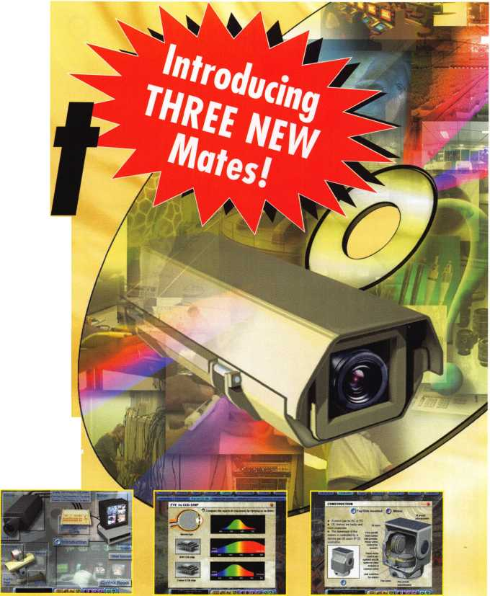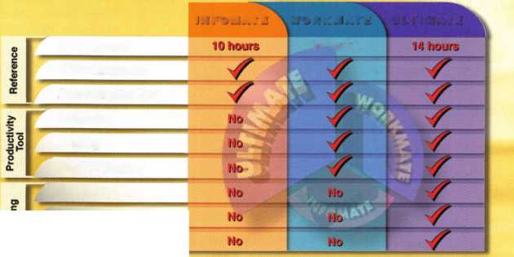

**SEPT I AUG JULY**

upcoming

2 Ohio Valley Chapter of ALOA Membership Meeting 7pm Middletown, OH Mehdi Zahedi (937) 294-4241



11-12 6th Annual American Lock

Collectors Association Lock Show

Cleveland, Ohio

Jon Kolozvary 440-243-2032



6

Ohio Valley Chapter of ALOA Membership Meeting 7pm Middletown, OH Mehdi Zahedi (937) 294-4241

28-31 Second Annual IAIL Convention Mt. Laurel, NJ Don Shiles 800-598-9491 [www.iail.org](http://www.iail.org).

10 Fox Valley Chapter Summer Picnic Road Outing America David Clark

[daveslocknkey@greenbaynet.com](mailto:daveslocknkey@greenbaynet.com)



16 Oklahoma Master Locksmith Assoc. Annual Swap Meet Holiday Inn Select Tulsa, OK

|  |  |  |  |
| --- | --- | --- | --- |
| 3 Ohio Valley Chapter of ALOA | 18-20 Lou-Miss Locksmith Assn. | 19-21 Assoc, of Ontario Locksmiths | 21 Fla. West Coast Locksmiths Assn. |
| Membership Meeting 7pm | Fall Convention Biloxi, MS | 30th Anniversary Convention | Lite Seminar with Safe Lock |
| Ryan's Steakhouse | James Portie, CRL | Sheraton Parkway Toronto | Troubleshooting |
| Middletown, OH (off exit 32) | [lockjock@bellsouth.net](mailto:lockjock@bellsouth.net) | 888-272-8265 | James Barnhardt |
| Mehdi Zahedi (937) 294-4241 |  |  | [ernie28@ix.netcom.com](mailto:ernie28@ix.netcom.com) |

**UPCOMING PRP SITTINGS**

7/10/2003

7/19/2003

7/20/2003

8/7/2003

8/17/2003

9/11/2003

9/21/2003

9/28/2003

10/9/2003

11/13/2003

10/17/2003

10/18/2003

8:00AM • Dallas, TX • ALOA Janelle Ramirez 800/532-2562 X30

8:00AM • Las Vegas, NV • ALOA Janelle Ramirez 800/532-2562 X30

8:00AM • Las Vegas, NV • ALOA Janelle Ramirez 800/532-2562 X30

8:00AM • Dallas, TX • ALOA Janelle Ramirez 800/532-2562 X30

8AM • St. Pete, FL • SERLAC Ken Kupferman 800/845-5294

8:00AM • Dallas, TX • ALOA Janelle Ramirez 800/532-2562 X30

8:00AM • Anaheim, CA Clark Security Products Joan Emrick 619/718-7308

8AM • Kansas City, MO Missouri-Kansas Locksmith Assn.

Greg N. Brandt, CML816/444-3233

8:00AM • Dallas, TX • ALOA Janelle Ramirez 800/532-2562 X30 8:30 AM • Dallas, TX • ALOA Janelle Ramirez 800/532-2562 X30 Friday PM • Portland, OR Pacific Locksmith Association Dan Cunningham F-360-835-1191

10:00AM • Chamblee, GA GA Chapter of ALOA John C. Elliott,Jr.,CML.CPS 770/314-7859

10/25/2003 9:00 AM • Sturbridge, MA

Yankee Security Convention Jack Hobin 800/209-8266

10/26/2003 10AM • Mt. Laurel, NJ • G.P.L.A.

Martin Arnold, CML 856/665-0464

11/13/2003 8:00AM • Dallas, TX • ALOA

Janelle Ramirez 800/532-2562 X30

11/16/2003 TBD Montgomery, AL

Alabama Locksmiths Assn.

Amanda Boyd 334/793-5060 11/16/2003 8:00 AM • Ellicott City, MD

Clark Security Products Joan Emrick 619/718-7308 12/11/2003 8:00AM • Dallas, TX • ALOA

Janelle Ramirez 800/532-2562 X30

**UPCOMING ACE CLASSES**

July 14-1 8 Las Vegas, NV • ALOA

David Lowell, CML, CMST 800/532-2562 x18 (77 ALOA ACE Classes 39 Seminars and Half-Day Classes)

Sept. 13-14 Gulf Shores, AL • AL Locksmiths Assn. Amanda Floyd 334-793-5060 Comprehensive 1C I & II (2 days)

Sept. 20-21 Syracuse, NY • Central New York Locksmith Association Ron Smith 315-782-0912 Life Safety Codes & ADA Your Bottom Line

Sept. 26-27 Casper, Wyoming

Wyoming Locksmiths Assn Gene Ficek, CPL 605-6424542 Safe Lock Manipulation (2 Days)

November 15 Montgomery, AL • AL Locksmiths Assn. Amanda Floyd 334-793-5060 Closed Circuit TV for Locksmiths

Oct. 6-1 1

Oct. 14-17

Oct. 22-24

Appleton, Wl

Fox Valley Technical College <http://www.fvtc.edu/>

Jerry Antoon, RL

P-920/735-2406 F-920/735-2414 Six-Day Basic Locksmithing Course

Portland, OR • Pacific Locksmiths Assoc. Dan Cunningham, CRL F-360-835-1191 [danslocksafe@juno.com](mailto:danslocksafe@juno.com) (various classes)

Sturbridge, MA • Yankee Security Convention • CPS Prep Class (2days)

t

i



t

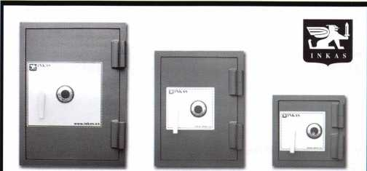

Now capture both the Residential and  
Business marketplace with our new  
inexpensive line of high security fire safes**-**

The SuperTuff is designed for businesses and homes needing more  
burglary protection without the intimidating price and cost.

Steel reinforced composite construction; one hour fire rating;  
expandable fire gasket; U.L. Group 2 combination lock; high quality  
adjustable hinges; 3 way boltwork (on 3219+); dual and electronic  
locking available; optional glass relocking system.

Custom interiors and colors available.

To become a distributor for one of North America's  
fastest growing safe manufacturers, please contact us.

For a full list of our current and future products, please visit our website.

**1-877-913-7233 • [WWW.INKAS.CA](http://WWW.INKAS.CA)**

Packing Them In

2003 Pacific locksmith  
Conference and  
Security Expo

Classes, Trade Show, Seminars,  
Fellowship

Oct. 14-18

Portland, OR • Holiday Inn at the Airport  
Contact: Dan Cunningham (Registration)

(FAX) 360-835-1191 • E-Mail [danslocksafe@juno.com](mailto:danslocksafe@juno.com)

Visn the pia web site for  
more information:  
[www.pla-pro.org](http://www.pla-pro.org)



Board Election Results

The results from the recent ALOA Board of Directors election are as follows:



William "Bill" Young, CML,

was elected to the office of President.

Mark Blum, CML, CPS, and John Soderland, CML, CMST,

were elected to each of the offices of Director, North Central Region.

Tom Gillingham, Jr., CML, CPS, and Ken Kupferman, CRL, were elected to each of the offices of Director, Southeast Region.

Gordon Racine, CML, and Julie McCluney, CRL, were elected to each of the offices of Director, Southwest Region.

VEGAS 2003: VAN AUCTION

The ALOA Scholarship Foundation, Inc., will once again auction a van package at the 2003 ALOA Kickoff Party in Las Vegas. The package includes:

* A 2004 Ford E-150 V-6 Automatic
* Adrian Steel Interiors Locksmith Package
* Kaba llco Rocky Mount 045 Key Machine
* llco Advantage CD
* Magnum Pick Set
* LSDA (assorted products)
* Southern Lock and Supply (Various tools)
* Tech-Train Productions TT2050/QEHC



Racine McCluney

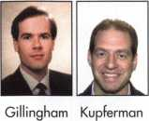

Blum Soderland

In Memory

Frank P. Agius, 78, founder and president of Framon Manufacturing Company, passed away in May, 2003. He braved Alzheimer's disease for several years in a quiet manner without complaint.

Frank was born in Detroit on May 6, 1925 and had 8 siblings. He worked con­struction jobs across the country before returning to Detroit, where he met and wed Barbara Noah on September 17, 1955. The pair moved to Alpena, Michigan soon after. Frank spent many years operating a cabinet shop and a few years later began doing locksmith work. He was a multi-talented person and at that time began invent­ing and manufacturing key cutting machines for the locksmith industry. Frank also began teaching in the field and always had time to help out anyone with their ques­tions and problems. He traveled world wide in his business, which is now operated by his family.

Frank particularly enjoyed his family, duck hunting, his bowling team, hockey, trav­eling and woodcarving. He was always grateful for his opportunities, friends, accom­plishments, and happy with his life. Some of Frank's dearest memories were of the many children he coached in both hockey and baseball. He had a wonderful spirit of adventure that took him canoeing on the Abitibi River for two months at the age of 18, to homesteading in Alaska & hopping trains across the country.

He is survived by his wife Barbara, daughter Ann (John McConnell), two sons, Michael (Norma) and Phil (Pam), grandchildren Andrew, Carrie, Taylor and Mitchell, and son-at-heart Milt Clark (Colleen). Also surviving are two sisters, Beatrice Bielskis and Mary Ann Tylenda, both of Alpena, and three brothers, Vincent of Rogers City, James (June) of Bridgeport and Theodore (Barbara) of Atlanta, GA.

Frank really enjoyed meeting all of the locksmiths in classes and at trade shows. Anyone who met him always felt that he had time to answer questions and wanted to help out whenever he could. Some of his fondest memories were the years he trav­eled the country with Bill Reed, Steve Young, Hank Spicer, Mike Miller, Gerry Finch, Jerry McNickle, among others. Thanks to the thousands who attended his classes or stopped by to say hello at the trade show booths. To say he enjoyed your friendship and associations is an understatement. The family thanks those in the industry who were such a big part of Frank's life. He will be lovingly missed by his family.

New Certifications

NEW CRL

KNUEPPEL, ROBERT R • AUBURN, WA STEELE, JOHN • CINCINNATI, OH WALKER, LARRY J • DETROIT, Ml

NEW CPLs

HUIZEN, GARY A. • JENISON, Ml



ALOA Open 2003

The ever popular ALOA Open Golf Tournament will be held at The Legacy Golf Club in Henderson, NV, on Thurs., July 17, 2003. The  
registration fee is $150 (tax deductible), and includes transportation to and from the course, greens fees, golf cart, beverages through-  
out the course, lunch and guaranteed prizes for each and every player. The main sponsor for the tournament this year is, once again,  
Yale Security Group. Other sponsors include Lucky Line Products, Inc., Strattec Security, Inc., AMSEC and Assa High Security Locks.  
Thank you to our sponsors for your continuing support, and we hope to see plenty of convention attendees show us how it's done out  
there at The Legacy in July.

S

**0**

Keynotes • July/August 2003

*\}\n*

PLTOmT

G»© ¥©(C

*Architectural*

*°°ors and*

'--tabSel,-":»^-are ^ ,

mm

Ruailable as single  
modules (one CD and  
guidebook) or the full  
set (three CDs and  
three guidebooks).

Seruer uersions are  
also auailable!

**SELF-STUDY GUIDEBOOK**

**Self-Study Course**

HLOfl

SPECIRL

FUNDAMENTALS OF:

**Get the award-winning  
*Fundamentals of architecture  
Doors and Hardware Self-Study  
Course* at a great price!**

The ultimate training tool for locksmiths... Now there is a complete in-house training  
program auailable! Order the Fundamentals of architectural Doors and Hardware Self

Study Course three CD/guidebook series.

**To** order, call **(800)532-2562** or imuLU.aloa.org.

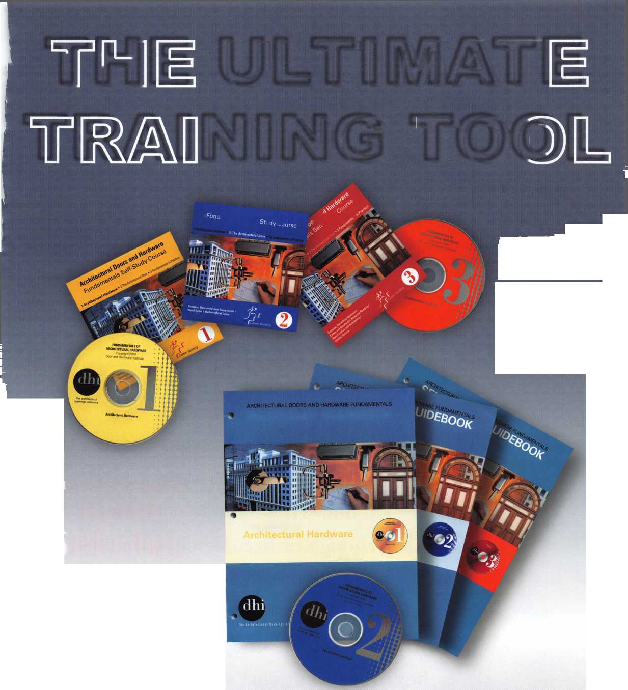

The Institutional Runnin’ Rebel:

Q&A with Richard Maxwell, Head of Housing Security for UNLV



The first time we  
spoke with  
Richard Maxwell,

we were impressed: He’d learned lock- smithing on the fly, and wound up being opportunistic enough to work his way into a high profile institutional lock- smithing gig at UNLV. Not bad for a guy who only moved to Vegas for the dry air, huh? As we spoke with him over time, though, it became clear that we had a special member on our hands, one who values knowledge and one who stresses keeping an open mind. Here’s how our recent chat with Richard went:

I

Keynotes • July/August 2003

Keynotes: As a locksmith, do you feel like a Runnin’  
Rebel?

Richard Maxwell: As a matter of fact, I do feel like a  
Running Rebel. The people I work for here and the  
entire University are great to work for, so you really  
feel like one of the team!

Keynotes: How did you get into this industry, and  
how did you wind up at a major university out in the  
desert sands of ritzy Las Vegas?

Richard Maxwell: I got into locksmithing because  
I saw a new challenge, and I enjoy learning new things.  
I saw that there was upward mobility in taking on this  
challenge. I like to find out how and why things work.

I am curious by nature. I found myself in the desert  
for health reasons (bad lungs etc.), I needed an arid  
climate and I already had a brother living here, so here  
I am.

Keynotes: What is your least favorite thing to do  
at UNLV?

Richard Maxwell: I like all of the work I do. My  
biggest frustration would be if I did not have enough  
work. This is definitely not the case.

Keynotes: What is your favorite part of campus?

Las Vegas in general?

Richard Maxwell: I think I would have to say that  
campus housing is my favorite place on campus. I have  
a lot of good friends all over campus who have been a  
great help to me since I started working there. I guess  
the main campus lock shop is right up there. Those  
guys trained me and all I know about locksmithing  
came from them. As far as Vegas goes, it’s like living in  
Disneyland, but I live in Desert Shores, and I love my  
home very much. I guess that my home is at the top of  
the list.

Keynotes: How many students/buildings/openings do  
you secure, and what do you secure them with?

Richard Maxwell: 1,650 students during regular  
school sessions. 14 buildings that I am responsible for  
securing. Falcon IC cores to secure the rooms. Mortise  
Falcon locks, Schlage cyclindrical locks, deadbolt pas-  
sage locks, magnetic card swipe readers with mag locks  
on all entrances and the new building, which will go

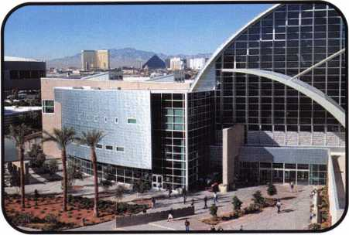

Lied Library

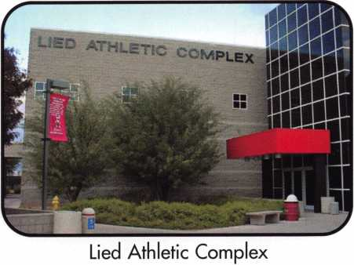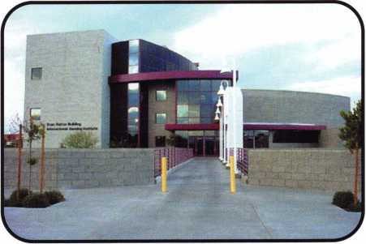

Stan Fulton Building for the  
International Gaming Institute

Keynotes • July/August 2003

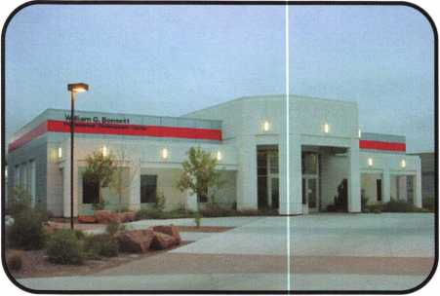

William G. Bennett Professional  
Development Center

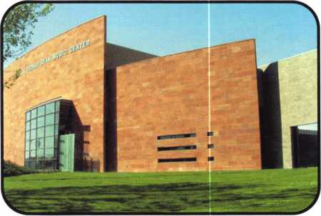

Lee and Thomas Beam Music Center

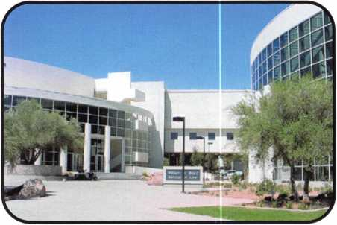

William S. Boyd School of Law

under construction shortly will have all stand-alone magnetic card reader locks by Tesa.

Keynotes: What’s the strangest thing a UNLV stu­dent has ever done to one of your locks? (Please keep it clean!)

Richard Maxwell: When the students put super clue in the lock.

Keynotes: Describe your office/shop, what you like about it, what you would change.

Richard Maxwell: Within the last couple of years, I have been given a larger shop area and office, which allows me to keep things more organized and readily at hand. I could use more storage space (like all lock­smiths), but it is much better than what I had original­ly. My supervisors are very good about allowing me to obtain whatever I need to do the job the best that I can, which is very helpful.

Keynotes: Tell us why you pursue education, and what it has meant to you in your locksmith career.

Richard Maxwell: I enjoy working at UNLV because of the diversity of the work and the great environment in which I work. The professional staff is great to work with and allows me to work at my full potential. This means that I have been able to enhance my knowledge and capabilities through ongoing classes offered by dif­ferent distributors.

Keynotes: If you could do anything to change the UNLV campus and its security, what would you do?

Richard Maxwell: Install closed circuit TV cameras. I've done everything else I can think of.

Keynotes: What advice would you give to a young locksmith who might aspire to head security at a large institution like UNLV some day?

Richard Maxwell: Be open-minded. Don't be afraid of change and never be afraid to take advice. Always be open to new and different ideas. Life is about change and how you handle it. Finding the best solutions with the tools at hand rather than trying to change things that can't be changed. Always seek out new ideas whenever you can.

Keynotes: Why did you join ALOA?



Keynotes • July/August 2003

Richard Maxwell: I joined ALOA in the beginning because a friend of mine here thought it would be a good idea and might be helpful to me getting started. And he was right: The magazine, Keynotes, helped me a lot. I learned a lot about the history of locksmithing, and many other things.

Keynotes: How has membership in a professional organization for locksmiths helped you do your job at UNLV more effectively?

Richard Maxwell: I think that membership in ALOA gives me a bit of respect from others and when I first got started, it was easy to get to know others in my field because they saw I was really interested, and serious about my profession.

Keynotes: Do you think it’s a good idea for institu­tional locksmiths to join a professional organization such as ALOA? Why?

Richard Maxwell: I think its a very good idea to join this type of organization. If you really want to do the job the best that you can, it’s part of the learning curve, a source of endless information.

Keynotes: What special challenges (heat? sand? underage student-gamblers gone crazy?) does Las Vegas pose for an institutional locksmith?

Richard Maxwell: The summer heat here poses real problems for locks on the external parts of buildings; when they face the east/west sun in the summer, it’s terrible. If you want to test a lock’s durability, this cli­mate will do it. And an angry student with super glue works wonders on IC cores. One thing I am good at is drilling out IC cores, and you have to learn new skills dealing with students and parents. Losing a girlfriend in the middle of the night sometimes means bad lock problems!

Keynotes: Closing thoughts?

Richard Maxwell: For someone who has had no for­mal training in locksmithing, I think I do a very good job and learn more and more about it every day. Being open to new ideas and different ways of doing things always helps; sometimes listening is a very important thing. I can’t stress that enough -- reading Keynotes and other magazines gives me insight that really helps me in my job.

Note: Interview conducted by Keynotes Editor, Jim DeSimone

Modern and tough-built, our safes have superior quality and a better price. Offer your customers more - from under­counter safes to depositories to burglar and fireproof composite safes. We have the widest selection.

For a catalog or to place an order call 1.800.421.0381

**Widest Selection at the Best Prices**

**Meet us at the ALOA Security Expo 2003!**

Keynotes • July/August 2003

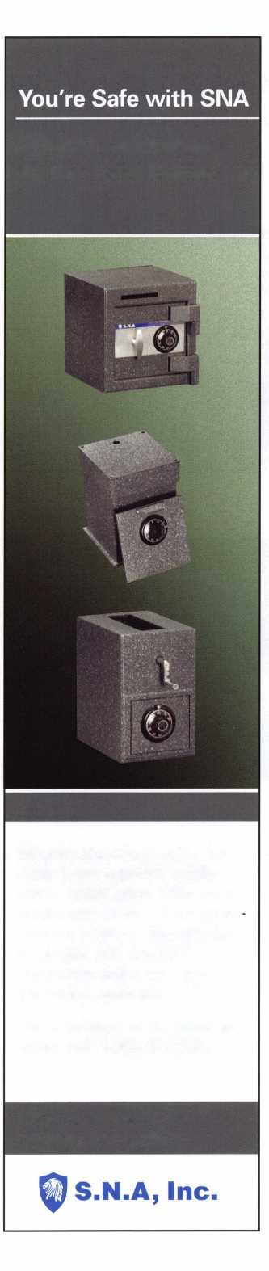

Biz Models - Vegas Style

Behind the scenes at Las Vegas' Ace Locksmiths & Security Alarms. By Jerry Newton, CML, CPS, Owner

—

cuswrus

■u.uru>

jvyjiT —

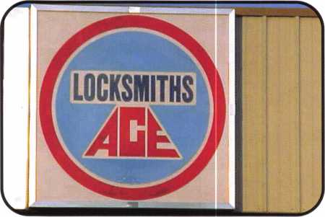

"The greatest danger for most of us is not that our aim is too high, and we miss it, but that it is too low, and we reach it..." (Michelangelo)

Since you are the most important person to decide this, is the following of measurable value? If you were selected to be one of our company’s team members, then you would receive the following Welcome from our company manual:

"Welcome to Ace Locksmiths & Security Alarms."

Dear Security Professional and Employee:

We're very happy to welcome you to Ace Locksmiths & Security Alarms. Thank you for joining us! We want you to feel that your association with Ace Locksmiths & Security Alarms will be a mutually beneficial andpleasant one.

You have joined an organization that has established an out­standing reputation for quality products/services. Credit for this goes to every one of our employees. We hope you, too, will find satisfaction and take pride in your work here.

Compensation andpersonal satisfaction gained from doing a job well are only some of the reasons most people work. Most likely, many other factors count among your reasons for work- ing — pleasant relationships and working conditions, career development andpromotion opportunities, and health benefits are just a few. Ace Locksmiths & Security Alarms is commit­ted to doing its part to assure you of a satisfying work experi­ence.

I extend to you my personal best wishes for your success and happiness at Ace Locksmiths & Security Alarms.

Sincerely,

Jerry Newton, CML/CPS Owner & President & CEO Ace Locksmiths & Security Alarms

**6**

Keynotes • July/August 2003

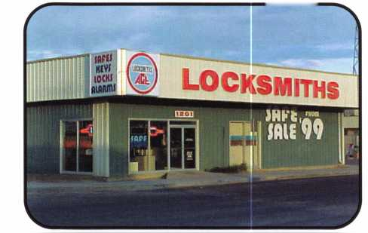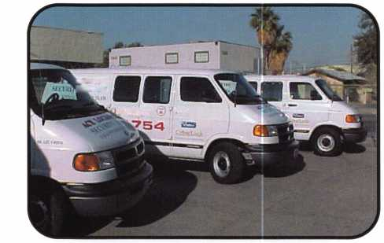

Since "You're Part of Our Team...

As a member of Ace Locksmiths & Security Alarms'  
team, you will be expected to contribute your talents  
and energies to improve the environment and quality  
of the company, as well as the company's services. In  
return, you will be given opportunities to grow and  
advance in your career.

Ace Locksmiths Sc Security Alarms is dedicated to  
two primary standards:

1. To provide our customers with the best quality  
   products and services at the best prices with the  
   best service to enable them to EXPERIENCE  
   profitable value.
2. To provide you with wages and benefits compara-  
   ble or superior to others doing similar work with-  
   in the industry and within the region to enable

you to also EXPERIENCE profitable  
value for yourself.

The only things we require for employ-  
ment, compensation, advancement, and  
benefits are performance and a good  
team attitude; however, all employ-  
ment at Ace Locksmiths & Security  
Alarms is "at will." No one will be  
denied opportunities or benefits on the  
basis of age, sex, color, race, creed,  
national origin, religious persuasion, mari-  
tal status, political belief,

or disability that does not prohibit performance of

essential job functions; nor will anyone receive special  
treatment for those reasons.

and family retired to independent pursuits, and Tom  
and Peggy retired from active management. Jerry and  
his wife, Trilla, continued operating and managing the  
company, and realigning the focus of the business  
with changes within the industry, and the economy.

Maintaining the leading edge in electronic lock-  
smithing, the company expanded the facility again in  
1984, combining an in-house alarm central station  
with a complete sales and service/alarm installation  
staff. This expansion in volume proved to be contrary  
to the mainstay principles of top quality in service  
and installations, so it was subsequently scaled back  
to focus on the premiere installations, whereby quali-  
ty, not quantity, was the guiding rule. The company  
"farmed out" the central station operations in the

early 1990s, and realized the benefit of more  
manageable quality installations and

service.

Continuing to the present, our  
company's focus and dedica-  
tion are to assiduously pro-  
vide the best in quality  
products and quality service  
for the customers' long term  
benefit.

Now, Ace Locksmiths Sc  
Security Alarms is at the plateau,

where building our business to the  
next level is our immediate objective.

With total commitment to our customers, our ulti-  
mate goal is excellence.

About Ace Locksmiths & Security Alarms

On July 1, 1968, our company was formed to provide superior locksmith service in the Las Vegas, Nevada area.

The company founders, Tom and Peggy Newton, and brothers Jerry and John Newton, originally established A-Ace Lock & Key Service at 10 E. California Ave. In 1973, the company expanded and built the existing facility at 1201 S. Casino Center Boulevard, Las Vegas, Nevada.

Following the build-up of contract hardware supply and volume safe distributorships in the 1970s, John

Background

The condition of the industry today is such that with­in the foreseeable future our participation in the chal­lenges and profits of the security industry will be diminished unless we maintain an active and aggres­sive posture towards solving our customers' security needs more completely This condition is an ongoing trend, which, in most respects, will not change.

Therefore, because of our company's qualifications, experience and skill levels, and because of our total commitment to excellence, we are at a threshold of new challenges and achievements which before now could not be realized.

Keynotes • July/August 2003



Vision

We, the Security Professionals of Ace Locksmiths & Security Alarms, entering the 21st Century:

Continue to dedicate our abilities and talents to pro­vide superior physical security to our clients, business­es and individuals through the intelligent application of the most appropriate practical security technology.

We will strive to maintain leadership in security excel­lence without compromising our personal honor or the public trust.

With total commitment to our customers our goal is excellence.

Concept: QUALITY

Quality without compromise will provide professional security solutions.

Quality without compromise will provide economical installations.

Quality without compromise commands customer satisfaction and loyalty.

The ability to provide this service to our customers is a capability unique to Ace Locksmiths & Security Alarms, since the strength of the concept is rein­forced constantly by our ongoing tool modernization, personnel training and consequent "Gung-Ho” spirit.

Training Premiums (patterned from our ALOA experiences):

To effectively achieve our goals Ace Locksmiths & Security Alarms must maintain a skilled and highly- trained workforce. In order to achieve this level of capability, we must continuously strive to upgrade our skills. To do this, we have chosen to adopt a premium pay in addition to your base pay. We encourage you to not only learn job tasks, but to grow through more advanced training. As a result, we offer premiums to you if you obtain further training, which will enhance your value and your contribution to the company. In order to remain competitive, training will be continu­ous. In the future, the requirements for these premi­ums will undoubtedly change due to the constant changes occurring in the workplace. Currently, for our Training Premium, we offer an additional forty dollars ($40) per week worked. This $40 dollars per level seven maximum is for attaining and maintaining certi­

fication through the testing and PRP programs of the Associated Locksmiths of America (ALOA five levels are: CRL, CPL, CML, CPS, CMST), the American Society for Industrial Security (ASIS level one is des­ignated CPP), and the AHC accreditation level by the Door & Hardware Institute (DHI level one is desig­nated AHC).

Our strategy for dominating the competition is better QUALITY -- our unique selling proposition - and the ultimate SERVICE of all phases of security, which nobody else delivers with our COMPETENCY.

Ace Locksmiths & Security Alarms' target market includes commercial, professional, industrial business­es, and upscale residential, supplanting the general automotive and residential work.

Ace Locksmiths & Security Alarms is rapidly moving into its primary marketing phase, aligned with some improvements in the company’s structure and infra­structure efficiencies.

In addition to our existing products and services we plan to introduce follow-on services to our primary clients as conditions and successes allow. CUS­TOMER FOCUS is our KEY.

The FUTURE

We are now involved in an exciting project to help REVOLUTIONIZE the way locksmithing and the security services are traditionally being provided.

From the humble origination of the concepts outlined in a Las Vegas pow-wow a few years ago by some lead­ing locksmith and security companies throughout the USA, and through subsequent learning curves and product developments, we are poised on the perch to launch -- even as soon as this year -- the next phase for total customer commitment via proactive services, resulting in profit retention for the customer and profit sharing for us the providers across the United States.

The outline and discourse for this new project is beyond the scope of this short article, which encom­passes just a brief overview of locksmithing as we encounter it in Las Vegas. However, if you are inter­ested in follow-up information, please contact me, Jerry Newton by e-mail at [acelock@earthlink.net](mailto:acelock@earthlink.net), or call (702) 382-1754.

1

**8**

Keynotes • July/August 2003

**Fastening Solutions**



TECHNICAL SALES, INC.

Pearl Technical Sales

***featuring sex bolt solutions from***

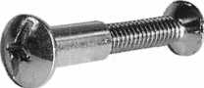

Sex Bolt Hardware and Fasteners - In stock for immediate shipment.

• Sex Bolts - Standard and Custom Sizes • Custom Service

* Sex Bolt Assortment Kits
* Barrel Bolts
* Binding Posts
* Connecting Bolts
* 50 Piece Minimum custom order
* Quick TurnAround
* CNC manufactured, Top Quality
* Brass, Stainless Steel, and Steel materials
* Architectural finishes

TECHNICAL IALES, INC.

17Timbercrest Lane  
South Setauket, NY 11720

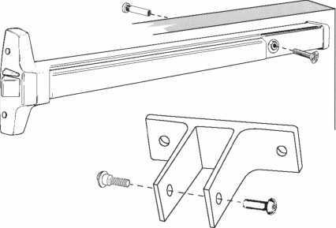

Phone:631-698-7173 • Fax: 631-736-5467

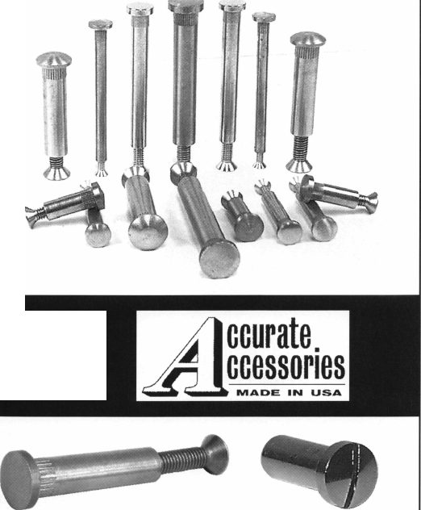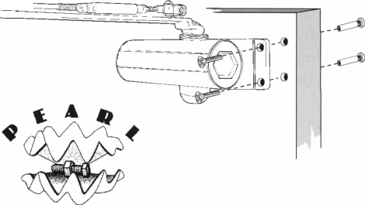

Hole Saw Alignment Guides

Tri-City Lock Company

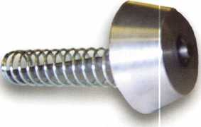

Photo 1

1-1/2” diameter Hole Saw Alignment Guide

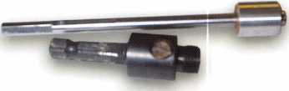

Photo 2

3/4” diameter Hole Saw Alignment Guide with arbor

I’m sure you’ve all been there: trying to put a jig on a door that has trim around the edge, putting plywood on the door with “C” clamps, measuring centers, and even using a small hole saw inside a large hole saw Or, just trying to “eyeball” your hole saw over the existing hole and then find the hole saw skipping all over the place (and ruining your customer’s door) when you turn on the drill.

Such was the case with Dan Mello, owner of Tri-City Lock Company in Fremont, CA. So, being a 25-year locksmith/inventor he decided to put aside all of the previous cumbersome methods and invented the Hole Saw Alignment Guides. The original Hole Saw Alignment Guide (1-1/2” dia.) was introduced in October 2001. He began receiving requests for smaller Guides to be used on desks and cabinets. So, in January 2003, he introduced the two smaller (5/8” and 3/4”) sizes.

These Guides are easy to use and don’t take half as much time as the “old” ways did.

To use, insert the Hole Saw Alignment Guide shaft into the hole saw where the pilot drill was, insert the arbor into the drill chuck, tighten up, and you’re ready to drill. No measuring centers, no adjusting jigs, no “c” clamps, and no plywood—just drill!

Photo 1

1-1/2” diameter Hole Saw Alignment Guide

The 1-1/2” diameter Hole Saw Alignment Guide (Photo 1) will enlarge a 1-1/2” diameter existing hole to 2-1/8” diameter or larger, depending on the size hole saw used. As you drill, the spring on the shaft keeps tension on the cone to keep it in place. To use, take out the pilot drill from the hole saw arbor, replace it with the Guide shaft, and tighten the setscrew. Put the cone into existing hole, drill halfway from one side, and then drill from the opposite side to complete.

Photo 2

3/4” diameter Hole Saw Alignment Guide with arbor

The 3/4” Hole Saw Alignment Guide enables you to enlarge an existing 3/4” diameter hole to 7/8” or 1” diameter, depending on the size hole saw used. An arbor (like the one shown on the left in Photo 2)

Keynotes • July/August 2003

should be used with the 3/4” Guide. Because the shaft  
of this Guide is much longer than the one used on the  
1-1/2” Guide, an arbor where the shaft can go directly  
through to be inserted into the drill chuck must be  
used. The end of shaft is tri-beveled to fit into the  
drill’s chuck so it won’t slip while you drill. The  
door/cabinet/desk does not have to be drilled from  
both sides.

Photo 3

5/8” Hole Saw Alignment Guide with arbor

The 5/8” Hole Saw Alignment Guide enables you to  
enlarge an existing 5/8” diameter hole to 7/8” or 1”  
diameter, depending on the size hole saw used. An  
arbor (like the one shown on the left in photo 3) should  
be used with the 5/8” Guide. Because the shaft of this  
Guide is much longer than the one used on the 1-1/2”  
Guide, an arbor where the shaft can go directly  
through to be inserted into the drill chuck must be  
used. The end of shaft is tri-beveled to fit into the  
drill’s chuck so it won’t slip while you drill. The  
door/cabinet/desk does not have to be drilled from  
both sides.

Photo 4

NOTE: All Hole Saw Alignment Guides are sold WITHOUT hole saws and have a money back guaran­tee.

Tri-City Lock Company’s Hole Saw Alignment Guides (Photo 4) are revolutionizing the way to over-bore existing holes - whether the hole was drilled the wrong size or you just want to modernize an old lockset with a new one and need a larger diameter hole centered over the old one. These Guides are easy to use and don’t take half as much time as many of the other methods. These Guides should be a part of your pro­fessional lock installation “arsenal”. They’ll save you time, money, and aggravation.

For more information, contact Dan or Sharon Mello at Tri-City Lock Company, 20059 Pleasant View Drive, Groveland, CA 95321. Phone (209) 962-4692, FAX (209) 962-4910, E-mail: [slmello@mlode.com](mailto:slmello@mlode.com) OR [Sharon@tricitylock.com](mailto:Sharon@tricitylock.com), or visit their website at [www.tricitylock.com](http://www.tricitylock.com) .

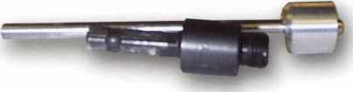

Photo 3

5/8” Hole Saw Alignment Guide with arbor

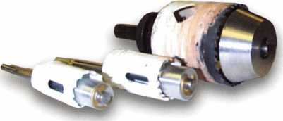

Photo 4

NOTE: All Hole Saw Alignment Guides are sold WITHOUT  
hole saws and have a money back guarantee.

Keynotes • July/August 2003

Basic Impressioning Part I: Tools

By Jim Hancock, CRL

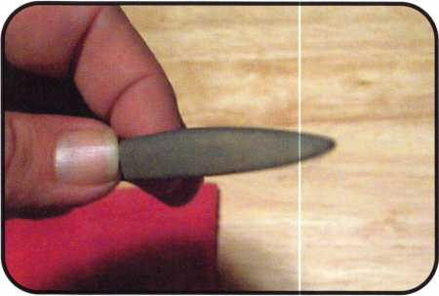

i

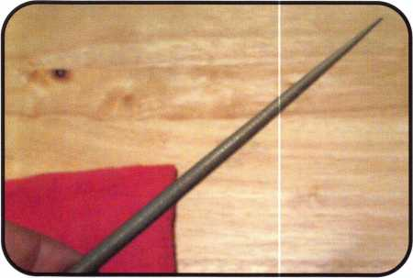

Impressioning in locksmithing is much like the Latin  
language to scholars; it is either a dead or dying art  
form. In today's hurry hurry gotta have it now world,  
it is much too simple (thanks to those heroes of ours at  
Dewalt or Makita) to put a hole in and then replace a  
lock rather than spend any time impressioning.

Because of the advancement in code recording and  
retrieval, the possibility of running across a lock that  
you can't produce a key by code for is slim. However,  
consider this: How many of you have what I refer to as  
a "test ring" of keys that you may carry to ascertain the  
keyway of a lock so you can cut the proper key by  
code? How many of you take this test ring into the  
office building, go up the elevator (or stairs), get the  
code from the lock, check the keyway, exit the office  
going back down stairs, go out to your service van, get  
inside and cut a code key, then repeat the process to  
try the key and write the bill? How many times has the  
key not worked because you misread the code or the  
code was wrong? How many of you have the luxury of  
parking directly in front of or by an entrance without  
having to walk any distance to the van? Wouldn't it  
have been so much quicker and more efficient to make  
the key while in the office the first time? No hassles  
with parking, bad or misread codes, code machines ill  
adjusted. And let's face it: In our little world, time is  
indeed money. If I can save io to 30 minutes per call,  
that's an extra two or three calls I can accomplish in  
the day. That is money.

There will be many opportunities in your career in which the ability to impression a key will serve you well. What I will attempt to do is give you the basics: tools, techniques and tricks to assist you in becoming proficient at impressioning. However, you must under­stand that you will only get better with much practice and this lesson is by no means a substitute for good old-fashioned, hands-on training.

Keynotes • July/August 2003

TOOLS

As with any mechanical skill, you must first begin with  
the proper tools. We will go through the list of necessi-  
ties, as well as tools you might want or may find help-  
ful. You will develop an affinity to certain tools as well  
as perhaps a dislike for others. My statement to you is  
very simple: Use what you like, what you are comfort-  
able with, and more importantly, ones that make you  
the most successful. First, we will look at files.

The files we use in our business are definitely special-  
ized. You will not purchase these at your local do-it-  
yourself hardware store. Probably the most prominent  
manufacturer of these files is a Swiss company, Grobet.  
(pronounced Grow Bay)

FILES

In Photo i is a Pippen file, also sometimes referred to as an apple seed or teardrop file because of its unique shape, having a rounded cutting edge on one side and a more pointed edge on the opposing side. The Pippen file is usually the file of choice for most locksmiths who impression, because of its shape. The pointed edge allows you to "score in" marks left by the disc and pin tumbler locks without fear of "bleeding" one cut into another, or what we will call losing cut definition. That same pointed edge allows you to work on disc or pin tumbler locks whose discs or pins are in such close proximity to one another that a regular file would cause you to lose cut definition. The rounded edge allows you to make wider cuts on locks whose internals are not small or close in proximity and also is useful in softening angles when you start making deeper cuts. One drawback to the Pippen file is that it is very easy while using the sharp edge to make your cuts to allow your angles to become too steep and allow the key to become bound in the lock. Also while using the point­ed edge, it is possible, especially while you are just learning and being cautious, that you will not get your cuts wide enough to accept the marks being left by the lock. And last, from a personal perspective, I find it difficult to control the file because of the shape. We will discuss file control later.

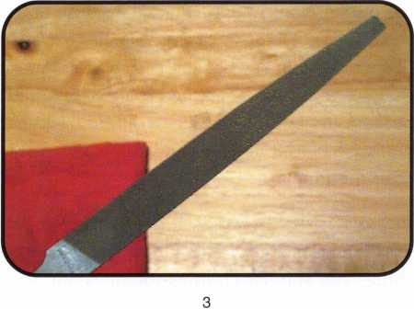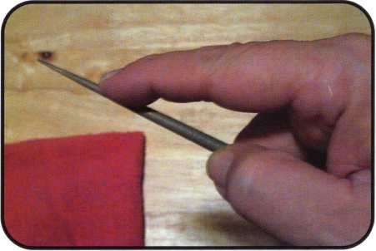

4

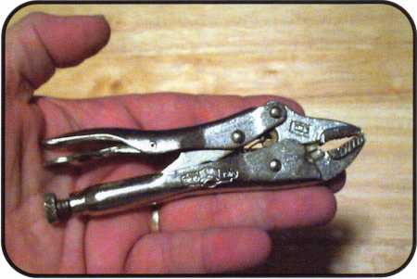

Keynotes • July/August 2003

The most commonly used is a round file, sometimes called a rattail because of its shape (photo 2).

However, don’t be confused by that term as there are indeed rattail files to be had a hardware store but the cut is not the same. To some of us old timers, this is the tool of choice for impressioning. It is easier to control than the Pippen, and because of its conical shape, allows you to make nice angles even as you get deeper into the key blade. Truth be told, most of us that are ’’old timers” learned to use the round file because it was much easier to obtain back many years ago, and it also was and still is less pricey than the Pippen.

Photo 3 is that of a typical flat file also known as a warding bastard file. This file will be used for many things, but standard impressioning is not usually one of them. It will be used to prepare key blanks for impressioning, perhaps soften the definition points between deep cuts and even impression lever type lock mechanisms where there is not a need for angles in the cuts. But I will say this: Once you learn the art of impressioning, and perhaps you are in a situation where you need to make a disc type key and all you have is a flat file, you can do it. Even though these tools are important, the know-how and person behind the file are equally or more important.

A few more points about these files. First, they can be purchased in three degrees of coarseness. There is a number 2 cut, which takes out substantial amounts of key material with each stroke. There is a number 4 cut, which will remove much less material per stroke, but will take enough to make a difference. Last, there is a number 6 cut, which is very fine and requires a good deal of pressure and stroke to remove material. My personal preference is a #4 cut; it allows me to remove a good amount of material without over-cut­ting on each stroke. Another point to remember about the file is the stroke. Files only cut in one direc­tion, and that is away from you. Pulling the file back toward you is not going to cut any material and can sometimes be counterproductive in that it will leave file marks and debris in the cuts, which can be misin­terpreted as a mark, causing you to overcut the key. Also, these files will come in various lengths. In par­ticular, the Pippen and round file can be purchased in a 6 or an 8 inch length. The longer file, in my opinion, is harder to control and also because it is longer, it

***24***

stands to reason that the diameter is also greater; therefore, it will make wider cuts, making it much easier to bleed the cuts into one another. Again, the thing to remember is use what is comfortable and suc­cessful to you.

Earlier we mentioned file control. Let’s discuss that in a little detail here. Simply stated, file control means making the file cut where you want, at the depth you want, and without having the bleeding effect, or over cutting. In photo 4, notice the keys to file control. First notice that there is no add-on handle on the file. Add-on handles accomplish two things: They get in the way when filing, and if held while filing, make you lose all control. Second, notice that the file is held like a drum stick with the index finger stretched out along the file. This grip allows you to hold the file firmly while the outstretched index finger allows you to put downward pressure on the file as you cut. Next, you will see that the position of the file in my hand won’t allow me to use more than half of the file’s length when cutting. This is done by design so as not to allow the width of the shank of the file to become a factor in getting cuts too wide or in bleeding cuts.

The last thing to notice is the hand holding the key blank. Notice that the blank is positioned on the workbench surface. You always want to file against a key that is on a solid surface, be it the workbench, or your knee, or whatever. Never hold the key in the air and file against it, or worse, hold the file and move the key back and forth under it. You have no control of your cutting if either of these methods are used. Also you will see that the hand holding the key is doing what we refer to as "pinching the mark.” Once I have identified a mark, I use the forefinger and thumb of the non-filing hand and pinch the blade of the key right beside the mark. I then use these pinched fingers as filing guides by placing the file against these fingers, on top of the mark, and make my cuts. Because the file is against my fingers, I can put a little pressure on the file in the direction of my fingers as I cut and my fingers won’t allow the file to run. This eliminates wiping out marks you have seen on the blade when the file runs.

These are the key elements to file control and if you develop good file control, your success rate in impres­sioning should improve.

Keynotes • July/August 2003

TENSION AIDS

As will be discussed later in this lesson, one of the ele­ments needed to impression is the ability to put proper amounts of tension on the key blank which will in turn put tension on the discs or pins and allow marking. No matter your finger strength, you will never be able to consistently put the pressure needed on the blank to accomplish your objective without the assistance of some form of leveraging device on the key Simply using a standard set of pliers would perhaps work in the short term. However, because of the repetitive nature of the motion used to obtain a bind, your hands would tire very quickly and I believe you would lose your ability to force marks in short order.

The tension aid probably used most widely, which is also the easiest to obtain and the least costly, is a pair of adjustable locking pliers, or vise grips (photo 5).

Oh, but not just any pair. You really do not want any­thing longer than a 4 or 5-inch pair. The shorter grips allow for good control of the key and are much easier to hold and manipulate. The longer pairs become awk­ward and cumbersome. The longer grips also tend to become a fulcrum or lever rather than a tension tool and lend to more broken keys, or worse, bent or bro­ken disc tumblers.

If you use vise grips, you will want to make certain to put the blank into the grip jaws as far as possible, get­ting the end of each jaw as close to the shoulder stop of the blank as you can (photo 6). Also, because of the four different key configurations, you'll want to make sure to insert the key in the grips the same way every time. Not sure about the four key configurations? Let's go through those now.

When dealing with disc and pin tumbler locks, there are four different key configurations. They are:

* Single-Sided - This is like most typical commer­cial/residential knobs, levers and deadbolts. The cuts are only on one side of the key because the pins or discs only contact or attack the key from one side and the key only goes into the lock in one direction.
* Single-Sided Convenience - This would be much like pre-1984 Ford type keys. There are cuts on both sides of the key. However, the pins or discs attack the key only on one side. The key is cut on both sides because it will enter the lock in either direction for convenience.

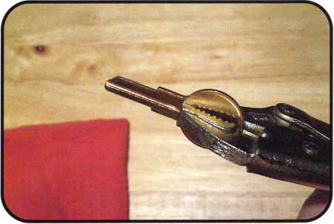

6

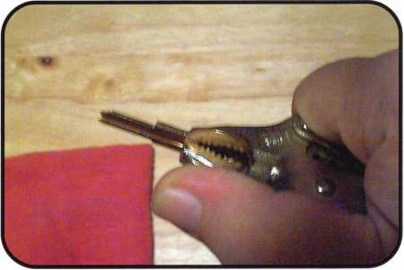

7

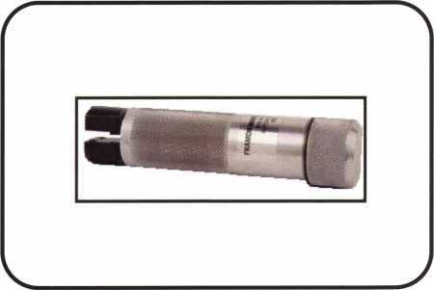

8

Keynotes • July/August 2003

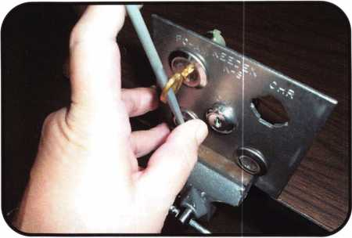

* Double Sided - These are like older Volkswagens,  
  Porches, Chicago and Illinois double-sided disc  
  tumbler locks. There are cuts on both sides of the  
  key because the pins or discs attack the key from  
  both sides however both sides are different and the  
  keys would only enter the lock in one direction.
* Double-Sided Convenience - This is much like the  
  majority of all foreign automobiles on the market  
  today. The key will enter the lock in either direc-  
  tion and the pins or discs attack from both sides.  
  The major difference is that the pins or discs are  
  generally in alternating chambers on each side. In  
  other words, on one side of the lock, they would be  
  in positions 1,3,5,7 etc, while on the other side, they  
  would be in 24,6,8 etc,. The cuts are transposed to  
  each side in order to make it a convenience key.

This brings us back to inserting our blank in the grips  
the same way every time, because as you can well imag-  
ine, it would be a bad thing to be impressioning a dou-  
ble-sided convenience key and, some time into the  
process, accidentally flip the key. The marks you were  
seeing now change, and you are lost. If you will look at

10 the vise grip, you will see that the jaw has a convex

angle on one side and a concave angle on the other. If you will use these as a reference point and insert the blank so that you can reference one of the sides as "up," you will not be apt to put the key in the lock incorrectly. If you’ll notice on photo 7, when I use grips (I’ll explain later) I always insert the blank so that my thumb runs along the convex side of the jaw. This is my reference, and it is a very comfortable position.

In photo 8 is a specialty tool known as an impression­ing handle. This tool serves the same purpose as the vise grips with a few differences, both good and bad. It is lightweight, and because of its cylindrical shape, is very comfortable to use. Also because it is light, you get a very good feel for the key, and are less likely to break one because you can feel it fatiguing first. A lux­ury that the vise grips may not afford. It has a flattened spot on one side of the handle that serves as your ref­erence point. The key blank is held securely in the handle by two setscrews. The key slips into the end of the tool and the two screws are tightened. The biggest downside is the price. Depending upon brand and your supplier, the handle will run between $25 and $65. That's a lot of vise grips.

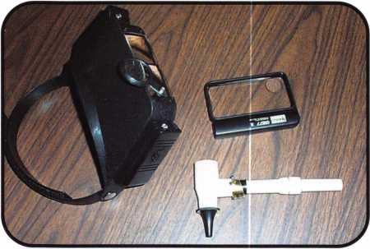

Keynotes • July/August 2003

The method I use to put tension on my key blank is admittedly a bit unconventional, and tends to drive bosses and co-workers crazy, but it works for me. Photo 8 shows my file, the handle end, sticking through the ring hole of the key I then use this as a lever to torque the key For me, this works well. I can feel the key better and, knock on wood, I haven't bro­ken a key since 1960-something. I also get more up close contact on the lock and can sense when I need more pressure, or bump. The key is to use the handle end not the cutting end. The last upside to using the file is, unlike the grips and impressioning tool, the file leaves no scarring on the bow of the key.

This is pretty important if this is the last blank you have. You can give this key to the customer. It also is important if you are a cheap son of a gun — like me. Why use two blanks when you can save a penny or two by using one?

a problematic lock to determine if something is amiss inside. It is equipped with a pretty powerful halogen light and will illuminate a blank well. With the cone attachments you will be able to light smaller specific areas of a blank. The downside to this Otoscope is no magnification. There are scopes, which provide both light and magnification however they are very pricey.

There are certainly many types, styles, colors, shapes and price ranges of visual aids that you can use. And by all means, use whatever you need to make impres­sioning work for you. But be cautious with these aids. Not only may they enhance the marks on the key, but they also tend to enhance every imperfection as well and these can easily be mistaken for marks causing you to miss-cut your key.

VISUAL AIDS

There are two factors that will help deter-  
mine our success rate at impressioning and  
sadly, we cannot control either; eyesight and  
lighting. What we can do is assist each of  
these factors as much as humanly possible. In  
photo 10, you can see three ways to assist  
these bad or deteriorated conditions. First is  
a lighted visor. It has a fixed lens of approxi-  
mately a 10 magnitude. A secondary flip  
down lens that combined with the first lens  
increases to a 15X power. There is also a jew-  
elers loop type third flip down, which will  
increase the magnification to 20X. On the  
sides of the visor are two AA battery pow-  
ered pen lights, which when used, will illumi-  
nate a blank in dark areas and is excellent for  
night work.

The second item is a typical magnifying glass.  
These single glass, handheld glasses can be  
purchased at many pharmacy and discount  
stores and usually in strengths from 5X  
to 15X.

The third item is an Otoscope. This is the  
same type of scope you as a locksmith would  
use to read a picked disc lock, or look inside

Advertise with Weatherproof Safety Labels!

Lockout your

competition

by placing your  
calling card on  
every door you  
service! Keep

your name in front  
of every customer  
with these Durable,  
Affordable Labels  
Call & Order Today  
1-800-355-6322

(Actual Label Size 1 1/2x4 1/2)

see you ii/t Lasvegas> ALOA Expo Booth 20&

Professional Business Products

ALOA Associate Member

Check out our competitive prices on Invoices with two color ALOA  
logo, Repair Tags/Claim Checks, Business Cards, Door Hangers,  
Shirts, Hats, Pens, Key Tags, Magnets.

[www.professionalbusinessproducts.com](http://www.professionalbusinessproducts.com)

Keynotes • July/August 2003

**2**

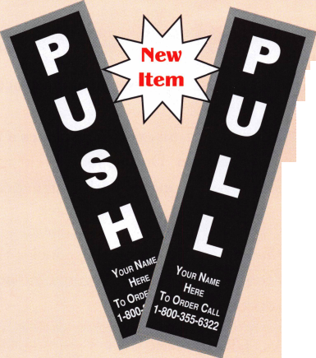

En-Aable Yourself

Aable Releases the All-New, All-in-One Ford Universal Flush-Mount and Chrysler 8-cut Ignition Removal Kit (patented)

By Frank Markisello, CRL

As you all know, the Ford Focus has been a popular car; however, the ignition locks have been a big problem. So at many of the conventions, locksmiths have came over to me and asked me to come up with a simple solution to remove these locks. Well, as always Fve done that — and gone even farther. Fve designed my Ui kit to not only remove the original Hurd focus ignitions, but all of the different types, including the new one from Strattec (#707592), which has no side bar, the #lCi34oU by Lockcraft, the 188 from ASP, and the old Strattec

(#706229).

The Ui kit also works on the larger face locks from Strattec (#703596). This is also a new design — this one simi-  
lar to the #707592; the face comes out the front and the plug comes out the rear of the lock shell. Also, with new  
adaptor kit, for the Ui, you can pick virtually all Chrysler, Dodge and Jeep, 8-cut ignitions in less than 5 minutes  
with no damage to the lock. Similar kits sell for over $100, and can only do Chrysler.

The kit includes:

* 1 force tool to break face caps out
* 3 drill guides to make access holes in all the different locks to  
  pick the side bar in
* 3 complete drill bits and arbors numbered for quick reference on  
  each car
* 1 side bar pressure tool to push the side bar in
* 1 turn wrench to turn the plugs to the ON position
* 1 steel plug removal tool needed to remove and replace the plugs  
  in the #707592 locks
* New, and now for just limited time, the kit includes a free  
  Chrysler adapter, to do Chrysler, Dodge, Jeep, 8-cut ignitions
* 4 sets of complete step-by-step photos with instructions for all the different cars.

You do not need any other tools to work on these locks; this kit includes everything needed. As all my tools, they are made of top quality tool steel to last a lifetime. One or two jobs will more than pay for this complete kit. A list of some cars the Ui works on

Ford cars: all Focus locks, T-Bird, Mark VIII, Explorer, Mountaineer, Continental, Escape, Mazda Tribute, Contour, Mystique, Lincoln LS, Aviator, and more. Chrysler cars (with adaptor): Chrysler IGN type: 703719, 705096 coded, 300M, Cirrus, Concorde, PT Cruiser, Sebring, Town Sc Country, Voyager. Dodge IGN type: 703719, 705096 coded: Caravan, Neon, Intrepid, Viper, Stratus. Jeep IGN type: 703719, 705096 coded: Grand Cherokee, Liberty, Wrangler, and more. Dodge truck IGN type: 704650: Durango, Ram pickup, Ram van, Dakota pickup.

Let’s take a look at some instructions when using this kit, starting with the Strattec #707592 type ignitions, for use with the Explorer, Mountaineer, Focus, etc. (no side bars)



Keynotes • July/August 2003

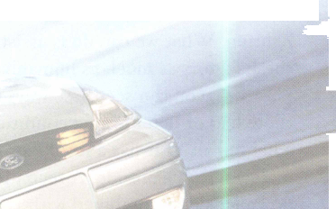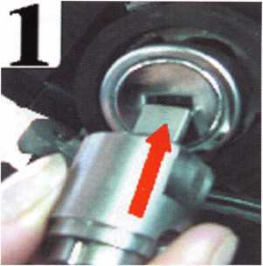

1. Insert the key blade into the keyway of the ignition face cap.

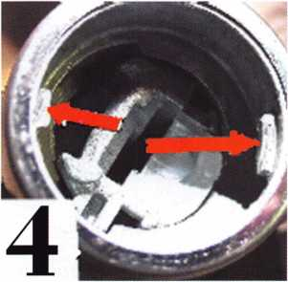

4. Here's the inside of the lock shell, pointing to the two small tabs on side wall. These tabs will ride into the slots on the outside of guide tool.

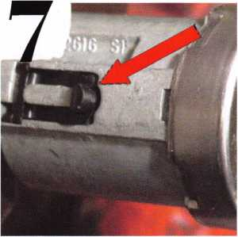

7. Push in the lock retainer, located about 9 o'clock.

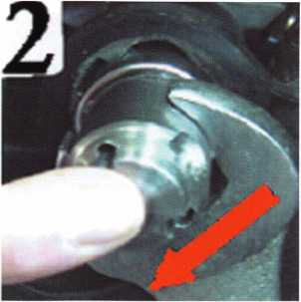

2. With a crescent wrench, put clockwise  
turning pressure on the face cap.

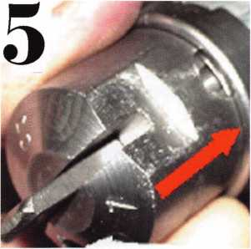

5. Turn the tool around and line up the small  
tabs in the cavity of the shell, with the

small grooves, on the tool. The tool will drop into the cavity of the shell; the edge of the tool should be flush with the rim of the lock shell. The arrows show that before you drill; also the arrow shows the 3/16-inch guide hole you must drill through for proper alignment. Keep inward pressure on tool while drilling.

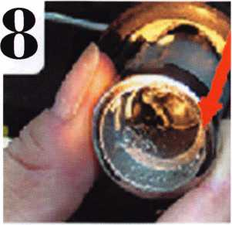

8. Then just slide the outer lock shell out of the housing.

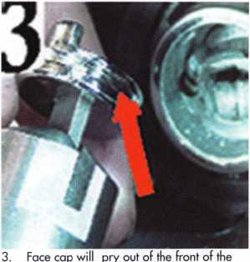

lock. Now remove any pieces of broken material from the cavity of the shell and the black plug pieces.

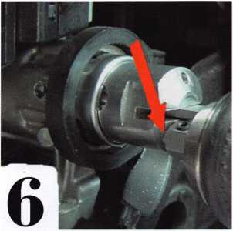

6. Using a drill and arbor #2, drill through 3/16-inch guide hole, until the arbor comes in contact with the drill guide tool, then remove the tool.

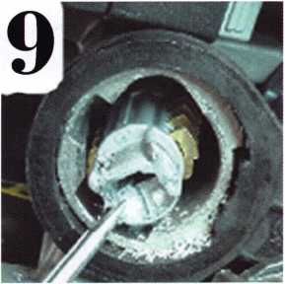

9. The plug will remain in the housing held in by the rear clip on the rear of the plug.

Keynotes • July/August 2003

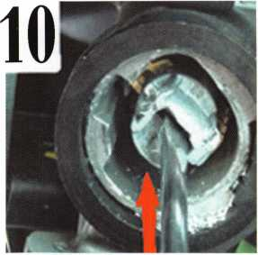

10. With a screwdriver, push in on the spring- loaded plug and turn it toward the ON position.

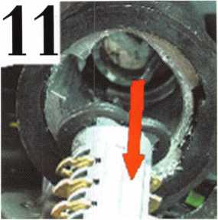

11. Now slide the plug out of the housing, fit the key to tumblers, transfer tumblers from the old plug to the new one, as the tum­blers are not damaged.

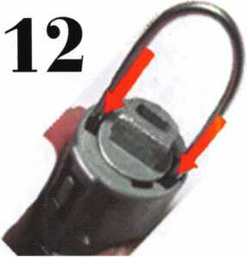

12. Here is the tumbler holding tool in use. Note: The tumbler holding tool can be useful to

remove these plugs when you have a

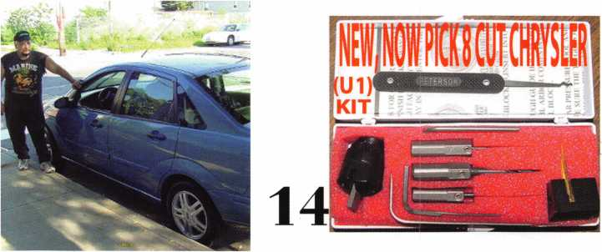

working key, and need to work on these out if you try to use the key to rotate plug to

locks. Because the plug comes out the rear the removal position. The tumbler tool will

of the lock shell, however, it will not come hold all the tumblers down, so you can rotate

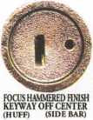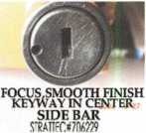

£707592, NO SIDE BAR

BEVELD FACE CAP

**TYPE FOCUS LOCKS**

the plug to remove.

1. Here I am in front of the 2000 Focus
2. U1 kit

15. Different types of Focus locks in use.

Now let’s look at some pointers for doing the #703596 larger diameter face locks. It’s similar to the #707592 steps; just follow steps 1, 2, 3, 4 and 5. Then go to:

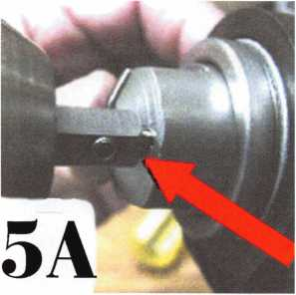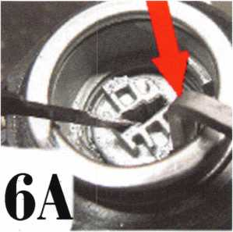

5a. Using a drill and arbor #1, drill through the 1 /8-inch drill hole until arbor hits the stop.

6a. Insert the side bar pressure tool into the access hole you just made, being sure the side bar tool handle is out, and it slides between the cylinder plug and the lock shell. Now pick the tumblers from the front to rear, while keeping inward pressure on the side bar tool. When the side bar tool drops all the way in, the side bar is then pushed into the plug, unlocked position.

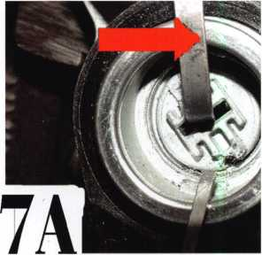

7a. Take plug turning tool and turn it toward the ON position; at the same time, pull the side bar tool out so plug doesn't relock.

Keynotes • July/August 2003

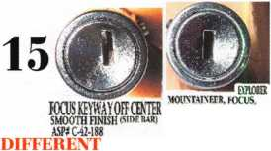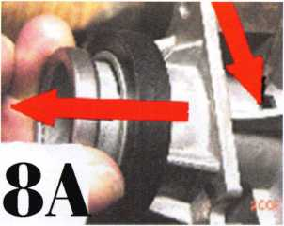

8a. Push the lock retainer in and slide the cylinder out of housing.

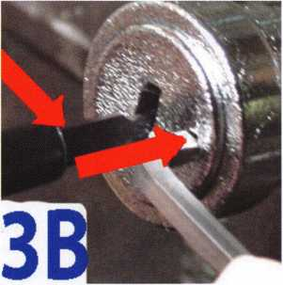

3b. Insert side bar pressure into access hole you made, being sure side bar tool slides between the side bar and the lock shell, while racking tumblers from front to rear, keep inward pres­sure on the side bar tool. Once the side bar drops in, the plug is in the unlock position.

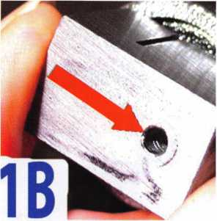

1 b. Insert drill block into keyway guide hole toward you

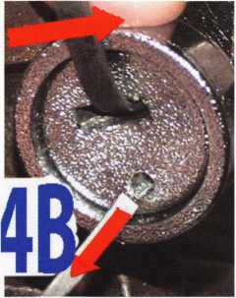

4b. With your finger, push the plug in, take plug turning tool, apply turning pressure toward the ON position while removing the side bar tool, so the plug doesn't relock. Push the retainer in and slide the cylinder out. Repair or replace.

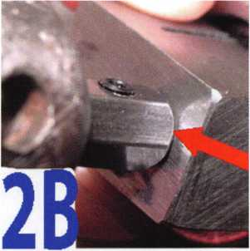

2b. Drill through guide hole using a drill and arbor #3, until the arbor hits the block.

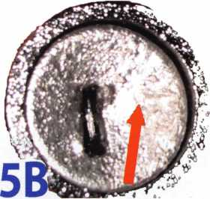

5b. Some plugs you can use a dab of auto body filler to fill the hole you made, then use a chrome spray paint and give a quick spray over the face of the plug; that's it. The arrow shows the lock plugged and sprayed; this will allow you to use the same lock. These items are easy

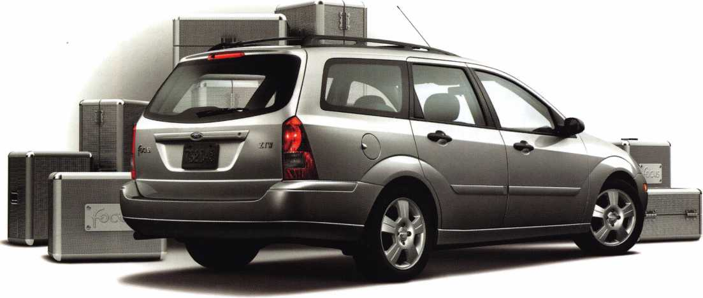

Keynotes • July/August 2003

Now let’s look at some tips for the Chrysler, Dodge and Jeep 8-cut ignitions (with adaptor).

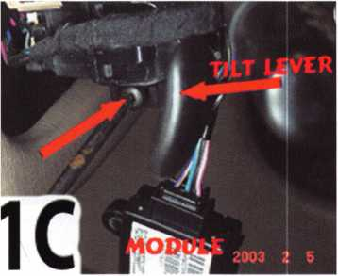

1 c. You must remove the tilt wheel lever on the left lower side of post before you can drop the shroud.

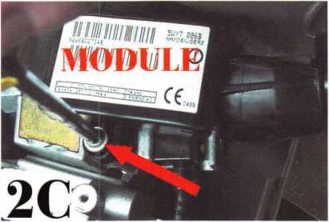

2c. You must remove the skim module and antenna ring so you can gain access to the lock retainer before you can remove lock. Note: Be careful to drop mod­ule only about one inch, then slide the unit forward about two inches so the antenna ring slides off the face of the housing, only then carefully let it hang down. This part is fragile and will easily break.

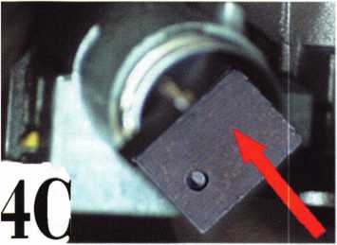

4c. Insert (U1) drill block with Chrysler adaptor, into the keyway.

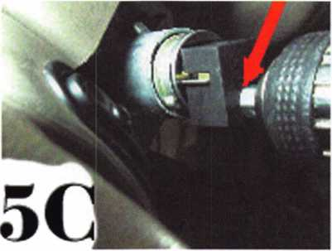

5c. Using a drill and arbor #3, drill into 1/8-inch guide hole until the arbor hits the block.

CHRYSLER

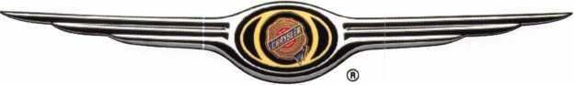

DRIVE 5c LOVE



Keynotes • July/August 2003

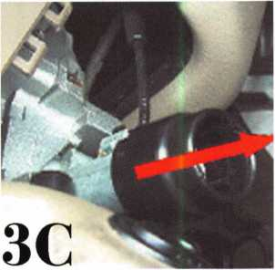

3c. Pull the black plastic cap off the front of the lock housing, held on by plas­tic tabs (just wiggle and pull it off).

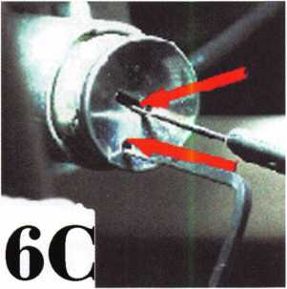

6c. Insert side bar pressure into the

access hole you just made; be sure it slides between the side bar and the outer shell of the lock. Put slight inward pressure on it, while you rake the tumblers from front to back. You will feel the side bar tool drop in; at this point, the plug is in the unlock position.

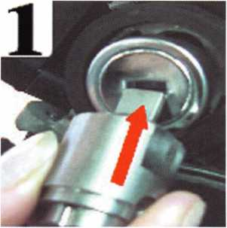

7c. Put turning pressure on the face of the plug to the ON position. At the same time, remove the side bar tool, so the plug doesn't relock.

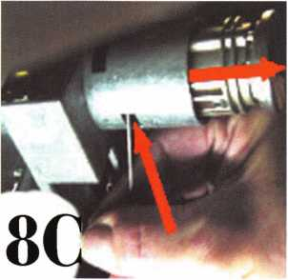

8c. Push in the lock retainer and slide the lock out. Then fit the key.

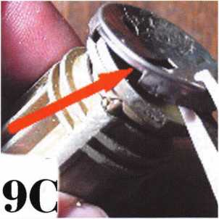

9c. To reuse the same lock, just pry off

the face cap.

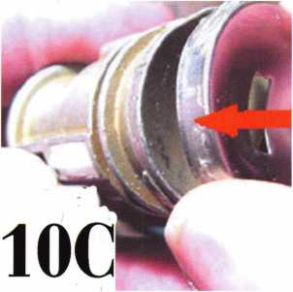

1 Oc. Insert the new cap #54 over the face of the plug and crimp it over the face ledge. Reinstall the lock. Reinstall the black plastic cap and the skim module with antenna ring.

11

1 lc. These are the tumblers used in these locks. Note that some have dummy cuts, code numbers stamped on the tumbler.

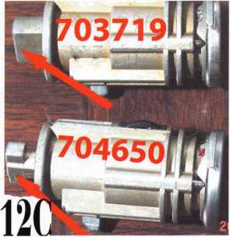

1 2c. These are the 2 main type of locks

used in these cars.

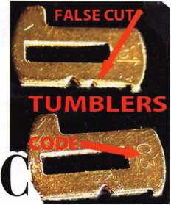

CHRYSLER ADAPTOR. FQRU1:

13C

13c. Adaptor for U1

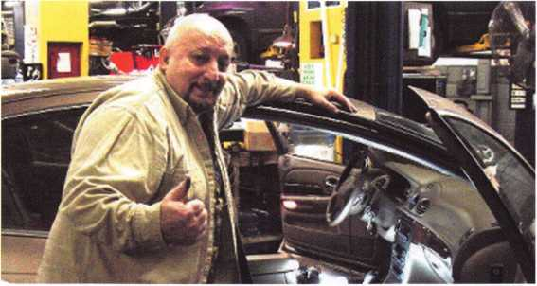

14c. Here I am standing over a 2002 Concord.

Keynotes • July/August 2003

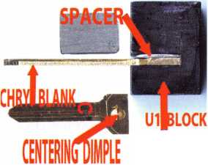

3 for i: Easy Safes Made Even Easier

By Greg Perry, CML, CPS

This month, I’m cleaning off my desk of these pesky safe pictures. Each safe is interesting, but not enough for an article on their own. The first two barely qualify as safes, although their manufacturers call them safes. The next one is an Amsec electronic safe I worked on several years ago with a disconnected wire.

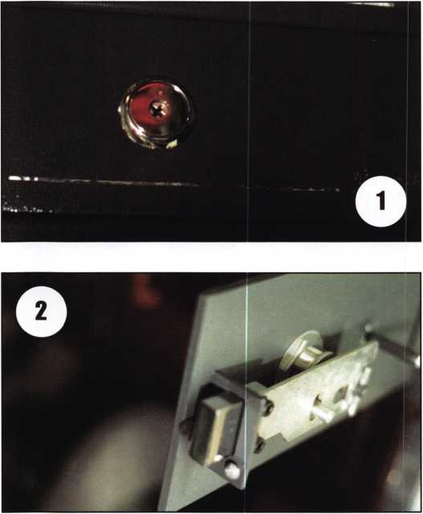

We’ll start with the easy one first. Pictures i to 3 are of a little gun box made by Sentry; our customer lost the keys and wanted it opened. I called Sentry to ask about blanks, cut keys and locks. The person I spoke to indi­cated that only cut keys were available and they would need the serial number of the container and that the customer would need to send a notarized letter along with $6 requesting more keys. My customer could not find his registration paperwork, including the serial number. When I inquired about locks, she said they no longer sold locks separately. The lock picked fairly quickly with a couple of rakes on each of the four sides.

The hardest part was keeping the turning tool in the keyway. Since the lock is no longer available, I consid­ered modifying the unit to accept a different lock; it’s really not cost effective. Our customer had to settle for open only.

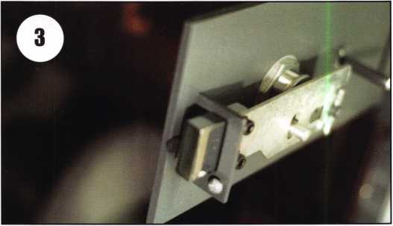

The second unit we’ll look at is a ServiSafe proudly made in Brazil (so claims the label on the back). The 12- button keypad can be seen in pictures 4 and 5. The key­pad has numbers 1 to 9, “o,” a “CLR” and “ON” button. There is also a 4-digit display to the left of the keypad. The handle has a small phono-jack type receptacle on the side. This unit came in DOA, no beeps, no display and the customer was having difficulty remembering how it operated, how many batteries and which type it took. I found a similar-looking unit on the SAVTA web site ([www.savta.org](http://www.savta.org)) photo directory named “Baker Safe.” It looked the same, but was it? I asked on the web site if anyone knew anything about the unit, and if they knew the voltage needed to power it. John Soderland suggested trying one battery, then two, then three, etc. until it powered up. After trying this method up to 12 volts and getting nothing, I decided it was time to drill, but where? Removing the keypad allowed me to look down the side with a scope. Looking through the scope I could barely see the bolt. I guessed the bolt would be at the center of the door. That was my first hole. The second hole was a little closer but still not on target. I could touch the bolt, but it would not budge.



Keynotes • July/August 2003

I finally drilled a hole centered on the bolt. Next, I  
used a punch and hammer to push in the bolt. The  
dimension to the center of the bolt is 2 1/2 inches  
down from the top of the door and 3/4-inch back  
from the face. Once the safe was open, it was time to  
see what makes it tick. Picture 6 is after the back  
cover was removed, revealing many things. First six  
“D” size batteries or 9 volts total. They were dead and

the battery box was not making a good  
connection. There are a couple of  
switches to indicate the door position.

tion, which is displayed on the screen. If the correct  
numbers are entered, the display reads “OPEN,” the  
bolt retracts and the bell sound is heard. Locking the  
safe requires the door to be shut, and again, you enter  
the combination. The display now reads “LOCd,” the  
bolt fires locked and the bell rings a little like an old  
phone ring. If the door is not shut, or another prob-  
lem exists, the display will be “ERR.”

Above the battery box is a solenoid; it  
controls the lock bolt position. If the  
safe is locked and the correct combina-  
tion is entered, the solenoid lifts and a  
second solenoid pulls the bolt back.

The first solenoid then extends to  
hold the bolt in the retracted position.  
Once the door is shut, the combination

is entered, the first solenoid lifts and the spring-  
loaded lock bolt extends. The bolt assembly is shown  
in picture 7. You see the cavity for the cam, but since  
this piece is held in place with the two screws, I have  
no idea what purpose the cam lock serves.

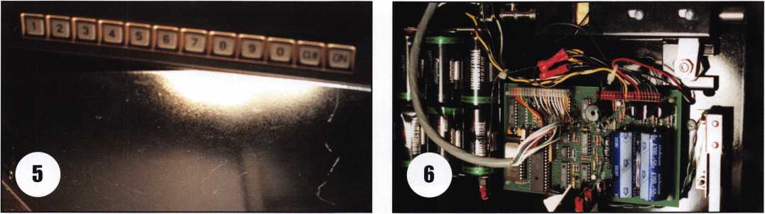

Also a cam lock can be seen in the picture, below the  
door bolt. It doesn’t show from the outside because  
the handle covers the keyway. The interesting thing  
about this lock is it doesn’t appear to have any pur-  
pose. It contacts the block that the lock bolt travels  
through, but this is held in place with two screws. You  
can also see the cable coming from the keypad to the  
circuit board. After I corrected the problem with the  
battery box, the safe started to operate properly.

Opening the safe is accomplished by pressing the  
“ON” button. Next, you enter a four-digit combina-

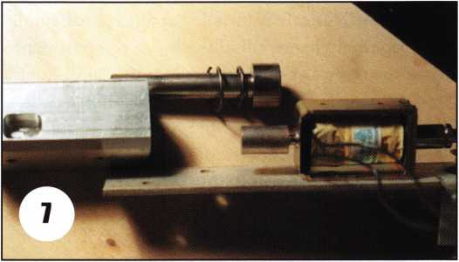

Keynotes • July/August 2003

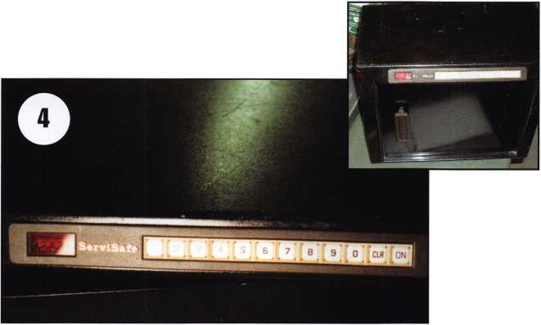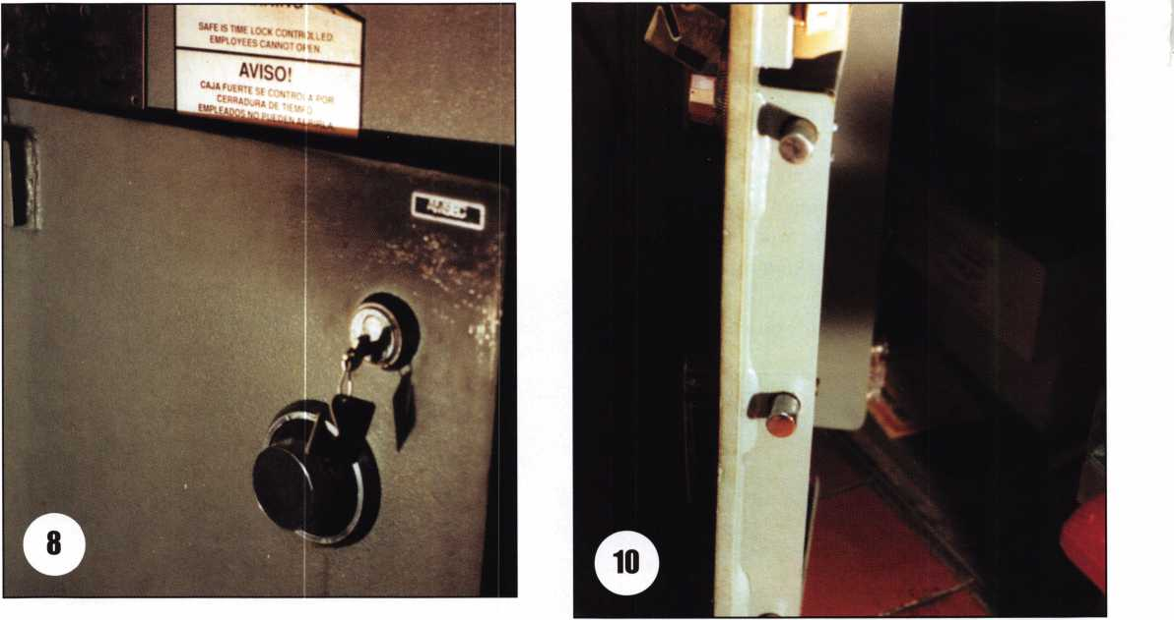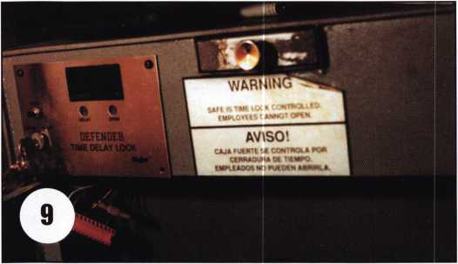

The last safe to look at is an Amsec safe. The electron­ic time delay lock still has the Major Defender name on the label. This safe is installed at a pizza restaurant; they keep their change till in the lower compartment and on the door. Let’s quickly look at the outer door before looking at the electronics and the inner door. The outer door is controlled by an S&G 6730 for night locking, and a Segal rim lock provides convenient “security” during the day so they don’t need to dial the combination lock every time they want access to the safe. This door is a common Amsec design. The combi­nation lock is mounted vertical down with a relock par­alleling it 1 1/2 inches

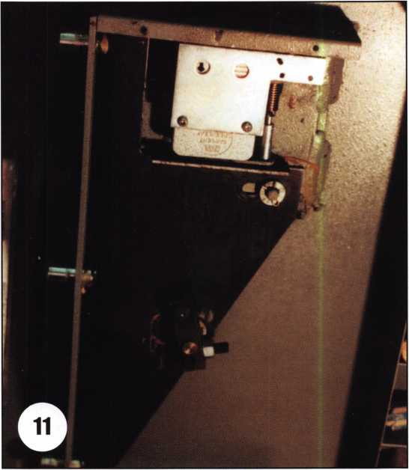

**36**

Keynotes • July/August 2003



over toward the hinge. It has three bolts controlled  
by an “E’ handle, 8 3/4 inches below the combination  
lock dial.

Centered at the top of the safe is a drop drawer.

It drops into the upper compartment of the safe  
behind an inner door. The inner door is locked by a  
solenoid centered on the door. The only thing on the  
outside of this door is a knob pull and a label:

“Warning — Do Not Slam Door.” The label is a clue  
— if not a dead giveaway — as to the type of bolt on  
the safe. An electronic timer controls the spring-loaded  
solenoid bolt. To open the inner compartment, a key is  
used on the front of the safe to turn a switch clockwise  
that starts the timer. Ten minutes later, the unit starts  
beeping, turning the key counter-clockwise sends  
power to the solenoid to retract the bolt. I was called  
out because the timer no longer operated. I removed  
the keyboard and found a disconnected blue wire. I  
called Amsec to find out the correct terminal location.  
Blue is a ground wire attached to terminal C. I’ve  
included a chart with the proper wire locations and  
colors. If you need to open this unit quickly and have  
access to the wires, terminal “K” is power out to the  
solenoid. Simply apply power to it from terminal “D”  
(labeled “12V”). Another option, if the solenoid is not  
operating, is to drill a small hole centered on the upper  
door about 1 1/4 inches back from the face of the door.  
This will allow you to push the spring-loaded bolt back  
and open the door.

These safes provide little challenge to the competent  
technician, the most difficult being the ServiSafe if you  
do not have good information. Hopefully, this article  
provides you with enough information to make them  
easy to open.

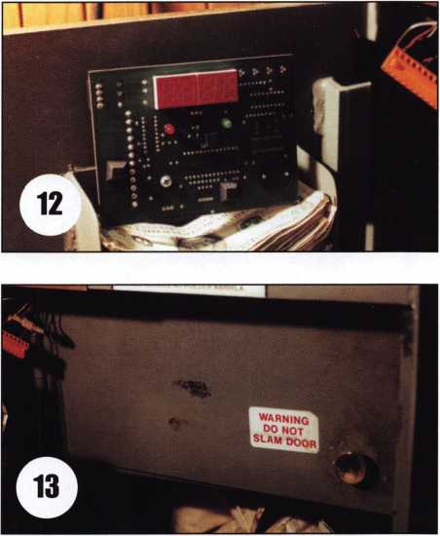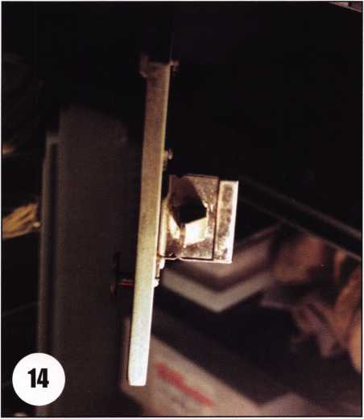

**SAFE CORPORATION**

MANUFACTURES OF QUALITY DEPOSITORY SAFES AND CHESTS

DISTRIBUTING FROM WAREHOUSES IN

* LOS ANGLES, CA
* CHICAGO, IL
* GLASSBORO**,** NJ

A & B is now a stocking distributor

for Mutual Safes

featuring

■

AB-4-30-3S AB-9-2 WS 10-2

Chose from over 75 models in stock

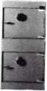

We ship your order within

24 hours

See us

*at [www.a-bsafecorp.com](http://www.a-bsafecorp.com)*800-253-1267  
Fax 856-863-1208

CALL FOR YOUR  
CATALOG TODAY

Keynotes • July/August 2003

**3**

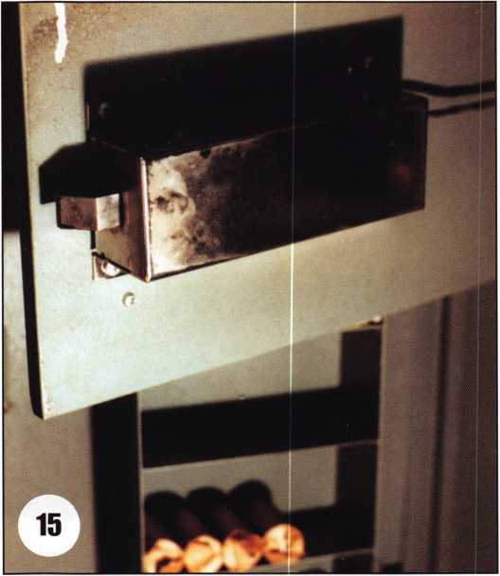

Wire chart for the  
Amsec/Major Defender  
A- AC blue wire  
B- AC Red wire  
C- GND Blue and Green wires  
D- 12V no wire  
E- Key Red wire  
F- GND Yellow wire  
G- BHi no wire  
H- BH2 no wire  
I- 5V no wire  
J- GND no wire  
K- SOL Red wire  
L- SIG no wire

Need information in a hurry? Use ALOA’s Fax On Demand service.

Just call 310-575-5074 and receive:

1. ALOA Index of Documents
2. Becoming a Locksmith (Ipg)
3. Locksmith Career Summary (3pg)
4. Locksmith School List (2pg)
5. ACE Class Schedule (8pg)
6. Certification lnformation(3pg)
7. PRP Category List (Ipg)
8. ALOA Membership Application(2pg)
9. ALOA List of Benefits (1 pg)
10. Scholarship Application Form (Ipg)
11. ALOA Video Library Order Form (1 pg)
12. ALOA Membership Items Order Form (Ipg)
13. Safe & Vault Technicians Association Member Application/Subscription Form (2pg)
14. ALOA Chapter Roster (3pg)
15. Legislative Action Network (2pg)
16. Legislative Action Network Newsletters (Ipg)
17. Various State Laws (lOpg)
18. Industry Position Pager (Ipg)
19. Current Legislative Action Network Newsletters (Ipg)
20. Board of Directors Nomination Form (2pg)
21. ALOA Convention Registration
22. ALOA Board Expense Reimbursement & Request Form

310-515-5074

Keynotes • July/August 2003

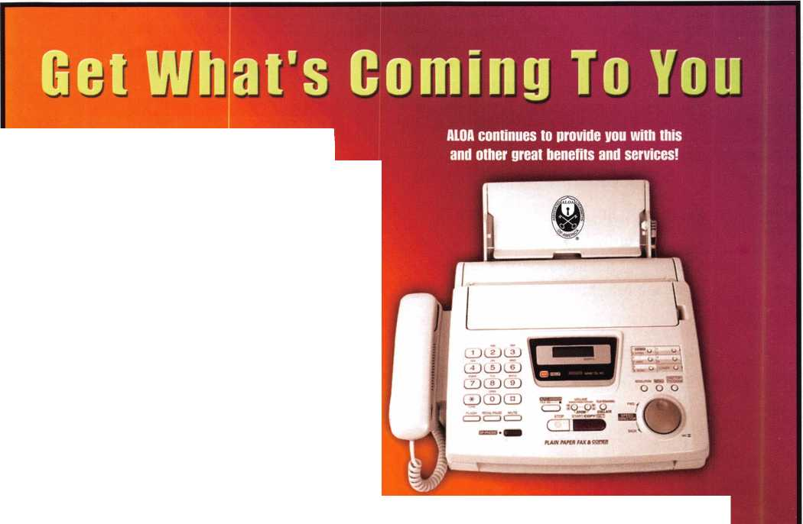

rx'™°v

CEN.XXXXXX

k kaba koupon

Ivard Stop Refresh **Home**

]© http //[www.kabamasdealers](http://www.kabamasdealers) com/

i

The Kaba Mas Dealer Network is the second phase of our new distribution channel that includes sales support, technical support services, product development and technical training classes. The first step was to create a network of wholesalers - the Wholesale Network - who all received extensive in-house training on all of our products and are supported by our internal and external sales team. By providing our distribution channel with education and sales support, they are better equipped to service your product needs.

**The Brand for Safe Locks**

A Member of the Kaba Group

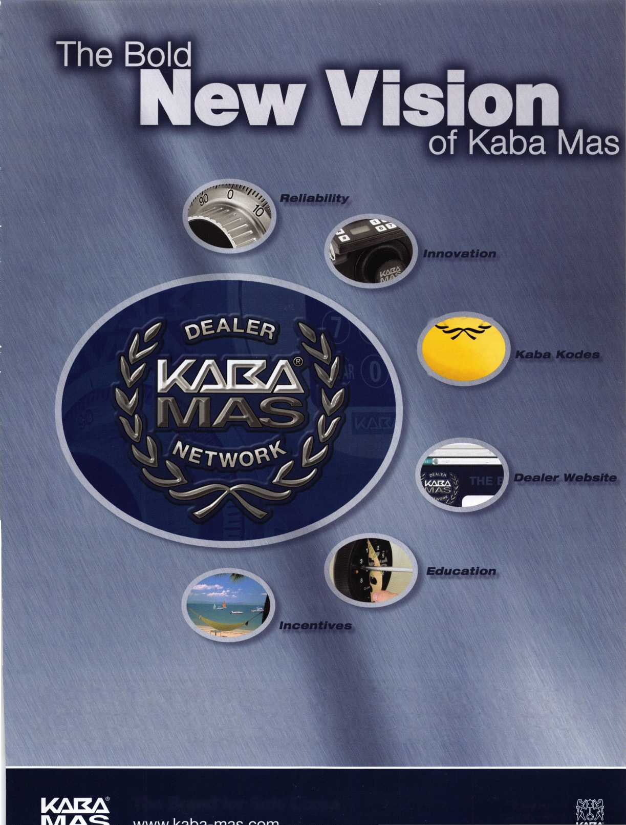

Ford Keyless Entry System (Explorer)

By Jeff Trepanier, RL

2. Driver's door with the keyless entry.

1. Front left view of the vehicle.

equipped, in the owner’s manual under “Controls and Features” you will find how to ry. (See illustrations.) I have selected a 2000 Explorer with the keyless entry system.

Keynotes • July/August 2003

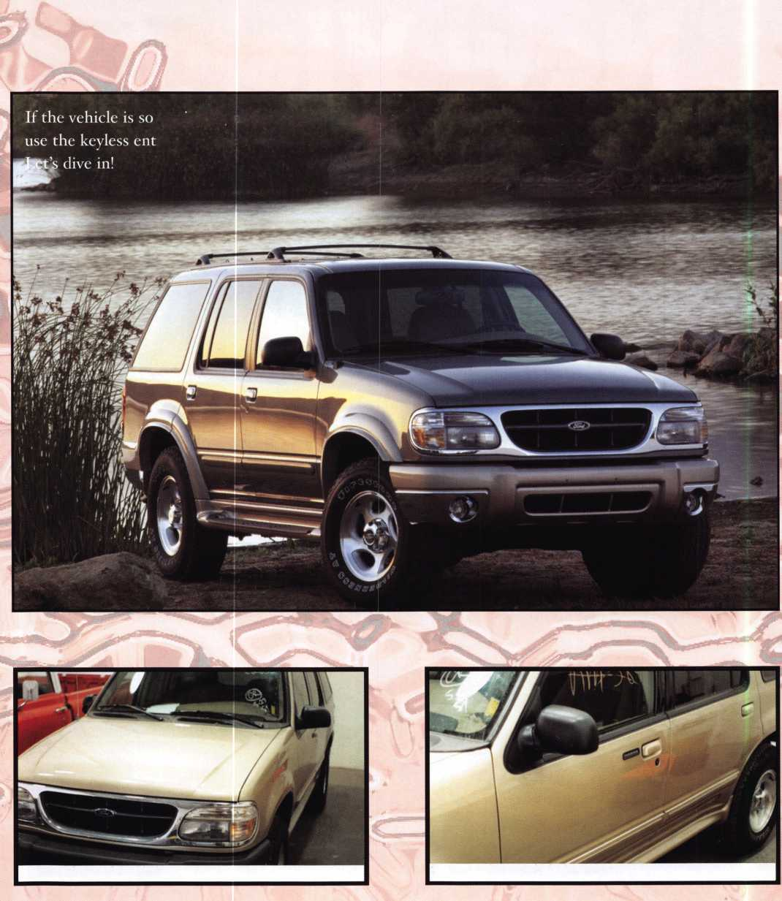

Shows

the

gged

The

will

the vehicle

NGS

NGS

power

using

and

check while

system

wait

power

you

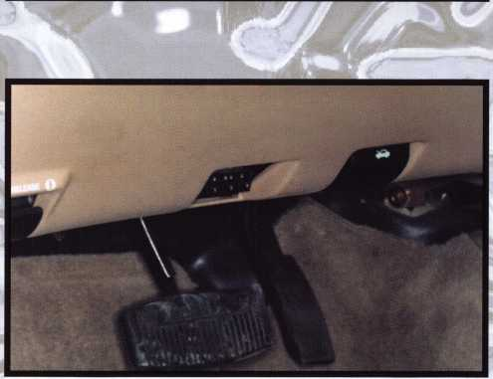

3. A close-up of the driver's door keyless entry, door handle and door lock.

4. The diagnostic connector location. Always make sure your battery is in good condition and is fully charged. If your battery is not fully charged, you may not get accurate readings or your procedure will not be allowed to continue. We will be using the red diagnostic card in the NGS. Put the key in the ignition cylinder and turn to the ON position.

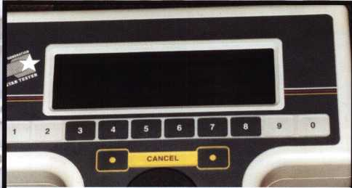

6. The upper half of the NGS.

Keynotes • July/August 2003

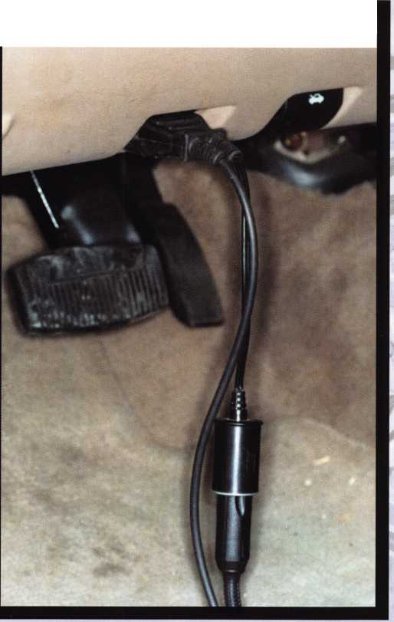

***Autolock***

Autolock is a featu?

all vehicle doors

* the ignition key
* you shift into <
* the brake ped;  
  The autolock fea
* any door is o
* the brake pe  
  Deactivating,  
  Before followi’  
  that the igniti  
  closed.

1. Enter the
2. Press anc  
   while holdii

3. Release

The horn  
was deact  
and one

activated

To reac

Autolo*

procec

You m  
will h  
must

1. T
2. **F**

! 3.r

**4. 1**

**5** e

loroaticaW closer

Cnnlmle -I *

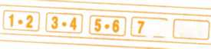

**^8J 9-0**

**Keyless entry system (if equipped)**

With the keyless entry keypad, you  
can:

* lock or unlock the vehicle doors  
  without using the key
* activate/deactivate the autolock feature

See also Remote entry system in this chapter for more information.

Your vehicle has a factory-set 5-digit code that operates the keyless

entry system. You can also program your own 5-digit personal entry

code.

The factory-set code is located:

* on the owner’s wallet card in the glove compartment
* taped to the computer module

When pressing the controls on the keyless entry keypad, press the  
middle of the controls to ensure a good activation.

***Programming your own personal entry code***

1. Enter the factory-set code (keypad will illuminate when pressed).
2. Press the 1/2 control within five

seconds of step 1.

1. Enter your personal 5 digit code.

Enter each digit within five seconds cf the previous one.



**5*6 7.8 9.0**

Do not set a code that includes five of the same number or presents

them in sequential order. Thieves can easily figure out these types of codes.

Your personal code does not replace the permanent code that the

dealership gave you. You can use either code to unlock your vehicle. If a

second personal code is entered, the module will erase the first personal code in favor of the new code.

In the owner’s manual under “Controls and Features you will find how to use the keyless entry



Keynotes • July/August 2003

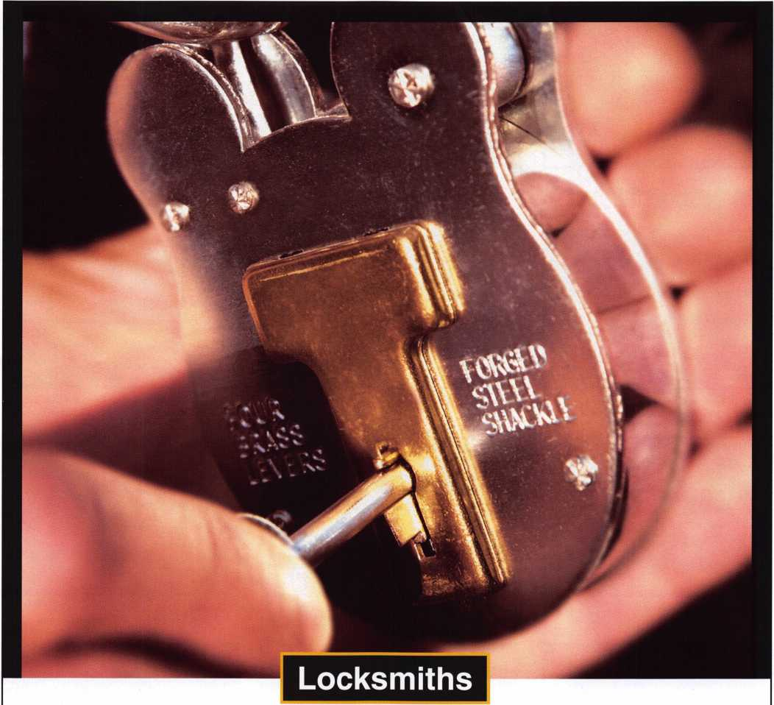

The Central Intelligence Agency is seeking Locksmiths to work with the best minds in the country while performing a mission critical to our nation.

To qualify for this position, candidates must have a bachelor’s degree in a technical discipline and/or the equivalent of 3 to 5 years’ work as a locksmith and/or in the area of physical security. Knowledge of electronic and manual safe lock servicing, electricity, and alarms is ideal. Knowing how to operate machinery to fabricate lock parts and tools will be beneficial. Candidates must be willing to relocate to the Washington, DC metro area and travel both domestically and overseas. The ability to show initiative and good judgment, excellent writing and interpersonal skills, be able to function on

a team and demonstrate leadership will be required. Qualified candidates must be able to work without close supervision.

Because of our national security role, applicants must be able to successfully complete medical examinations and security procedures, including a polygraph interview.

The CIA is America’s premier intelligence agency, and we are committed to building and maintaining a work force as diverse as the nation we serve.

To be considered, please apply online by visiting our website at [www.cia.gov](http://www.cia.gov)

An equal opportunity employer and a drug-free work force.

THE WORK OF A NATION. THE CENTER OF INTELLIGENCE.

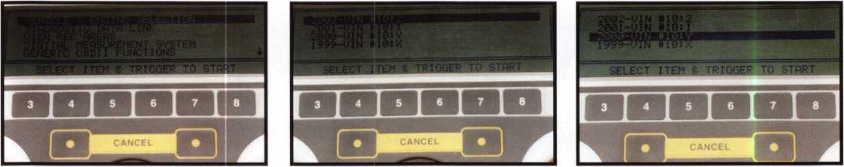

7. After the system check, you will see a choose list on the screen. We will use the VEHICLE & ENGINE selection. Press the trigger button.

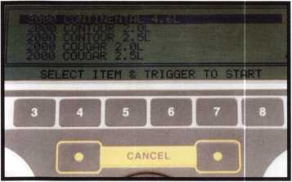

10. The next screen that will appear. Scroll down to  
select your vehicle model and engine size.

8. This is the next screen that will appear. Scroll to the year of the vehicle that you are servicing.

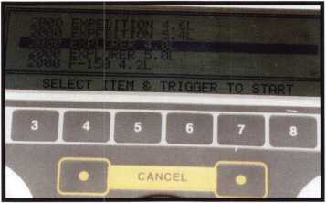

11. The selection I made; now press the trigger button.

9. The year of the vehicle is selected. Press the trigger button. Note the last number or letter to appear in each line is the year in the VIN, which would be the tenth digit.

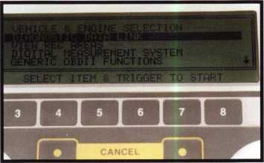

12. The next screen; scroll down to the DIAGNOSTIC DATA link and press the trigger button.

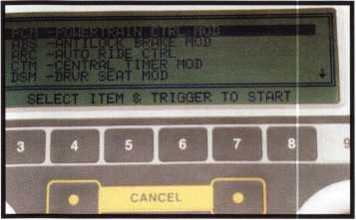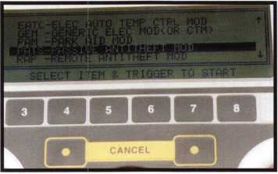

14. The PATS selection; press trigger.

15. The next screen; scroll down to PID/DATA MONI­TOR & RECORDS; press trigger

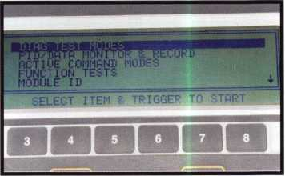

13. The next screen; scroll down to PATS

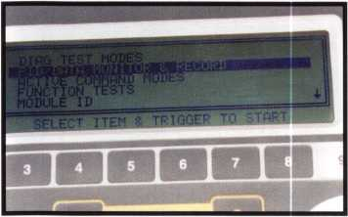

16. The next selection PID/DATA; press trigger.

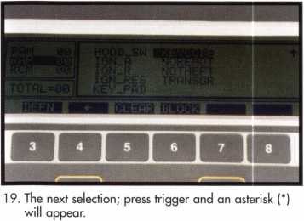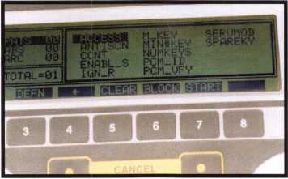

17. The next screen. Note: The inner box line around the choices is a heavier line; this is your area of selection. You must first change to your left catego­ry by pressing the number 4 Dutton. Now scroll down to RAP and press the number 4 button to change to the correct category.

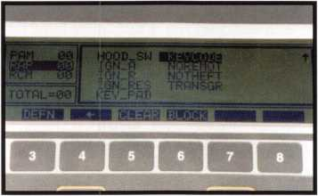

20. Here is how the screen has changed; you now have more options. Press the number 7 button to start.

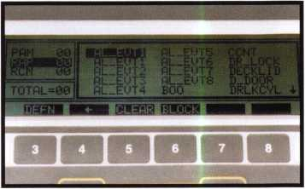

18. The next screen; now scroll down to KEYCODE, which will appear once you scroll past the last choice on this screen.

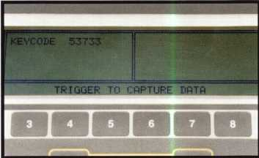

21. Here is your factory set keyless entry code. After the link is initialized.

Keynotes • July/August 2003

**THE HINGE DOCTOR**

**by GKL Products**

**[www.hingedoctor](http://www.hingedoctor). com**

**The Hinge Doctor**

The Hinge Doctor set of tools is a great

way to repair those sagging metal

doors! All you do to fix it is to slip the tool over the door hinge and open

the door. This action causes the door hinge to bind while the  
tool is in place. Open the door only an inch or two past the  
point of where it binds against the tool, then remove the tool  
from the hinge and check the door. That's usually all it takes!

HA3  
for ball-  
bearing &  
large hinges

"I used mine twice in the last week. It really impressed my  
customers that a "little girl" like myself could repair a big oP steel  
door by myself! I never let them see my secret weapon, I let them  
assume that I had to take the door down and do all sorts of work to  
it!" -- Melanie Long, Lock Stock & Barrel

**Guaranteed for Life!**

**"The Hinge Doctor is a great way to repair those sagging metal doors. Slip the tool over the hinge and open the door an inch or two past the point where the tool binds against the hinge, remove the tool and check the door, which should now be working properly," Joe Maruscak - Spring City, PA - USA**

If you're a locksmith these tools will turn a profit the 1st time you use them!

**Uses - schools, hospitals, commercial buildings, storefronts with butt hinges, office doors, new construction, door alignment, sagging doors, jail cells, anywhere there are commercial grade hinges.**

**HA1 For  
Standard**

**Commercial**

**4-1/2" x 4-1/2"**

**Butt Hinges**

**For Ball-**

**Bearing &**

**Larger**

**Commercial Hinges**

**For Prison**

**& Institutional**

**Hinges & Standard**

**Spring Hinges**

**To Locate a Distributor Near You Call...**

**800-924-5397**

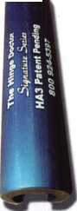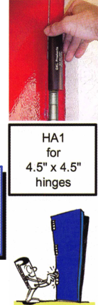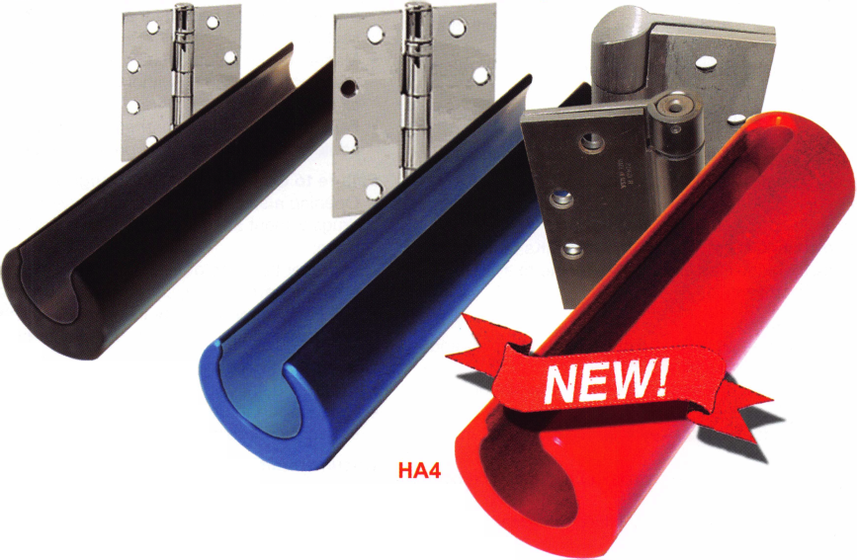

Issues of Liability for Locksmiths and Security Experts: Part II

By Marc Tobias

In Part I of this article, the author examined general liability questions that can confront the locksmith or security profes­sional. In this second and final installment, Marc examines spe­cific problems relating to master key systems, and related legal issues.

Improper Installation, Maintenance, Repair, or System Design:

* Improper installation of hardware that is the proximate cause of a loss;
* Failure to properly maintain, program, or set codes, combina­tions, or time locks that result in a lockout condition;
* Failure to reset factory established or default passwords on combination locks, alarm systems or other systems, and that such failure results in a security breach;
* Failure to make proper repairs to safes and vaults after forced entry or drilling. Such failure may make the container more vulnerable to subsequent attack, reduce or eliminate insurance coverage, nullify UL classifications or ratings, cause subsequent malfunction or lockout, and may also sub­ject you to liability for destruction of the container;
* Defective repairs that reduce tolerances or reduce resistance to covert entry. This may include filing of pin tumblers or plugs, or adding unnecessary master pins;
* Improperly change or modify UL or other rating labels;
* Failure to adhere to manufacturers recommended installation procedures;
* Use of old or worn pins or springs;
* Failure to utilize pins and springs in all chambers within a lock;
* Setting the combination in the forbidden zone which results in a mechanical malfunction;
* Violation of MACS rules that result in mechanical malfunc­tion;
* Erase the audit trail within electronic memory, either inten­tionally or by mistake and which causes a loss;
* Failure to utilize balanced drivers, thereby allowing the lock to be covertly opened through "combing";
* Designing change keys, master keys, orTMKs that do not follow industry guidelines and that contribute to system bypass or circumvention;

Master Key Systems:

* Work performance that calls into question the training and competence of the locksmith;
* Improper system design that creates key interchange and that results in a loss;
* Use of non-standard master key systems that result in loss of security;
* Improper system design that results in unintended cross-key­ing and subsequent loss;
* Poor documentation that makes it difficult to expand, main­tain, or evaluate a system;
* Repeated use of the TMK or master key system in the same geographic area for different customers;
* Mistakes in defining the KBA that result in key interchange, unintended cross-keying, or other errors;
* Use of master pins that are not required and which reduce

the security of a lock, creation of additional incidental master keys or unintended cross-keys, or that results in ease of picking or other covert means of entry;

* Release of master keys to the wrong individual, contrary to established guidelines;
* Cutting or duplicating sectional keys on the wrong blank that allows access to keyways for which the user does not have authority;
* Pinning certain cylinders that should not be on the master key system;
* Failure to follow the .023" rule that results in mechanical mal­function and inability to access critical areas;
* Failure to advise property owners in major housing or apart­ment construction projects that locks have been master keyed for construction personnel, and that such keying will remain after the project is completed;
* Utilizing pre-written master key systems that are published and are available to the general public;
* Utilization of the identical master key programs for more than one customer;
* Use of the same bitting lists, keyways, and master key sys­tem architecture for multiple clients;
* Failure to warn and document such warning to customer regarding the risks associated with the use of master key systems;
* Failure to adequately warn customers of cross-keying issues and the reduced security that results from intentional cross­keying;
* Master keying different customer locations for the conven­ience of the locksmith without disclosing such fact to each client;
* Failure to conduct comprehensive site surveys and keying conferences with the client prior to performance of work;

Failure to Consider Inherent Dangers

* Opening a safe that contain explosive residue, tear gas, or drugs without adequate precautions and which results in harm;
* Improper handling of heavy container that falls and damages other property or results in injury to persons;
* Failure to report property found in locked containers, such as explosives, drugs, child pornography or other contraband;

Damage to Property

* Property damaged within a container that is opened by force;
* Relockers that are triggered due to lack of experience; caus­ing additional damage during the opening process;

Documentation of Work Performed

* Failure to properly document installation, upgrade, or mainte­nance;
* Failure to maintain adequate records of work performed in order to refute allegations of negligence;

Performance of Work to Recognized Industry Standard:

* Failure to properly or adequately assess the security require­ments of a customer location;
* Misrepresentation of the security of hardware components or



Keynotes • July/August 2003

of a system that is installed or implemented for a customer. There are two issues: making a representation regarding security that is not actually provided, and charging for some­thing that was not received;

Failure to utilize restricted blanks. There are two issues: if such security is required and not sold or recommended, or they have been represented or sold as restricted, when in fact they are readily available;

Improper pinning of interchangeable core locks that allow for a change key or TMK to act as control key;

Create key interchange between interchangeable core sys­tems that creates an unknown or unauthorized control key and which leads to a loss;

insurance, including liability, errors and omissions, defalcation, theft, malpractice, worker compensation, all-risk, interruption of business, and a sufficient umbrella policy to cover all possible contingencies and losses. Be certain that there is sufficient motor vehicle coverage to insure against any accident or dam­age that is caused by an employee while utilizing company transportation. You should discuss the issues outlined in these articles with your insurance agent to be certain that your cover­age is sufficient for your type of business and will protect you against all foreseeable contingencies. Remember, certain tortu­ous acts are generally excluded in most policies.

Failure to Exercise Due Diligence and Follow Standard Procedures:

* Effecting entry into locked location for a third party after failing to obtain sufficient identification to verify authority to enter, and which results in trespass, invasion of privacy, theft, other loss, or burglary;
* Owner claims disappearance of goods from container or other area that was opened by locksmith, but to which there was no witness to document the contents during the opening;

Violation of Fiduciary Duty

* Disclosure of confidential information to law enforcement or others without author­ization or court order;
* Non-disclosure of known security defects or potential for bypass in locks and hard­ware that is sold to, or utilized by a cus­tomer;
* Failure to be current with regard to litera­ture and security advisories regarding products that are sold and represented as secure;
* Failure to maintain control of customer locks, keys, or key blanks within invento­ry;
* Use of customer information or key data for unauthorized purposes;
* Theft from customer location by employ­ees of locksmith as a result of access to confidential information regarding the premises;
* Sale of restricted blanks to unauthorized individuals or entities;
* Unauthorized creation or milling of blanks to create restricted blanks that are utilized by customers of the locksmith or other locksmiths. There are two potential issues: violation of copyright or patent protection, and compromise of customer security. The author addresses these issues in another article.
* General breach of fiduciary duty owed to the customer;

This series has outlined actions that can subject you, your employees, and your business to liability, both of a civil and crimi­nal nature. Every locksmith, security profes­sional, and entity that employs or provides such services should maintain adequate

THE NEW ASSA KEY SWITCH

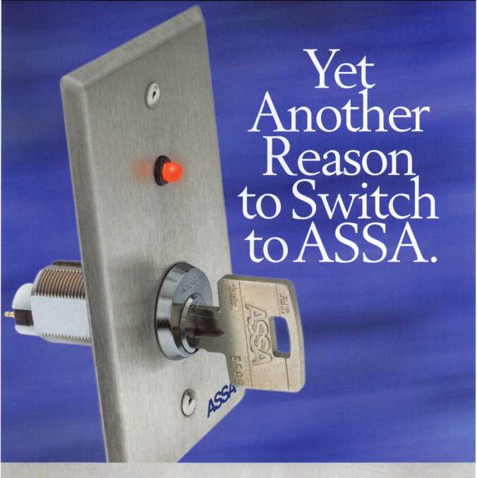

Now you can bring the highest level of security to any access control system with the ASSA Key Switch. Our key switch is field reversible from Momentary to Maintained, and it accepts any existing ASSA sidebar.

The standard stainless steel gang plate and optional narrow gang plate, designed for storefronts, feature a bi-LED system indicator lamp for easier use. And of course, the key switch is rekeyable and master keyable into any existing ASSA master key system. Isn't it time to switch to ASSA?

ASSA, Inc.

110 Sargent Drive New Haven, CT 06511 (800) 235-7482 Fax (800) 892-3256 [www.assalock.com](http://www.assalock.com)

ASSA Canada 3475 14th Avenue Markham, Ontario L3R OH4 Canada

ASSA*

We Secure The World

an ASSA ABLOY group company



Keynotes • July/August 2003

The Simplex 5000 is Actually SIMPLE!!

By Eric Costley, CRL

Here is the  
new  
Simplex  
5000, in all  
it's glory.  
Note the  
change tool  
hole,  
(barely  
visible,)  
just above the  
numeral i."

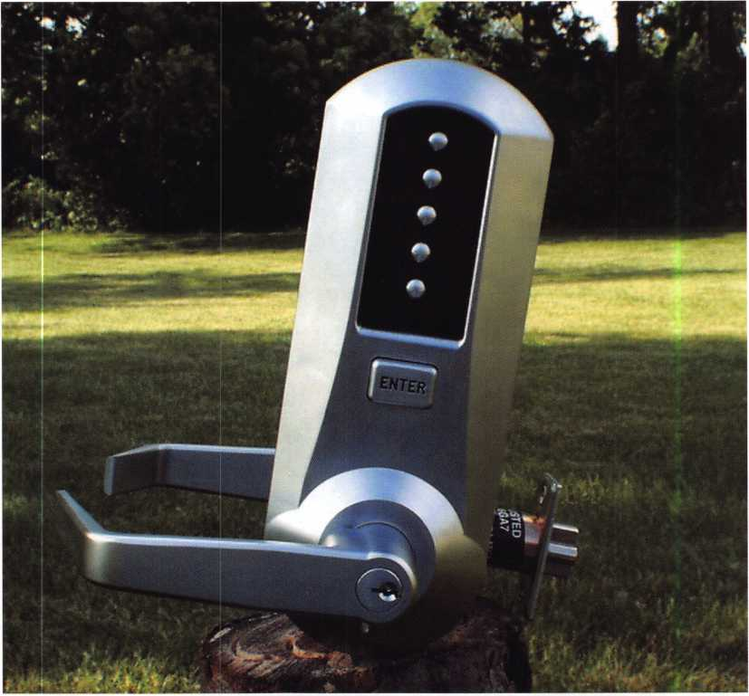

From the initial opening of the box, I was on edge: Here was something new from the folks who have given us reliable push-button locks for ages! I was intrigued and giddy, somewhat like a kid in a candy store. It immediately caught my eye that there was an "ENTER" button. (Hmm.. that’s new ... wonder what THAT means?) My curiosity was shortly satisfied with­out ever touching the instruction book. However, I found it very stiff to push, and the boss immediately mimicked a customer, saying "That's too hard, I don't like it. That's not the way the other one worked!" My attention was drawn to the instruction manual.



Keynotes • July/August 2003



LOKK-LATCH®

Pedestrian  
Gate Latch ^

(lockable)

Also discover our leading range of

GATE HARDWARE & SECUMTY PRODUCTS...

MAGNA.LATCH®

Magnetic Safety Gate Latch (lockable)

LOKK*LATCH® "PRO"

Pedestrian Gate Latch (6-pin lock)

TRU*CLOSE® Safety Gate Hinges

For all types and styles of gates. Most are adjustable, self-closing. Tough & durable. No rust, binding, sagging or staining!

**I**

dfid^ECIlSTni^g^S D&DTechnologies (USA) Inc., 7731 Woodwind Drive, Huntington Beach CA92647 Compan/

Tel: (800) 716-0888 Fax:(800) 464-6400 Web: [www.ddtechusa.com](http://www.ddtechusa.com) E-mail: [info@ddtechusa.com](mailto:info@ddtechusa.com) “S

**Safety, Privacy & Security**

—

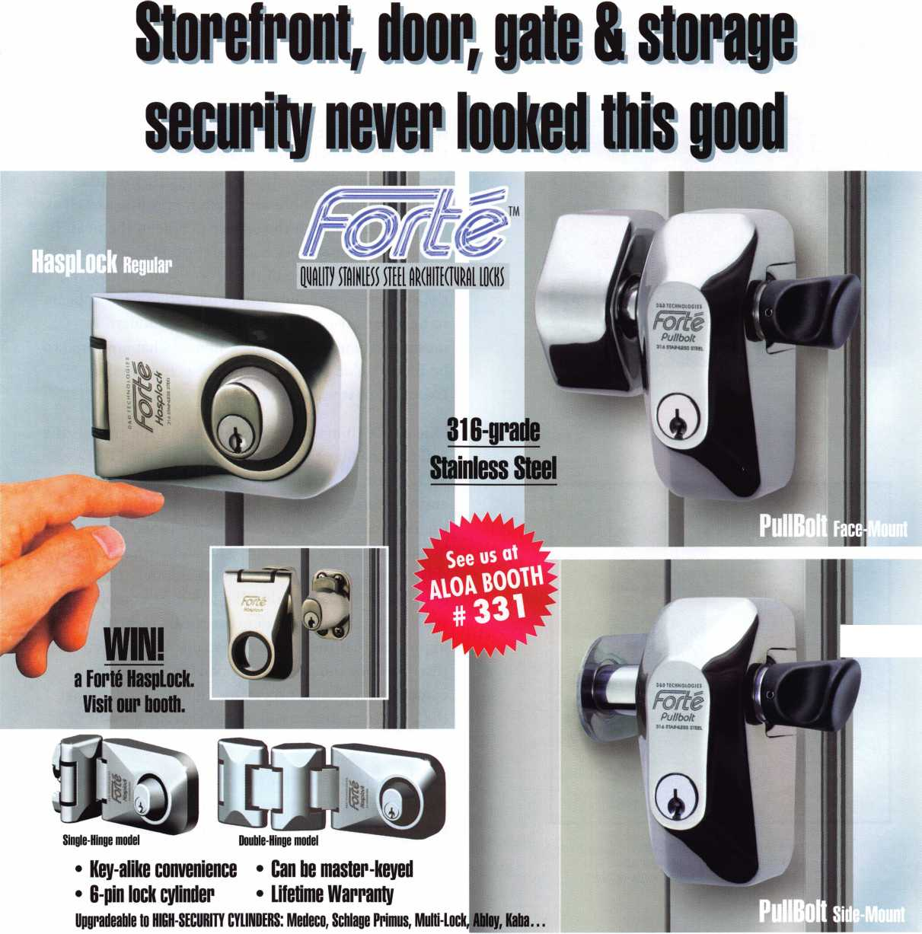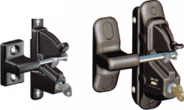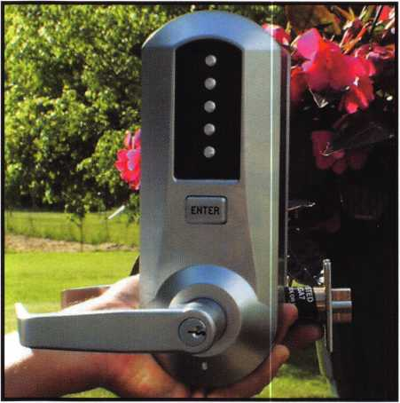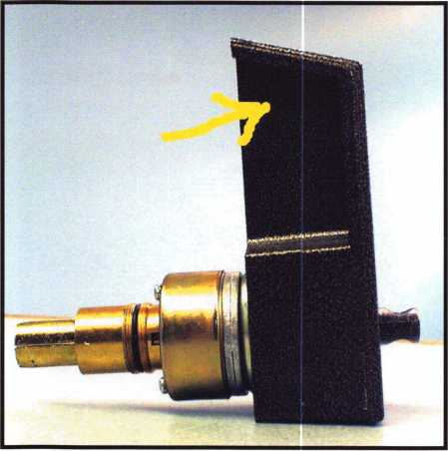

The 6200 series, with the pesky  
rubber plug generously pointed at:

I dared NOT attempt to remove it for the photo!"

Well, right out of the box, the new Simplex 5000 is impressive. The fact that the handing is field-reversible is a BIG plus: It not only means less stock on the shelf, it means less parts to order as well. From the manufac­turer's standpoint, it makes "cents," dollars even!

Unlike other Simplex lever locks that come handed, this one will require only one set of parts for either hand. Less tooling translates to more profits, as well as more convenience to the service people in the field. It also means that the price of the 5000 is less: about $35 less than the list price of the Liooo series. However, the cylindrical assembly comes packed in what appears to be white grease, and for this "new product," it meant cleaning out that thick film of what appeared to be Elmer's glue before the thing was functioning smoothly, or it was even installed.

One of the things that scares me about the 5000 is the ability to change the combination from the OUT­SIDE. I am already having nightmares concerning a customer attempting to change the combination with the door closed, failing to follow the procedure careful­ly, and facilitating a lockout. The one saving grace in this situation is the key override, assuming that the customer has a key, or that the lock isn't equipped with some high security cylinder that resists picking. I was impressed that the instruction manual clearly states that the door should remain open during the entire combination change procedure, but we all know that the average customer will ignore that little tidbit of information and proceed to screw things up royally.

In addition, the hole for the change tool is located on the face of the lock, where the wonders of our north­ern winter road salt can find their way into automobile trunk locks despite the shutter cover. Coastal area locksmiths are already cringing, too, I would wager. This external change hole is also used on the 6200 series residential lock, except that the 6200 has a neat little rubber plug that tends to pop inside the body of the lock when you're trying to pry it out with a point­ed probe. More than once, I've had to rip the whole assembly off the door, disassemble the lock, and find the pesky thing. Oh, and the 6200 does not come equipped with a key override, nor can it be left unlocked, which some of my customers have found annoying. But I digress -- back to the 5000.



Keynotes • July/August 2003

Why didn't the manufacturer use the same security torx screw that they use in the 1020 series to cover the change hole? In my opinion, this would have provided a nice sealed environment for that oversensitive combi­nation chamber, and the fact that the change hole on the 5000 is on the face of the lock under a ledge would inhibit the rust and corrosion, which occasionally plagues the 1020, where the change hole is on the top of the lock body and rust tends to form in the threads.

There are a few other things to note before we tear into the meat of this mechanical creature. I was relieved to find that the instruction manual for the 5000 is divided into 3 sections that are clearly ear­marked. English, French, and Spanish are no longer running simultaneously on each page! Although I passed both French and Spanish in college, my vocabu­lary is limited, and I frequently got frustrated with the layout of the Simplex manuals. At last, all the words I understand in a single place, and I could rip those first 19 pages out and dispose of the rest! The installation templates now come as separate sheets, so you no longer have to rip them out of the center of the manu­al. Also, the 5000 comes with a two-year warranty, whereas the other mechanical locks in the Simplex line carry only a one-year warranty. Evidently, the manufac­turer is very confident that this product is much more reliable! The manual is well written, and the instruc­tions for the recovery of a lost combination are more "user friendly," and I was also duly impressed that the initial paragraph in this section advises that "only tech­nically-trained personnel in the lock and hardware field should undertake this operation." (Thank you! Thank you!)

After removing the back cover of the 5000, I was astounded. I was sitting on the front porch, watching the lazy New York rain, and had to run inside and dis­turb everyone in the household by exclaiming "Wow, this is totally different from anything they've ever made!" (Deb looked up from her magazine long enough to roll her eyes. Well, I was impressed.) Unlike the 1000 and Fiooo series, where the push-buttons are simply drop in parts, the buttons on the 5000 are spring-loaded, and built into the external housing, with no means of removal. These buttons are not servicea­ble. The "enter" button is similarly attached, but has a

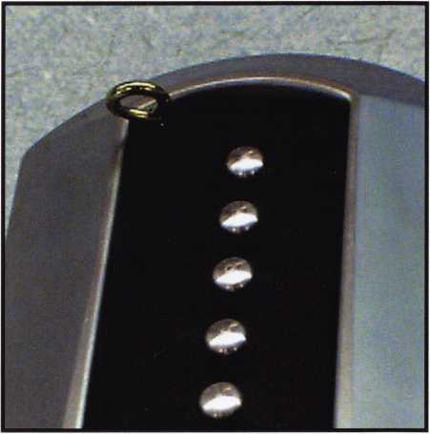

The 5000 with the combination change tool dangling from the wide open change hole."

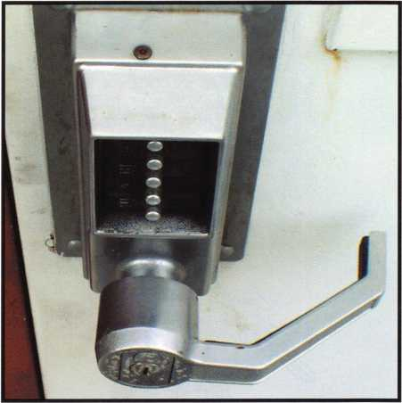

The security torx screw covering the change  
hole on the 1020 series, located on top. Note the  
rust already forming!"

Keynotes • July/August 2003

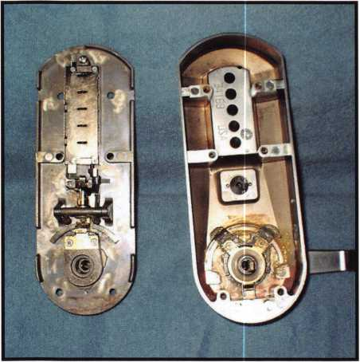

The exterior assembly of the 5000, with the  
back plate removed. On the right, immediately under  
the 5 push buttons is the "ENTER" button assembly.  
Below that is the inside driver. On the left portion,  
from top to bottom: the combination chamber, actuator  
assembly, actuator button, and extension sleeve."

small screw that facilitates removal from the interior of the lock body. There are two springs under the enter button: one to reset it after it is depressed, and anoth­er, heavier spring that acts in accordance with the chamber actuator, so that an improper combination renders the enter button inoperable. Remember those pesky clutch assemblies that are forever succumbing to abuse on the Liooo series? You know: the spider-like assembly that comes handed, and creates mysterious sporadic lockouts, eventually causing the combination chamber to fail as well? Gone. The 5000 is totally redesigned.

When I say "totally," I mean it! Even the combination chamber itself looks unfamiliar. Unlike previous cham­bers, which needed to be "carefully pried apart" to service, this one has two small Phillips screws that secure the cover. The combination chamber is attached to the back plate with two screws as well, but removing it is much easier, since the assembly doesn’t make direct contact with any of the other parts of the lock when it is idle. The enter button presses against two offset "toggles," one brass-colored, and the other silver. This portion of the lock is called the "actuator assembly." When an incorrect combination is entered, the brass-colored chamber actuator remains rigid, unable to activate the combination chamber. When the proper combination is entered, the chamber actua­tor pivots, activating the combination chamber and allowing the silver actuator driver to pivot as well. The actuator driver depresses the actuator button, which holds down a spring-loaded locking piece on the exten­sion sleeve, allowing it to turn freely. The portion of the lock that contains the outer lever has two symmet­rical stops on the driver that bypass the spring-loaded locking piece on the extension sleeve unless the proper combination has been entered, and the enter button has depressed the locking piece. Sound a bit complicat­ed? Ha! It’s a Simplex. And this one, I must say, is actu­ally simple!



Keynotes • July/August 2003

Now that we have an idea of how this thing functions, let's address that emergency lockout situation again. Let's set up a hypothetical situation. For the sake of our demonstration, let's assume that a maintenance man has carefully installed a 5000 on a door that rep­resents the sole means of entry to his tool crib. Failing to heed the warnings in the instruction manual, our customer attempts to change the combination with the door closed, and somehow inadvertently misses a step in the process, cleverly leaving himself red-faced and embarrassed, with no means of entering this area. First of all, the 5000 is a lever lock. If picking the bypass cylinder proves fruitless, there is always the under-the- door lever-opening tool, manufactured by Keedex.

This, of course, assumes that there is a slight gap at the bottom of the door. If all else fails, drill out the key bypass cylinder and replace it. If you have to resort to this, make sure to keep the tailpiece from the cylinder, and attach it to your new cylinder. Why?

One of the quirks of the 5000 is that it comes packed with five separate tailpieces, which correspond to a variety of manufacturer's original cylinders. However, the proper tailpiece must be selected and attached to any replacement cylinder prior to installation in the 5000. The bypass cylinder that comes factory- installed has a Schlage C keyway, and the instruction manual contains detailed instructions concerning which of the five tailpieces should be installed on replacement cylinders.

If you have problems or questions concerning installa­tion or service, there is a toll free technical assistance number listed on the first page of the instruction man­ual. Via this number, you can speak directly to the engineers who designed the lock, and I am indebted to both Charles Hayes and engineer James Warden for their help in giving proper names to the "toggles, do- hickeys, and whatcha-ma-callits" that adorned the rough draft of this article. Their patience and prompt response was refreshing and extremely helpful.

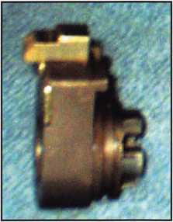

The extension sleeve, with  
the spring

loaded locking piece."

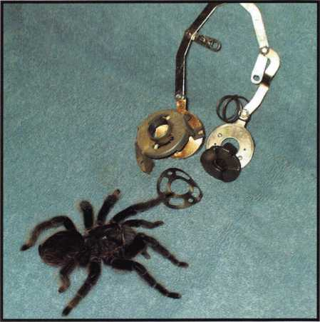

Mr. Kite inspects the remnants of the  
LI 000 clutch assembly

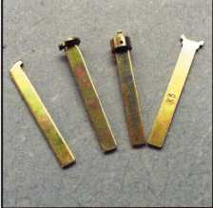

The four extra supplied tail-  
pieces for the  
5000 key override cylinder:  
the fifth is on the  
supplied SC-1 cylinder."

Keynotes • July/August 2003

A Brief History of S&G's 6120

By Brian Costley, CML, CMST

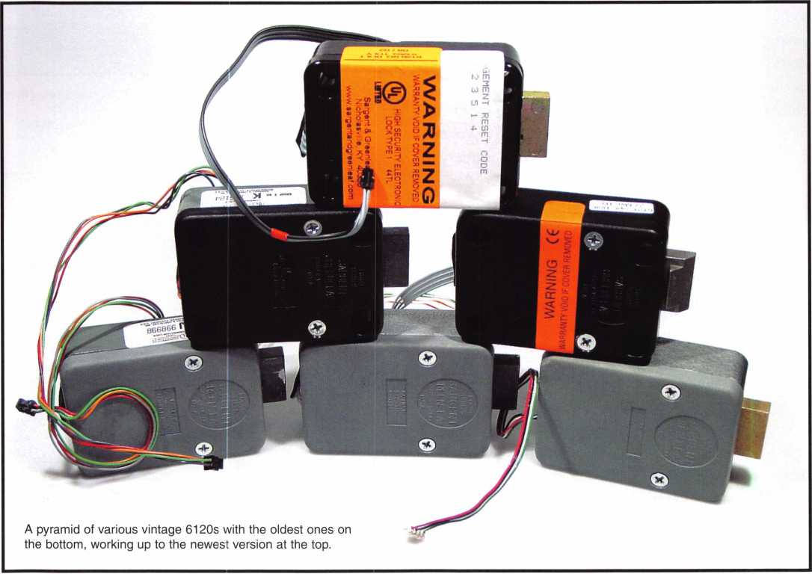

The Sargent & Greenleaf Model 6120 was born in mid-1994 and, like a child fast approaching his ninth birth­day, it has gone through many changes. It hasn't grown any larger, but it has definitely become more mature, and no longer embarrasses its parents in restaurants.

The first S&G electronic safe lock predates the 6120 by several months, and was never released for sale. It was known inside the company as the 6100 ECL (short for "Electronic Combination Lock"). Laboratory and field testing showed it to be very dependable, but there were drawbacks. The cable running from the lock to the keypad terminated in a rather chunky plastic plug. The size of the connector at the cable's end made it some­what difficult to snake through a typical spindle hole. Also, the power requirements made it necessary to house eight double-A batteries in the keypad. That translated into a rather large and ugly keypad. Still, end users who participated in the field tests loved the convenience of push-button unlocking and do-it-yourself code changes. Managers soon discovered that an electronic safe lock with automatic locking greatly deters "day-locking," or the practice of leaving the combination dialed into a mechanical lock, even though the door is closed and the handle turned to the locked position. Not only is it difficult to day-lock an automatic locking mechanism, but employees really don't mind punching a six-digit code to open the safe. It's a heck of a lot easier than doing



Keynotes • July/August 2003

that left-so-many-turns, right-so-many-turns, left-so- many-turns thing.

The 6120 addressed many of the nagging issues asso­ciated with the ECL. It would run an impressive 5,000 cycles on a pair of 9-volt Duracell(r) alkaline batteries, which were neatly tucked behind a much more aesthically-pleasing keypad. The ECEs cable plug shrank to a much smaller size that could easily slip through a 5/16-inch spindle hole. I've even man­aged to get one through a 1/4-inch opening with a lit­tle nudging and mild cursing.

The 6120 function set was created with home safes, gun safes, and even small, lightweight commercial safes in mind. The lock had to be easy to program and easy to operate -- and it is. The features and program­ming have remained consistent throughout the 6120’s history, and include:

[1] master code for programming and opening the lock

{8] user codes for opening the lock a time delay pro­grammable from one to nine minutes {1} management reset code

At the time the 6120 was introduced, it was decided that the existence of a management reset code would be kept between S&G and its safe manufacturing cus­tomers. The MRC is typically held by the safe maker and used only in the event that a lock’s master code is lost. When entered, this special code deletes all user codes, zeroes out the time delay (if one is being used), and sets the master code back to the factory original 1-2-3-4-5-6-#. It’s a handy feature, and the secret of its existence lasted about... two minutes. To this day, there is no mention of the MRC in 6120 operating instructions, but you can go to S&G’s website ([www.sglocks.com](http://www.sglocks.com)) and download the technical bul­letin that describes the management reset code and its use in detail.

Did you know the first production run of the 6120 was deadlatching? This feature didn't last to the sec­ond run because it could be overcome with moderate finger pressure, and forcing the bolt into the lock case jammed up the drive mechanism virtually one hun­dred percent of the time. Most of the first run locks were destined for table top mounts and demo safes, so the "oops" was not a catastrophe, and was addressed quickly for subsequent iterations of the

lock. Deadlatching wouldn’t return to the product for another eight years.

From the very beginning of S&G’s foray into electron­ic lock development, it was decided that "fly-by-wire" was the way to go. The only connection between the keypad and lock is a wire cable. Officially, this means the lock can be mounted up to one meter away from the keypad. In reality, only a couple of safe manufac­turers have ever used this feature to remotely locate the lock body. While this would be a remarkable secu­rity feature, it would also mean a safe door design dedicated to the "fly-by-wire" concept. In most kinds of manufacturing, standardization is very important. Safe makers benefit from using a door that will accommodate either a mechanical or electronic lock, without alteration. One door design means one setup, one assembly line, one bill of materials, and probably a lower incidence of production problems. Keeping it simple keeps it efficient, and it keeps the finished product competitive. One very big efficiency benefit of the 6120's "fly-by-wire" design is speed of installa­tion. There is no spindle to cut, align, and coordinate with wiring.

When the 6120 was introduced in 1994, Underwriters Laboratories was listing electronic safe locks under the Mechanical Lock Standard (UL 768). It was tested and awarded a Group 2 Listing. Since that time, UL has developed Subject 2058, a pre-Standard set of specifications it uses to test electronic safe locks. It categorizes the devices as either Type 2 or Type 1, with the latter Listing indicating a higher level of security. The 6120 was initially changed from Group 2 to Type 2 under the new, evolving specifications, and is currently Listed Type 1. Underwriters Laboratories says it hopes to have Subject 2058 ready as a full- fledged Standard by the end of the year. To keep these good intentions in perspective, let me refer to a letter from UL dated July 10,1997, in which it is stat­ed, "Currently Subject 2058 is going through an edito­rial cleanup, estimated not to impact its basic require­ments, and will be subject to a major Standard revi­sion for final printing estimated by the end of 1998."

On the software side, there has only been one major change in the 6120 since its first appearance. The change involves the penalty timer. In case you're not familiar with the concept, a penalty timer allows a predetermined number of incorrect, consecutive code

Keynotes • July/August 2003

**55**

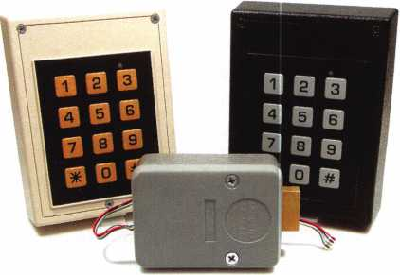

The ECL 6100 never made it to market, but was a valuable  
learning experience for S&G. Two different keypad styles  
are shown. Each one held eight AA size batteries. The lock  
bolt was operated by a heavy duty solenoid.

|  |  |  |
| --- | --- | --- |
| • |  | m |
|  |  | m |
| lit 1 | u | • |

The mounting side of the ECL 6100. Note that the under-  
side of the bolt is hollowed out. This was done to reduce  
weight so the solenoid wouldn't have to work as hard as  
necessary had the bolt been solid.

entry attempts, then refuses to accept any more code input for a certain length of time. It's pretty simple, and absolutely necessary for a security device that can be connected to a computer programmed to rapidly enter sequential codes until one that works is found.

For the first four years of production, the penalty timer was set up to shut down the lock for 15 minutes if four or more incorrect codes were entered in a row However, the penalty timer could be canceled by enter­ing the lock's master code. Then any valid code (master or user) could be input to open the lock.

In 1998, S&G applied to Underwriters Laboratories for a Type 1 Listing (under Subject 2058) on the 6120. One of the product changes UL requested was removal of the ability to override the penalty timer by using the master code, or any code for that matter. S&G com­plied and dropped the penalty period from 15 to five minutes.

One feature of the penalty timer that has remained consistent throughout the 6120's history is noteworthy. Any time the penalty timer is engaged, pressing any button on the lock's keypad immediately resets the timer to its maximum value. For instance, if you enter four or more incorrect codes consecutively into a cur­rent production 6120, the five-minute penalty timer starts. If you wait four minutes and 59 seconds and press any button, the penalty time shoots right back up to the full five minutes. When the lock is in penalty mode, it is imperative to leave it powered up without pressing any keypad buttons for at least five minutes. If the vintage of 6120 is not known, leave it untouched for at least 15 minutes. And don't try to fool the penal­ty timer by temporarily removing the batteries. When power is removed, the timer stops wherever it is, then picks up its count at the same place when power is restored. I can't tell you how many 6120s have been returned to S&G in penalty mode over the years. Each and every one was sent to us by someone who was gen­uinely convinced there was something wrong with his or her lock. All that was necessary to return it to oper­ating condition was to apply nine volts of power and refrain from pressing any keypad buttons for at least 15 minutes. Discovering you initiated a warranty claim for a lock that was simply in penalty mode falls under the category of "imagine my embarrassment."

Although the 6120 has been the subject of dozens of changes, large and small, throughout its history, the

**56**

Keynotes • July/August 2003

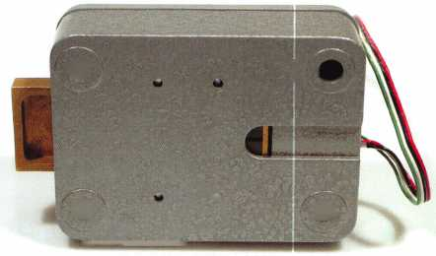

most apparent and significant ones came in 1998 and 2002. The upgrade from Type 2 to Type 1 status in 1998 was achieved by altering the relock trigger (to make it harder to probe after a punch attack), and by inserting a hardened, free-spinning steel disc between the lock case and motor housing to deter spindle hole drilling. As we’ve already discussed, this was also the point at which the lockout penalty time was decreased to five minutes, and rendered impossible to override. A significant benefit to the refinement of the 6120 design was increased battery life. S&G lab testing showed the lock would typically run 8,000 cycles on a pair of Duracell alkaline batteries.

Perhaps the most significant changes to the lock took place just about one year ago, in mid 2002. After a year of analyzing sales and warranty data, it’s accurate to say that last year's changes have significantly improved the performance and durability of the 6120. Let's take a look at them.

Change i-Since its inception, the 6120 sported a plastic cover. You'll now find it's made of Zamak, just like the rest of the lock case. Changing to a metal cover has two advantages. First, it makes the process of electri­cally grounding the board to the lock case (and there­fore to the safe) much easier. It also eliminates the pos­sibility of cracking the cover if attaching screws (espe­cially those used with relock device plates) are tight­ened too much.

Change 2-Two extra wire channels have been added to the mounting surface of the lock case. Optional devices (such as an electronic time lock or remote- enable module) can be added to the 6120. The extra channels provide a safe place to route the necessary cables. Prior to the big 2002 changes, the channel where the lock cable is placed had already been widened, and its corners rounded off, to lessen the pos­sibility of an imperfectly routed cable being crushed between the lock body and the safe door's mounting plate.

Change 3-In conjunction with a redesign of the drive nut, the bolt received a very sturdy deadlatching device. It will withstand over 225 pounds of force, as documented in VdS (think of it as the German version of UL) testing. I've been sworn to secrecy on the actual maximum bolt end load, but rest assured, it's a LOT more than the required minimum. The way the dead-

A first production run 6120 (circa 1994), complete with ane-  
mic deadlatching bolt. Note the individual wires with col-  
ored stripes. That's a good way to identify this rare version.  
Zamak case and plastic cover are gray.

The next version of the 6120 had wires with solid colors.  
The cover had to be removed to access the mounting  
screw locations. Hard to see here, but the UL label says  
Group 2. This one was probably made in late 1994 or early  
1995.

Still a Group 2 label, but the cover has changed to a bolt-  
through design. The circuit board was too vulnerable to  
stray screwdrivers and debris when the cover was removed  
from previous versions to insert mounting screws. This  
cover style made its debut in mid 1996.

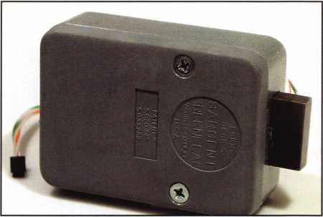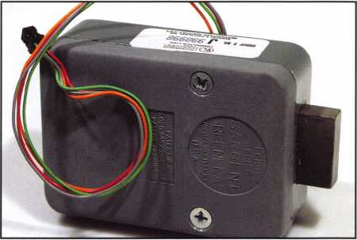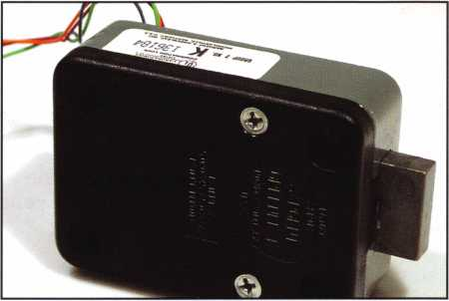

Keynotes • July/August 2003

**5**

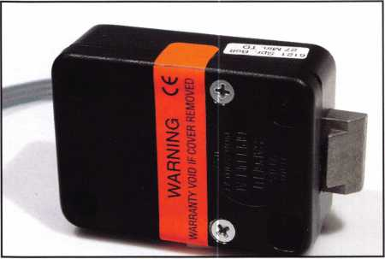

This is a 1998 vintage model with a radius bolt. The 6120  
family has always been offered with a choice of traditional  
square bolt for boltwork blocking applications or radius bolt  
for lightweight doors that require the lock to act as both  
latch and lock.

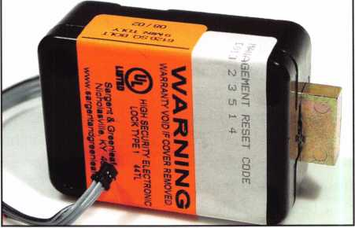

The current 6120 is easily identified from outside the safe by the red band near the keypad connector. The bolt is yel­lowish in color due to a chromate coating. Case and cover are metal, and the bolt deadlatching. This one has a man­agement reset code sticker attached.

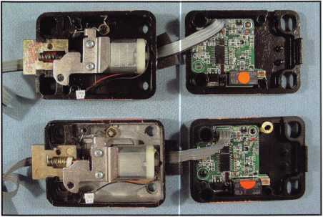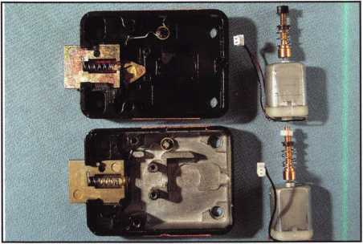

You don't want to try this at home, because it requires the breaking of the cover seals, voiding the warranties. The newer 6120 is at top, with the previous version below.

With lots of inside stuff (that's a technical term) removed,  
you can see part of the deadlatching mechanism just  
under the inside edge of the lock bolt in the upper 6120.  
It easily withstands over 225 pounds of end pressure  
without collapsing.

latch functions, it could also be considered an active relock trigger. The addition of this mechanism raises the level of difficulty when it comes to drilling the 6120. No longer is it feasible to pop a hole anywhere in the safe that will allow you to get a probe on the end of the bolt. That won’t do you much good any­more.

From outside a safe, how do you know whether or not the 6120 is the newer deadlatching style? Just look at the end of the lock cable just ahead of the keypad connector. If the lock is deadlatching, you'll see a band of red tape or paint here. It’s unmistakable.

Installation and operating instructions for the 6120 and several other S&G products are available as

Adobe Acrobat documents at Sargent & Greenleaf’s website ([www.sglocks.com](http://www.sglocks.com)). And the ALOA Video Lending Library has a video you might find enlighten­ing. It’s titled ”6120 Comptronic Lock Installation.” It was produced earlier this year, and gives you the next best thing to a hands-on installation experience. The technician who performs the taped installation is real­ly good, and probably could have had a major career in Hollywood if not for his fascination with locks and safes.

Even though this may be more than you ever wanted to know about the 6120, it just hits the highlights. There’s a lot more history than what’s related here, and there’s bound to be a lot more to add in the future.

**58**

Keynotes • July/August 2003

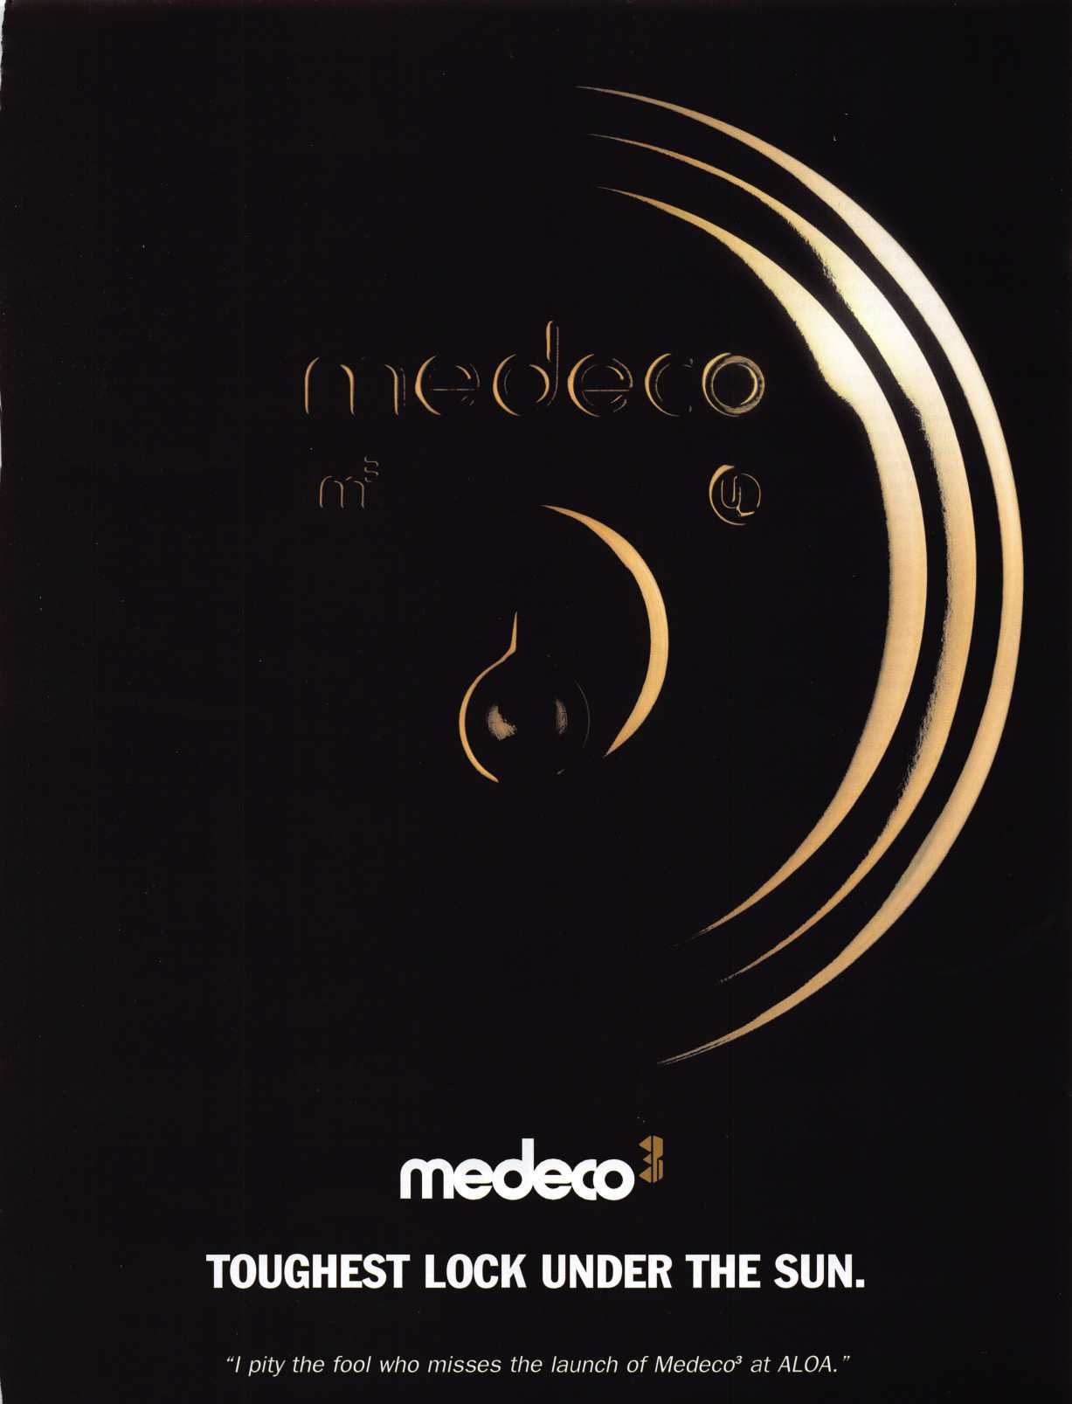

ALOA Scholarship Recipients 2003

Jeffrey Ahrens I am writing to you because



I am applying for the ALOA scholarship for the 2003 convention. Last year was my first of hopefully many conventions, and I really have enjoyed the experience. I am a member of the Fox Valley Chapter of ALOA, and under the guidance of my father-in-law, William Smith, RL, I am learning a lot.

I hope to learn everything that you and your instruc­tors are able to give, in order to gain knowledge for myself and in the field. Thank you for letting me apply for this scholarship, and for your time. I hope that you are generous enough to recommend me for it.



Joel Anderson I am a resident of Spokane, WA. I have been in the security business over 40 years with the U.S. Army and Army National Guard, with top-secret security clearances where needed. My wife, Jane, has been an ALOA member for 16 years. After the passing of her late husband several years ago, she relocated to Spokane. We married a couple of years ago, and then established West Plains Lock & Key. While on service calls, I do the administration, and then assist Jane while she does the lockouts and locksmithing. Our business is very small, and I have learned a lot from Jane. I desper­ately need the formal hands-on training this scholar­ship would afford. We have already made reserva­tions for the July convention. And Jane plans on several classes herself. The expense of the lost busi­ness, convention, dues, accommodations and Jane's classes make it impossible for me to attend these much-needed classes without scholarship assistance.

Aaron Beeler I used to think the only profes­



sion that truly helped people was the medical pro­fession. After working as a locksmith for the past three years, I have proven myself wrong. From the young couple who has no key to their ignition to the elderly widow striving a piece of mind, locksmiths help people greatly. It is truly an honor to be a part of this profession. I have acquired a challenging career involving new aspects and knowledge every day. I know I have much more to learn, and I look forward to advances in the technology of our indus­try. I feel that by taking the classes the ALOA Scholarship Foundation provides, I would broaden my knowledge and professionalism, and make a valued resource for our customers and fellow co­workers.

William Campbell, CML I strive to do



my job to the best of my abilities, better every day. I take classes every chance I get; I talk with, and learn from other locksmiths distributors, anyone who deals with things I work on, or thing my cus­tomers will ask me for. I got the continuing educa­tion bug from my main mentor, David Lowell, CML, CMST. I quickly worked my way up to a CML desig­nation. I also teach what I know to the local associ­ation here in central Arizona (PAL - Professional Associated Locksmiths of Arizona), which I have been deeply involved in for 20 years, and have served all capacities, including president. I read three different locksmith magazines cover-to-cover each month; I guess I've got what they call the "lure of the lock." I need even more education: I work for Anderson's Key Shop, and the shop is expanding into new fields with new customers. What I need more of is electronic locks, including proximity, Mag locks, and their advanced circuits with clocks, timers, battery backup, etc. Also, alarms and wiring, and detention locks and new automotive transponders are where I need new information to round out my skills as a security professional. Money is tight for me now, so any help that your committee could offer would be greatly appreciated. The convention is close to me, and this would be the place to get the "good stuff" that I have been need­ing; my last convention was about 18 years ago, and I'm ready. Thank you for your consideration in this matter - hope to see you all at the Las Vegas convention.

Chris Cyree In January, 1998, I took a leap of



faith and purchased my current locksmith business and struggled to make it thrive. Things were going well, by reinvesting the profits, buying better, more accurate equipment, etc.; Tullahoma Lock & Key has gained notice as a professional quality service com­pany. The one thing lacking has been the quality education. Yes, I have been lucky enough to survive the last few years (with the help of local associa­tions); however, the knowledge of a real profession­al is the goal. Everyone knows ALOA is the place to gain this knowledge. Cost is prohibitive. As every­one knows, the economy is in a slump, and my area is no different. With the assistance of an ALOA scholarship, the chance to move forward with the goal of helping others and myself through the sharing of knowledge will come one step closer to reality.



Curt Burton I am applying for this ALOA scholarship for the following reasons:

* To make my family more financially stable;
* To broaden my knowledge in the field of lock- smithing;
* To get involved with ALOA again and meet other professionals in the field.

In 1996, I had the opportunity to go to the ALOA Convention in Reno, NV. I had arrived a few days early, and decided to go and see if I could volunteer to help with the show. Not only did I get to help with the ALOA classes, but I also got to meet many people and really found out the true meaning of ALOA. I got to meet the president of ALOA (at that time, David Lowell, CML, CMST), and we talked about the industry. I was impressed with the classes I took at the convention, and with the conversation I had with Mr. Lowell. Later, I received a letter from the committee, thanking me for helping at the con­vention, and they sent me a piece of luggage. I have been wanting to do this for a long time, but because of bad times, I have not been able to do so.

Jeff DaVIS After attending the 2002 ALOA



Convention in Chicago, I was sure this was the field for me. At the same time, I leaned how diverse a field it can be, and how much I could benefit from a scholarship. For the last several years, I have worked at the University of Wisconsin, and have some basic locksmith work in emergency situations (at night, until the resident locksmith came in during the day to double check my work). I find this work challenging, and I enjoy it very much. Thank you.

**Recipient Not Pictured:**

**Brenda Freiberger • Sparks, NV**

Josh Dyer I was first introduced to the world of locks in the mid 1990s. My father, an aspiring locksmith, invited me to attend a trade show organ­ized by Clark Security Products. Growing up, I was always interested in how things worked, and why. I didn't really put too much thought into locks; how complex or challenging could they really be? My father began involving me on a few large mas­terkeying jobs; this sparked my interest in the lock­smith industry. I went to college directly out of high school; I attended a university in southeast Kansas,

12 hours from home.

During my second year in school, I applied for a job at a local lock shop. I was hired to assist the owner with various lock-related tasks. I worked for them for about a year, learning the basics of lock- smithing. I wanted more. I wanted to be a locksmith full time. I rented a shop and began to acquire knowledge and equipment. I started out slowly. I told my father about my plans to become a lock­smith, and was supported 100 percent. A few weeks later, my parents showed up with all the parts and equipment I needed to get started. I knew I could do this. Business was slow at first, but in a small town, news travels fast. I began to do work for several large chain stores. But there was more out there to learn. I subscribed to a couple of trade magazines and found these resources good, but not I wanted to attend a large trade show and partici­pate in as many classes as possible. I saw my father doing well in all he was doing, and I wanted to follow.



In 2000, my father bought my business and hired to work for him full time. Shortly after working for my father, he left the business in my hands while he attended the ALOA convention in Las Vegas. I kept the business running smoothly and picked up some new long term customers, as well. Today, I am involved in all forms of locksmithing, including com­mercial and residential lock service, automotive locksmithing, electronic access control, and CCTV. I am now very interested in safe service, opening and repair. I have a lot to learn. I have been an ALOA member since 2001, and I'm impressed with all that ALOA has offered in the past, and plant to utilize all that it can offer in the future.



Alma Engelsman I am applying for an

ALOA scholarship so I can take classes that will enable me to achieve my goal of becoming a CML someday. Since the age of 9, I have had an interest in locks and how they work. Upon moving to the United States, I went to work in the janitorial field. During this time, while doing janitorial work for Grah Safe and Lock in San Diego, I was allowed to observe them and eventually, they made me a deal I couldn't refuse. They offered to switch me from janitor to apprentice locksmith, but my English had to improve. I immediately started taking classes and improved enough to obtain the apprenticeship. I have moved to Orange County, and have been working with Hill's Bros. Lock and Safe for the past five years. After two years, I became a CRL. I feel I need to take more classes to help me understand parts of the CPL exam. I have hands-on knowledge, but my vocabulary is not good. I need these classes so I can reach my goal of becoming a CML.



Luke Geithman I have been working here



at J&K Lock and Security in Madison, Wl, for about 18 months. I am writing to you in hopes of receiving a scholarship that would enable me to attend the 2003 ALOA convention. I got into locksmithing hop­ing to find a career that would support my family (I have a one-year-old daughter.) I have found that and much more. I attended the ALOA 2002 conven­tion in Chicago, and the knowledge I gained from the classes and from my fellow locksmiths was great. I know that if I am granted a scholarship that sends me to the next convention, I will make the most of the opportunity to advance my career.

Thank you for taking the time to read this and for considering me for a scholarship.

William Good, III The city of Van Wert,



OH, has never had a full-time locksmith. Serving the city as a police officer, I referred our citizens to out- of-county lock professionals. As retirement approached, I took a Foley-Belsaw mail locksmith course and slowly started my business. Since my retirement, I am able to commit a full-time effort to the locksmith needs of my community. We all under­stand the limitations of learning locksmithing skills via a correspondence course. I attempt to supple­ment my training by reading Keynotes and other magazines. Attending classes at the ALOA conven­tion would allow me the opportunity to attend hands-on training that is not available in NW Ohio. In the end, the citizens of Van Wert County will prof­it from a well-trained locksmith to fill their needs.



Glynn Hankins I thank you for the opportu­nity to apply for this scholarship. I entered the lock­smith industry upon completing the Foley-Belsaw course. Applying the basic knowledge of locks learned from this course, combined with previously learned mechanical skills, I have built a business that offers some automotive, residential and com­mercial locksmith services. I am applying for this scholarship in the pursuit of knowledge that will fur­ther enable me to serve my customers security needs. My ability to expand the business is slowing due to a lack of knowledge and specialized equip­ment. I am interested in learning more about high security automotive, electronic commercial hard­ware, and safes. Thank you for making this scholar­ship available to beginning locksmiths. I believe ALOA will make a difference in my business. I appreciate your consideration on my request for an opportunity to learn and grow in the industry.

Tammy Haroldson I discovered your



scholarship opportunity while paging through a  
Keynotes magazine. I have also attended a few of  
my ALOA chapter meetings. I am interested in  
becoming an ALOA member and being an active  
participant in your organization. My background  
and education are in the law enforcement field, and  
all phases of property management. I have a voca-  
tional degree and an Associates degree in Business  
Management. Currently, I am employed part-time as  
a property manager of a new $4 million, 48-unit  
senior apartment rental community in the city of  
Chippewa Falls, Wl. I am a very determined, hard-  
working and committed individual who is totally  
fascinated and eager to learn about the  
locksmith/security field. I would like to devote the  
extra time I have available to attend any work-  
shops or conferences that would allow me to obtain  
the necessary skills, knowledge and experience to  
enter the field on a part-time basis. I plan on invest-  
ing my time in a home study course and eventually  
starting my own business, which would offer all  
aspects of locksmithing, security devices and safes.

Steve Hudson I am applying to your scholar­ship program because I am just beginning in the profession. My knowledge in the field prior to this time has been obtained through on-the-job training, reading locksmithing manuals and magazines, and watching training videos. I am anxious to take all the classes I can to further my knowledge and edu­cation in the field of locksmithing. It is my hope that I can acquire training so that I can become a preci­sion locksmith, thereby representing the profession well and benefiting my employer and satisfying our customers.



I have been a toolmaker for 20 years, but the recent  
downturn in the economy has closed that door, so I  
m now pursuing this new profession, which I have  
been interested in since 1985. Thank you for your  
time in reviewing my application.

Daniel Huson I am interested in this opportu­



nity to further my education in the area of lock-  
smithing. I have already completed courses through  
Foely-Belsaw in locksmithing, and received very  
good ratings in all areas. Through my current  
employment with the City of Peoria, I am now per-  
forming all locksmithing needs for the city, including,  
but not limited to: repining locks, adding security  
lock systems to buildings, repair and maintenance  
of existing city lock systems, and upgrading city  
lock systems on remodeling projects throughout the  
city. I am particularly interested in upgrading my  
skills as the city grows and the need for advanced  
locksmithing knowledge will be needed. The city is  
continually in the process of remodeling projects,  
building projects, and upgrading the current sys-  
tems. It is extremely important for me to be up-to-  
date on all equipment and methods in the profes-  
sion in order to complete the required work for the  
city in a timely and productive manner. We are now  
in the process of updating our overall lock system  
for the city in order to be able to better track loca-  
tion of keys and, thus, being able to limit access to  
secure areas of the city property. I would appreciate  
your careful consideration of my application. I am  
extremely interested in pursuing my education and  
would work very hard to use that knowledge for  
the benefit of all city property.

Vincent Lia I am writing to you in hopes that you will accept my enclosed application for the 2003 scholarship program. I have been an ALOA member since 1999, and have enjoyed the many benefits that accompany my membership. Unfortunately, the past year has been difficult, and has limited me in what I have wanted to accomplish in my career. However, I now have the time, but not the resources to expand my knowledge. Due to the nature of locksmithing, there are not many classes available in the area. This makes the annual ALOA show that much more important to attend. In the past, I have found the ALOA show vital in establish­ing relationships with other locksmiths from all over the world. The amount of information available at this show is priceless. I currently work for Bass

Security Services, and it is very important for me to

stay up-to-date on the latest technology available in BBj * the locksmithing industry. Learning is a lifelong ven- l ture, and the annual convention provides an excel- *ent opportunity to receive a large amount of valu- able information in a short amount of time.



Phillip Merriman I am applying for an  
ALOA scholarship. I'm currently an institutional lock-  
smith for Caterpillar, Inc. in East Peoria, IL. I would  
like to continue my education so that I can provide  
my customer's with the best quality service. This  
scholarship would provide me with the ability to  
attend the ALOA convention in Las Vegas without  
putting undue cost on my company. I'm trying to  
attain my goal of CRL and possibly CML; being able  
to attend these classes will help me attain that goal.

David Pettis I have been in the industry for 19 years. I started my own business - Wissota Lock & Key - in 1984 as I was completing the Foley- Belsaw course. In 1995, I became an active ALOA member and regularly attended chapter meetings. I continued in my own business for 11 years until I met Ken Briggs, owner of Chippewa Valley Lock & Key. At that time, we decided to join forces, knowl­edge and experience to better serve the citizens of the community and surrounding areas. I am current­ly the shop manager of the business, and work in the field on all aspects of locksmithing. I would like to receive an ALOA scholarship because I would like to increase my current knowledge and professional skills to provide superior service to our customers. I would like to increase my productivity by obtaining the latest education and technology available, with­out compromising quality workmanship. I would like to increase my ingenuity to prepare for a rapid­ly growing and ever-changing industry.



Joyce Piehl I am applying for an ALOA schol-  
arship for this year's classes in Las Vegas. I am  
planning to take classes on master keying, because  
the person who does this for us will be leaving  
soon, and I will have to fill his place. I know the  
basics of master keying, but he has taken the course  
through ALOA and has much more acquired knowl-  
edge that he gained with his instruction. I also am  
the office manager of our locksmithing business,  
and therefore, would be interested in any classes to  
help in that area. As in all home businesses, money  
is always a factor. We could probably afford to pay  
for the classes, but the cost of the trip to Las Vegas,  
meals hotel and the classes, would be quite a hard-  
ship for the business and me. Therefore, any help  
you could give us would be greatly appreciated.

Clemens P. Schulze I started in this field

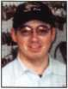

in October of 2001, because I got laid off at my  
other job. When I started, I did not realize what the  
field consisted of, and how much a person could like  
what he or she does for a living. I have been trying  
to learn as much as I can by going to our local lock-  
smithing meetings every month, and by taking some  
classes when they offer them somewhere close to  
home. I went to the ALOA convention last year and  
took Fundamentals of Locksmithing. I thought the  
class was very helpful and learned a lot about the  
field and to present oneself to the customers. I am  
applying for this scholarship to help with the cost of  
going so far this year. The last time I could drive,  
but being in Las Vegas will require plane fare. I  
hope that one day in the far future, I can be one of  
the instructors instead of one of your students. That  
is far away, but I hope I can achieve that, and much  
more. I strive to help out our profession, and to let  
the public see what we can - and do - offer them.



Keynotes • July/August 2003

**Michael Vorpahl, CRL** Attending the

ALOA convention will give me the opportunity to expand my knowledge in order to keep up with the industry. That is very important to me, both person­ally and professionally. I take great pride in being able to service my customers and company with the latest and greatest in locksmith technology. Representing the locksmith industry effectively means being a good consultant and service person. Professionally, I know how important it is to support my company by providing knowledge to help them provide more electronic access control products. Being successful at the ALOA convention also means I'll be able to continue to train new lock-

^ smiths to keep up with industry trends. Thank you

for considering my application for the ALOA scholar- ship. If I am a recipient, I will make the most of the . opportunity to further my education and advance

locksmith profession. I look forward to hearing | from you.

James Wiedman I would like to be consid­



ered for an ALOA scholarship at the annual conven-  
tion in Las Vegas. The reason for this request is that  
it would be financially impossible for me to attend  
otherwise. I have had my own locksmith business  
for four years in Nashville, TN, and have always  
prided myself in providing quality professional serv-  
ice. The last convention that I was able to attend  
was in Baltimore. At that convention, one of the  
classes I took was Master Key Methods and  
Formats, with Jerome Andrews, CML, instructing; it  
proved to be a tremendous asset to me and my  
business. It is quality education like this that I feel is  
necessary to promote professionalism in our indus-  
try. The education that I would gain from this schol-  
arship would be passed on to the general public  
through the avenue of continued quality service, and  
to my fellow locksmiths to promote professionalism  
throughout my service area.

Andrew Youngblood I recently graduat­



ed from high school, and this year, I plan to go to a  
local community college and continue living at  
home. This will give me options, as I'm deciding  
what to do with my life. It will also be a good time  
for me to work with my dad in the locksmith field.  
Remembering back to the time when I was a little  
boy, I always wanted to go with my dad on lock-  
smithing jobs. There was a desire to be involved  
with the locks, whether was getting a ride in the  
truck, or seeing my dad magically open up a car  
that was locked. Many things can trigger a child's  
mind. Some times at night, while my dad was  
working in the basement, he would show me how  
to take apart locks and put them back together  
again. For some reason, this interested me and con-  
sumed hours of my time. Now that I'm old enough  
to get involved in the business, I am doing every-  
thing I can to get plugged into the security industry.  
So when my father told me about this scholarship, I  
got really excited about it. I believe this opportunity  
will help me along in entering the locksmithing field.  
I plan to use this information, if accepted, as a basis  
for my locksmithing career. In conclusion, I hope this  
letter has supported the reader with enough infor-  
mation about me to make a logical decision about  
my scholarship opportunity with the ASF. Thank you  
for your time.

Susan Zipp I'm writing to you in hopes of



being considered for a 2003 ALOA scholarship. I  
have been an active member since 2001. I currently  
work for Hobby Key Works, where I have been for  
almost four years as a locksmith. With the busy  
pace of our shop. I'm not always able to stay  
informed of the industry's advances. As the shop  
technician and the person who does the purchasing,  
this puts me at a disadvantage. And being a single  
parent, I find it difficult to attend classes because  
there are limited amounts of classes offered in this  
area. I know this opportunity will benefit my career  
in many ways. I will be able to service my cus-  
tomers in a more informed way. I will be able to  
assist other employees in a knowledgeable manner.  
I also plan on advancing my Proficiency Registration  
Program certification. I have found that in the lock-  
smithing industry, knowledge is a very valuable  
commodity, and it separates the locksmith from the  
professional locksmith. I appreciate your considera-  
tion and look forward to hearing from you.

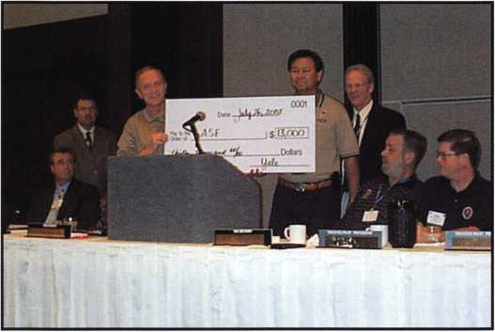

The ALOA Scholarship Foundation is an independent 501(c)(3) educational,  
tax exempt corporation established in 1993 to encourage and provide for edu-  
cational services, programs and materials concerning locksmithing and security  
devices and procedures; develop scholarship and assistance programs for per-  
sons interested in pursuing a career in the security and locksmithing field; to  
provide and to receive funds in implement the purposes of the Foundation;  
and to perform and do any and all such other acts as are necessary, convenient  
and proper for the attainment of these objectives.

We invite and encourage you to join the effort to provide funds for educa-  
tion and training of locksmiths to help secure our future. For more informa-  
tion, to make a fully tax-deductible contribution, or to volunteer your ideas  
and talents, please contact us at through our headquarters at: ALOA  
Scholarship Foundation, 3003 Live Oak St, Dallas TX 75204 or phone us  
(800) 532-2562. Your support of education, training and development of  
locksmiths can provide security for our future.



Keynotes • July/August 2003

MEMBERSHIP MILESTONES:

2003 ALOA Anniversary List

Each year, ALOA recognizes those members who are celebrating membership anniversaries. The follow ing list represents this year's list of milestone members, whose years and years of service and participa­tion in their profession set a great example for those in subsequent generations.

**1956**

Ewell W. Bradburn James L. Britt RL Herman B. Brust Jr, RL Edwin Dietzel John Dziuba RL Harold Gort William C. Kenton James F. Love Philip A, Macy Arthur E. McGinnis

William D. Mclnerney RL, AHC, CPP

Roman G. Moncur Jay Nelson RL Roger J. Paradise RL Ernest J. Ricciuto Don J, Spenard Sr, RL Carl A. Stapel RL Herbert Stein SJ Sussina RL James L. Taylor RL George E. Walters

**1957**

Stanley C. Haney CPL Harry J. Kroll Joseph T. Smith Sr

**1958**

Lawrence P. Buchanan RL Charles M. Cooper RL Harold Edelstein RL William J. Greenberg RL Edgar L. Jones Jr, RL Fredrick R Leimbach RL Richard M. Lockman RL Robert C. McCown RL George A. Petrie Edward A. Pfeil CML Louis Weberman RL

**1959**

Joseph S. Anmuth RL Sam Charm RL Donald G. Dobs RL Aaron Max Fish Walter H. Stiering RL Kenneth J. Troy RL Joseph A. Veniero

**1960**

James C. Ard Sr Joseph A. Dube CML

John R. Malinowski CML,CMS

Gerard E. Mangione David M. Williams Sr

**1961**

Raymond E. Beggs CML Robert W. Freed RL Warren G. Heaton RL John McManus William A. Meacham Ramon F. Merlin RL Jerry C. Shaffer Robert E. Sontag RL Charles W. Thomas CML Leonard E. Whitford Sr

**1962**

Dan C. Ellis CPL

Timothy G. Griffing Jr, RL

Louis N. LaGreco CPL

**1963**

Maurice W. Hatfield RL Eugene Haywood RL Alfred C. McAfee CML Jerry Meilan RL Arthur C. Miller RL Walter L. Miller

Thomas E. Minick Lew F. Noyes Jr, CML Alexander W. Rose RL Harvey W. Sass George J. Trouland RL Karl C. Wentz RL Gene S. Winne RL Milton F. Wolferseder RL

**1964**

Charles M. Angelroth RL John H. Berg RL James C. Condil Edward J. Delphia, RL George F. Frey Robert G. Henke CRL Yehuda M. Hersh Ernest Jones T C. Mickley CML Edwin L. Phillips RL George Pinson Alan P. Stelzer

**1965**

Eugene R. Anderson RL, CPP, AHC

Edward R. Crossman CRL George I. Esthus RL George A. Iffrig Paul H. Jamieson RL John N. Keefe RL Walter W. Lascar RL William G. Schultz

**1966**

Garvis E. Crider John DeCosta Jr, CML Carl A. Fowler RL Patsy Gunkel RL Stuart W. Johnson Edward Kotler RL David E. Leeper RL

James Mozisek CML Charles E. Skobrak Sr, RL John W. Walter CPP Marion J. Walters CRL

**1967**

Lewis A. Alessandrini RL Edward R. Attkisson RL Lawrence I. Barrett Sr, RL B.W. Cook

Michael F. Cutler CML Richard E. Fullmer Jr, CPL Ronald E. Hutchison John E. Jackson RL David J. Killip CML Roger D. Kline RL Raymond P. Knecht Larry B. Ralston RL John L. Shandy CML Paul C. Taormina RL Walter R. Wasilenko RL Arby R. Watkins Ronald W. Weaver Harold J. Wills

**1968**

Arlin E. Buck RL Arthur L. Dedge CRL Nicholas DeSalvo RL Alan K. Eigenbrod RL Jack W. Kilgore RL Keith R. Lewis CML Robert A. McCoy RL Reginald W. Moxley CPL Merritt L. Perkins RL Ralph J. Schmitt RL Frank W. Tellerico Albert S. Townsend CML Norman F Ward Leo F. Wright RL

Keynotes • July/August 2003

**4500 Series**

**> =/>**

;

S ****» '.c • vs> « * \H

- 's—7

HES has modernized the traditional style fire rated electric strike. Introducing the 4500 electric strike, designed to accommodate virtually ALL 3/4"cylindrical and mortise locks.

The 4500 is also the FIRST and ONLY electric strike designed for installation in 2" UL 10C fire rated frames with the required Vi drywall penetration.

Based on the design of our 5000 series, the new 4500 electric strike features:

Low profile 1-3/8" depth

Heavy-duty cast stainless steel construction

Horizontal adjustment for simple installation

Dual voltage 12/24V DC

UL 10C (3 hour),

UL 1034 rated

*The NEW4500 electric strike. Yet another first from HES.*

hes

An ASSA ABLOY company

ASSA ABLOY

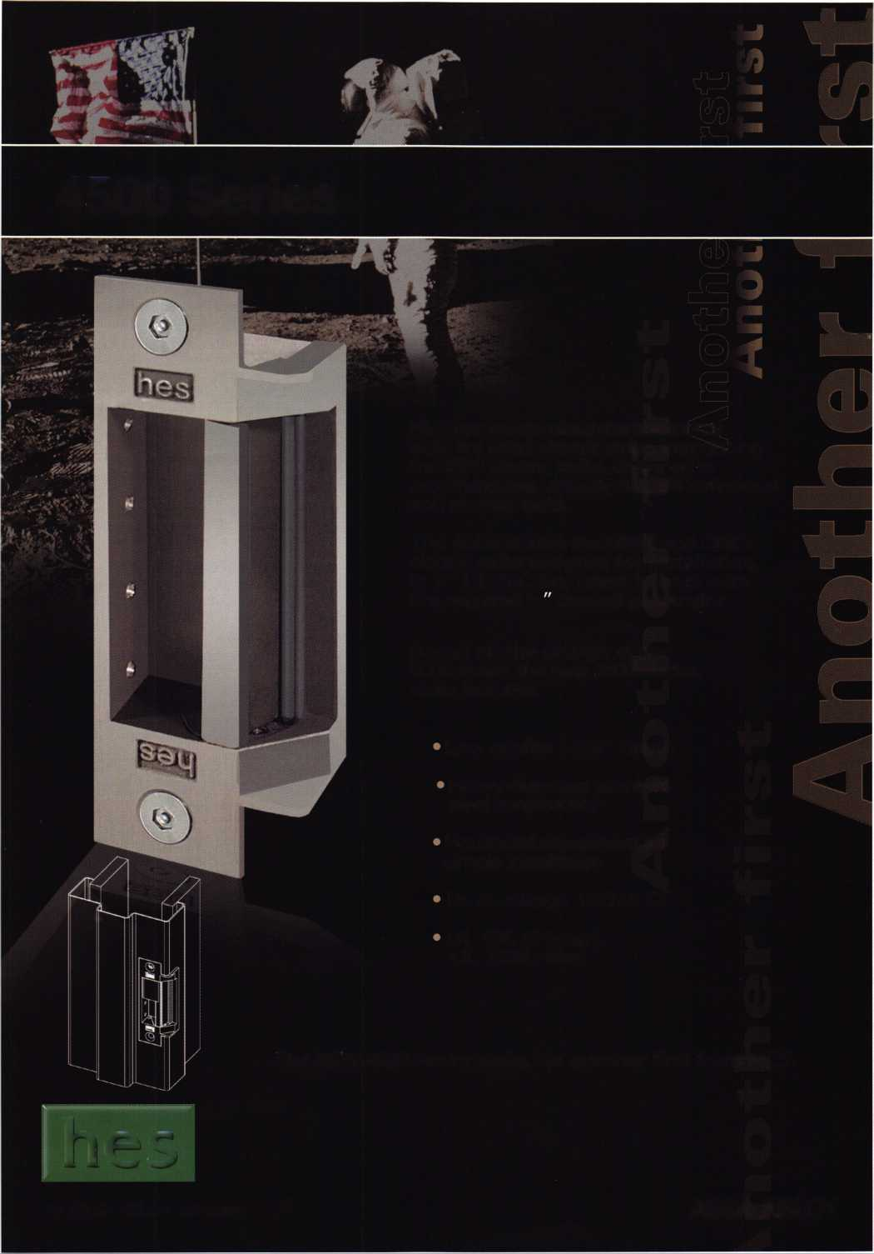

STATE OF THE ASSOCIATION

Charles W. Gibson, Jr., CAE, Executive Director

The Governance policy of the ALOA  
requires that the Board of Directors estab-  
lish the "Ends" of the Association. That is,  
the Board decides what products and serv-  
ices shall be provided to the members. It is  
then the job of the staff to decide the  
"Means" to accomplish these ends. The  
board has asked me to provide a report to  
the membership concerning the activities  
(Means) that have been conducted over the  
past year in order to show what ALOA is  
doing on behalf of the membership.

The four "Ends" specified by the Board are:  
Education, Recognition, Legislation, and  
Communication. Each of the Ends is further

defined in the ALOA Governance Policy that can be found at  
[www.aloa.org](http://www.aloa.org). If you do not have access to the internet, contact the ALOA  
office, 800/532-2562, and a copy will be sent to you. You can get a  
copy at the ALOA Booth at convention as well. Following is a summary of  
some of the activities conducted to accomplish the Ends.

EDUCATION

Last year, the ALOA Continuing Education (ACE) program conducted 159 full day and 36 half-day ACE classes and seminars at 22 locations. Ninety-five of these full day classes were conducted away from the con­vention at sites that ranged from Tokyo, Japan to Sturbridge, MA.

ALOA has developed a skilled service network of members for each area of specialization. To that end, last year we conducted training in Automotive (25 classes/423 students); Electronic Security (31 classes/497 students); Safe and Vault Servicing (25 classes/344 students); Mechanical Security (82 classes/! 391 students); Business Management (11 classes/ 102 students).

RECOGNITION

The Proficiency Registration Program (PRP) provides recognition for the participants within and outside of the locksmithing community. We have administered the PRP at 46 sittings with 531 participants. There were 52 ACE classes that provided after class PRP exams. There were 297 students that chose the option to take the after-class PRP for that class. The pass rate for these exams is 86 percent. Currently there are 699 CMLs, 634 CPLs, 2,843 CRLs and RLs (646 grandfathered RLs). This represents 50% of the total ALOA membership - that's one of the highest ratios of trade association voluntary certification in the world!

ALOA members are recognized as security professionals by related indus­try groups



It is important that those outside of the association recognize that our members are the best security professionals, especially in this day of heightened security. In the course of soliciting advertising and booth sales we repeatedly inform manufacturers and distributors of the quality of our members and the association. The interaction between these companies and our members at convention and similar events serves to acquaint com­panies with our membership. Several members of the manufacturing com­munity have served on the ALOA Board, and the Security Hardware Distributors Association (SHDA) has adopted a policy of attempting to place one of its members on the ALOA Board as the "Associate Region" director.

ALOA participates in the Security Industry Association (SIA), Door and Hardware Association (DHI), Institutional Locksmiths Association (ILA), Association of Security Industry Specialists (ASIS), The Security Hardware Distributors Association (SHDA), the National Burglar and Fire Alarm Association (NBFAA) Board Meetings. ALOA is a member of The National Health Care Coalition, and the Automotive Repair Coalition. ALOA chairs the Electronic Systems Alliance that includes 1 2 associations with a com­mon interest in protecting the low-voltage industry.

ALOA has worked with various locksmith associations for "Locksmith Day" proclamations. We were successful with Wisconsin, South Carolina and Oregon in bringing awareness of our profession to the general public.

LEGISLATION

Pro-active role in Locksmith legislation: Worked to turn around the situation in Maryland to include locksmiths under the Security Systems Technician Act with our own acceptable language. We worked extensively with the Coalition for Auto Repair Equality (CARE) on the passage of the Motor Vehicle Owners' Right to Repair Act, and began the process of introducing federal locksmith legislation (The Federal Facilities Protection Act) by securing a Washington D.C.-based lobbying firm.

A membership that is informed and consulted about legisla­tive activity that may affect it: We monitored over 500 bills relat­ed to the security industry, focusing on 16 of them in 14 states that directly affected locksmithing. The Legislative Report page on the ALOA website was updated constantly on these 16 bills to give members up-to-the-minute information on legislative activities in their state. We developed an "Action Alert" page where members may look at specific bills, their status, and write a letter to the appropriate legislator. We used it extensively for Ohio. For all bills, we notified the Chapter Chairman, or Association President of pending legislation. Sent letters, faxes and emails to all appli­cable LAN and ALOA members notifying them of these bills and asked them to take action. We produced a Legislative Report in all issues of Keynotes magazine. We conducted a State-of-the-States roundtable at Convention with over 21 Chapters, Affiliates and Locksmith Associations in attendance.

Effective representation of the members to legislators, regu­lators, and other industries: ALOA effectively represented mem­bers' interests opposing bills that would impede locksmiths to do their work in Connecticut, Maryland, Mississippi, Ohio and Pennsylvania. We were successful in getting these bills either killed or amended. We assisted the Ohio Locksmith Association in acquiring a lobbyist to defeat the alarm bill, and were successful in obtaining funding from SHDA for this lobbyist. ALOA chaired the Electronic Systems Alliance meetings. The mission of these 12 associations in the low-voltage industry is to exchange and dis­cuss information regarding legislation impacting the electronics industry. We worked hard to pass the International Association of Security and Investigative Regulators (IASIR) model law on licensing electronic security systems to make it more favorable to locksmiths. We visited key Congressional legislators and lobbied for the locksmiths' interests in the Motor Vehicle Owners' Right to Repair Act.

COMMUNICATION

Members' access to industry experts at all appropriate levels is best dis­played in the numerous technical articles written by these experts every month in Keynotes. Last year we had a wide menu of technical articles every relevant topic. The "new and improved" Keynotes also has made it easier to focus on specific aspects of locksmithing from one month to the next, because we showcase five different categories of locksmithing in each issue: mechanical, electronic/AC, automotive, institutional and safes. Articles are not limited to technical subjects. There is information concern­ing business, taxes, employment, legislation and many other things that members find useful.

The Legislative Action Network (LAN) has been established to inform key ALOA members of legislative activity as quickly as possible, usually by email.

The ALOA web site, www.aloa.org<<http://www.aloa.org>> is continually updated. It contains, among many other things, a calendar of events, con­vention information, membership application, an ALOA store, a security reference section, legislative information, membership list, and news bul­letins. In the month of June there were over 18,000 visits to the site, 7,000 of these were repeat visitors.

ALOA has had a busy and productive year. The association is profession­ally and financially capable of continuing to provide the services directed by the Board of Directors.

Kpvnnfp<; • Inlv/AiiniKt 900.9

Your Future

Join us next summer at the East Coast's premiere travel destination as we set the stage for the biggest security event in the world. Come to Baltimore and discover classes, workshops, and exhibits that will help you shine in today's marketplace.

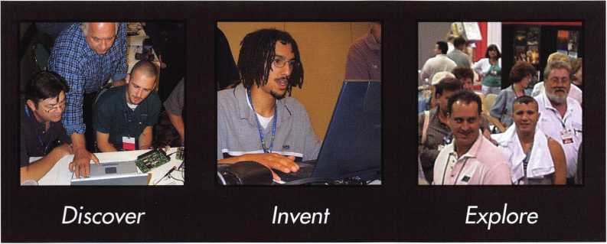

Ml-TtMOSE, Ml?

get it... together

The ALOA Convention and Security Expo • Baltimore Convention Center • July 23-25, 2004 • (800)532-ALOA(2562)

[convention@aloa.org](mailto:convention@aloa.org) • [www.aloa.org](http://www.aloa.org)

FINANCIAL REPORT

The Associated Locksmiths of America, Inc. engaged the firm of Sutton Frost Cary LLP to conduct the annual audit of the association's financial records for 2002. The audit was completed and a report made to the Board of Directors in March, 2003. Part of this report, The "Statement of Activities" (Profit and Loss), "Assets" and "Liabilities and Net Assets" (Balance Sheet) are included with this report to the membership. The auditing firm was of the opinion that the financial records fairly and accurately portrayed the association's financial activities.

The purpose of the Associated Locksmiths of America is not to make a profit; rather the purpose is to provide the services specified by the Board of Directors. These services, in no particular order, include Education, Recognition, Legislation, Communication and Professionalism. However, these services cannot be properly providing without a sound financial base. Last year, 2001, as the American economy did not do well neither did ALOA. ALOA lost, before depreci­ation, $167,691.00. Recognizing the severe economic problems, adjustments were made. In 2002, another bad year for the American economy, ALOA had revenue in excess of expense, before depreciation, of $38,234.00. This is an improvement of $205,925.00.

So far, 2003 is going well. The two major components of income, dues and convention are at, or near, budget so far. With attention to controlling expenses, ALOA should have another good year.

ALOA remains financially capable of providing the services expected by the membership

ASSETS

|  |  |  |
| --- | --- | --- |
|  | 2002 | 2001 |
| Current assets: |  |  |
| Cash | $297,748 | $312,274 |
| Certificate of deposit | 64,341 | 62,515 |
| Accounts receivable | 257,527 | 225,299 |
| Inventory | 35,907 | 29,400 |
| Prepaid expenses | 134,020 | 115,213 |
| Due from affiliate | - | 2,852 |
| Current portion of notes |  |  |
| receivable from affiliates | 23,232 | 21.882 |
| Total current assets | 812,775 | 769,435 |
| Property and equipment: |  |  |
| Land | 79,836 | 79,836 |
| Building and improvements | 302,516 | 302,516 |
| Furniture and equipment | 495.912 | 476.616 |
|  | 878,264 | 858,968 |
| Less accumulated depreciation | (670.935) | (641.567) |
| Property and equipment, net | 207.329 | 217.401 |
| Notes receivable from affiliates, |  |  |
| less current portion | 159,395 | 182,627 |
| $ | 1,179,499 | $1,169,463 |
| LIABILITIES AND ASSETS | |  |
|  | 2002 | 2001 |
| Current liabilities: |  |  |
| Accounts payable | $74,735 | $82,911 |
| Accrued expenses | 51,179 | 40,948 |
| Current maturities of long-term debt | 7,061 | 11,062 |
| Current maturities of |  |  |
| capital lease obligation | - | 3,616 |
| Due to affiliate | 22,572 | - |
| Prepaid dues | 538,132 | 578,372 |
| Prepaid exhibit fees | 449.230 | 422,400 |
| Total current liabilities | 1,142,909 | 1,139,309 |
| Long-term debt, less |  |  |
| current maturities | 7,060 | - |
| Total liabilities | 1,149,969 | 1,139,309 |
| Net assets-unrestricted | 29,530 | 30,154 |
| $1,179,499 | | $1,169,463 |

STATEMENT OF ACTIVITIES

|  |  |  |
| --- | --- | --- |
| Revenues | 2002 | 2001 |
| Membership dues and services | $988,257 | $933,362 |
| Convention | 763,044 | 752,724 |
| Management fee | 126,000 | 92,400 |
| Advertising | 53,831 | 63,696 |
| Promotional programs | 56,480 | 28,363 |
| Interest | 24,065 | 38,803 |
| Educational programs | 91,300 | 111,974 |
| Miscellaneous | 41.296 | 10.860 |
| Total revenues  Expenses | 2,144,273 | 2,032,182 |
| Administrative | 1,228,229 | 1,258,409 |
| Convention | 387,804 | 460,552 |
| Keynotes magazine | 181,934 | 204,558 |
| Building operations | 55,652 | 72,633 |
| Member services | 75,168 | 39,169 |
| Depreciation | 38,858 | 42,365 |
| Promotional programs | 35,579 | 20,291 |
| Educational programs | 133,606 | 140,339 |
| Committee | 8,067 | 3,922 |
| Total expenses | 2,144,897 | 2,242,238 |
| Decrease in net assets | (624) | (210,056) |
| Net assets at beginning of year | 30,154 | 240,210 |
| Net assets | | |
| at end of year | $29,530 | $30,154 |



Keynotes • July/August 2003



*those who passed over it on their way to Virginia City and the gold recently discovered there. Fuller also provided gold-seekers with a place to rest, purchase a meal, and exchange information with other*

***prospectors.***

Keeping up with the latest the industry has to offer has never been more impor­tant for safe technicians. Time is of the essence when it comes to education. New developments spring up each year, making top-notch safe classes as good as gold in our ever-changing environment. The only chance to get world-class education and meet with the industry's top safe technicians and suppliers is the SAFETECH Convention and Trade Show. SAFETECH 2004 offers you a chance to explore your profession in ways you never thought possible. Register now to benefit from the future of this exciting industry.

*&*

*vote*



i(/io avu/ vaa/t iiic/udAy/

SAFETECH 2004

MARCH 20-28  
JOHN ASCUAGAS  
NUGGET RESORT  
RENO, NEVADA

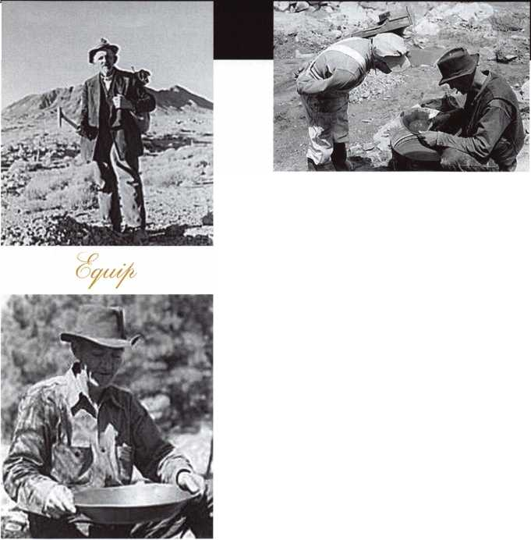

The Associated Locksmiths of America, Inc.

(ALOA) worked very hard this year on legislation affecting the security industry at the state and fed­eral levels. We actively worked on 16 bills in 14 states plus one federal bill.

There was only one alarm licensing bill intro­duced this year (Mississippi), which never made it out of committee. In Illinois the Private Detective, Private Alarm, Private Security and Locksmith Act is going through changes to update the law. Again, in Minnesota they introduced a bill that requires criminal background checks for "electron­ic security system companies" which is further defined as "burglary detection, access control, or closed circuit television." However, this is in the criminal code, not the licensing code (where elec­tronic security system is not defined), so we will

i s I a t i v e a t e

have to see how this is interpreted. Missouri intro­duced an Electrician's Licensing bill that includes low-voltage. Louisiana and Tennessee have both introduced locksmith licensing laws.

We have also been working with the Coalition for Auto Repair Equality (CARE) and Rep. Joe Barton (R-TX) to pressure the auto manufacturers into pro­viding information to originate keys, or else have the "Motor Vehicle Owners' Right to Repair Act" introduced. Rep. Barton has specifically asked that information for locksmiths be includes on what the manufacturers provide to the aftermar­ket. We have also been in contact with Rep. Brad Sherman's (D-CA) office about introducing a bill that specifically requires manufacturers to supply information to originate keys using scan tools to the consumer or his/her agent.

**JOIN THE LEGISLATIVE  
ACTION NETWORK TODAY!**

As we continue to expand our resources and become more competitive  
in the legislative arena, we need the monetary resources to match our  
successes. You can help with as little as $24.95 to the Legislative Fund.  
This is only the minimum that we are asking, and encourage you to give  
more if you can. Those that contribute will be given a Legislative Action  
Network Member kit to use in their grass roots efforts. Members who  
donate $100 or more become Legislative Action Network Council mem-  
bers, and enjoy the following extra benefits: a reserved place of distinc-  
tion on the special LAN Council; Discounts on ALOA bookstore items;

10 % rebate on all ACE classes; Complimentary Legislative Convention  
merchandise. Join today online at [www.aloa.org/news/lan.htm](http://www.aloa.org/news/lan.htm).

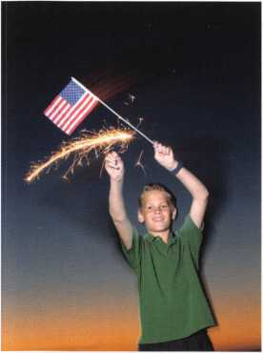

Keynotes • July/August 2003

2003 LEGISLATIVE HIGHLIGHTS

CONNECTICUT SB14

Requires the licensing of locksmiths.

* Failed Joint Favorable deadline

ILLINOIS SB487

Revises the Private Detective, Private Alarm, Private Security and Locksmith Act.

* To Committee on Executive

INDIANA HB1946

Establishes a voluntary registration program for locksmiths who pass a background check.

* To Committee on Commerce.

LOUISIANA HB310

Provides for the licensure of locksmiths and requires a license to install and maintain access control devices and closed circuit television alarm systems.

* Introduced

MINNESOTA HB773/SB797

Requires that employees of electronic security system com­panies, undergo criminal history background checks.

* To Committee on Ways and Means

MISSISSIPPI SB2609

Licensing of alarm industry. Alarm definition tied it to a monitored system.

* Died in Committee.

MISSOURI SB680

Establishes a licensing board to regulate electrical contrac­tors, which includes low-voltage.

* In Committee on Financial and Governmental Organizations, Veterans Affairs and Elections

NEVADA SB39

Requires landlord to change entry locks of dwelling unit before delivering possession of dwelling unit to new tenant.

* To Senate Committee on Judiciary

NEW YORK AB2646

Establishes security requirements to be fulfilled by owners of multiple dwelling units including deadbolt locks.

* To Committee on Housing.

NEW YORK AB5024

Provides that class A multiple dwellings having 8 or more apartments erected or converted prior to 1968, must have automatic self-closing and self-locking doors at every entrance.

* To Committee on Housing.

NORTH CAROLINA SB655

Allows the licensing Board to conduct criminal history record checks.

* To Committee on Commerce.

NORTH DAKOTA HB1159

Relates to the jurisdiction of the private investigative and security board. Gives vague definition on what constitutes "security services"

* Died in committee.

SOUTH CAROLINA SB! 86

Provides certain instances in which dead bolt locks requir­ing a key for operation on both sides may be used on exit doors.

* To Committee on Judiciary

TENNESSEE HB274/SB656

Relates to locksmith licensing.

* To Committee on Commerce

TENNNSEE SB188

Requires that all alarm system contractor employees take and successfully complete the National Burglar and Fire Alarm Association Level 1 training.

* To Committee on Commerce, Labor and Agriculture.

TEXAS HB2594

Relates to the voluntary registration of locksmiths.

To Committee on Licensing and Administrative Procedures.

Keynotes • July/August 2003



EMPLOYMENT

HELP WANTED

Emory is one of the five largest private employers in the Atlanta metro area and the largest employer in Dekalb County. The University is admired worldwide for academic, patient care, research and technologi­cal excellence. As an Emory employee, you are part of a community which values diversity, education, training, and personal development. Creativity and innovative ideas are nourished and rewarded. We invite you to share in a unique culture of education, research and health care.

We currently have a great opportunity for a Supervisor, Security Systems in our Security Shop. They will Provide locksmith, alarms, control systems and security system services including installing, repairing, inspecting, and recombination mechanical, electro-mechanical, electronic locking and monitoring devices and door hardware. Performs diagnostic tests on digital, key pad and card-locking, and other electronic locking systems for the University.

MINIMUM QUALIFICATIONS: High school diplo­ma or equivalent. Five years combination locksmith and electronics/security systems experience, includ­ing two years supervisor experience. Thorough jour­neyman level knowledge and skills in mechanical, electro-mechanical, electronic locking and monitoring devices and door hardware. Journeyman level skill in maintenance and repair procedures including pre­ventive maintenance, breakdown repair and trou­bleshooting, construction, installation and fabrication techniques typical in trade; perform mathematical computations of trade. Knowledge of ADA specifica­tions and proper use and maintenance of hand and power tools, test equipment and electronics equip­ment related to job functions. Valid Georgia driver's license and insurable driving record. Some positions within this classification may require the ability to lift 50 pounds and to bend, stoop and twist.

Departmental Information/Preferred Qualifications: Ideal candidate will have a high degree of organiza­tional, communication, customer service, and good leadership skills.

We offer competitive salaries and world-class ben­efits including major medical/dental/vision/life insur­ance, disability insurance, paid holidays/vacation, tuition assistance, a generous employer matching 403(b) retirement plan and courtesy scholarships for family members and same-sex domestic partners. For

more information about our benefits, please visit our website at: <http://emory.hr.emory.edu/benefits.nsf> A career with Emory University affords a level of prestige and stability not found in many Atlanta Employers of Choice. We invite you to become a part of the Origins of Excellence!

Please submit your resume via (online from) the Emory Careers Website at

emory.hr.emory.edu/careers.nsf or by mail at Emory University, 1762 Clifton Road, Atlanta, GA, 30322. Phone: 404.727.7611 Fax: 404.727.1922 Please reference Job posting 136542 when applying.

Emory University is an AA/EOE Employer

LOCKSMITH WANTED

Work with some of the best in the dynamic and ever­growing Fort Collins - Greeley - Loveland are of Northern Colorado. Present opening is specifically for the Fort Collins area. Must have good driving and clean criminal record. Must be experienced in auto­motive, commercial, residential and safes. Experience in access control and other areas a plus. Advancement commensurate with experienced and performance. Benefit package, including paid vaca­tions, health insurance, retirement and more is avail­able. Please contact:

Raymond D'Adamo, CML • Tri-City Security, Inc.

3517 S. Mason St. • Fort Collins, CO 80525-2616 Cell: 970/566-6517 • Fax: 970/223-4779 E-mail: [rdadamo@mindspring.com](mailto:rdadamo@mindspring.com)

STOP LOOKING!!!!!

EXPERIENCED TECHNICIANS WANTED

Lock into your future now! If you are experienced, intelligent, and desire a secure future, come join our team. We are a full service commercial/residential security service (locks,keys,safes,cctv,access control, door related hardware). We offer: top wages, com­pany vehicle, 401k, paid vacation, paid holidays, new uniforms, cross training, and job satisfaction. We are looking for the best tech's, who are ready to be treated and compensated as professionals.

Bass Security Services, Inc.

Ph#216-755-1200 ex.#128

Fax#216-755-1220

E-MAIL / [rmesnick@bass-security.com](mailto:rmesnick@bass-security.com)

LOCKSMITH-SUPERVISOR-INVESTOR

Great opportunity for experienced locksmith to be part of the company. Established and expanding 43- year business in residential, commercial, safes, CCTV, and access control looking for key person to help take us to the next step! Tri-County, Ml. Top pay, med­ical, vacations and bonuses. Fax resume to: 248/969-1398, or call 248/442-2233, or page me direct at 248/908-2277. Large investment - if any - not required! More interested in opportunity-minded person with good locksmith and communication skills. Ask for Mr. Walters!

BUSINESS FOR SALE

BUSINESS FOR SALE

Locksmith glass and screen business located in fast growing NW Arizona between Kingman, AZ, and Laughlin, NV. Well-equipped 1995 Dodge van and leased shop on busy highway. All equipment and inventory included. $48,900 takes all. Health demands retirement. Call (928) 565-2294 or e-mail at [lmburks@ctaz.com](mailto:lmburks@ctaz.com).

BUSINESS FOR SALE

Owner Retiring. Well-established business in central Ohio, est. 1965. Sale includes equipment, inventory, 2000 Dodge Ram 2500 van. Commercial and resi­dential accounts. We are a Medeco Patriot dealer for the county and surrounding area. Call 419/562- 4896, or write to: Wink's Lock and Safe • 1 13 W. Warren St. • Bucyrus, OH 44820

FOR SALE

Well-established lock shop, fully-equipped shop van. Hub city, serving all of northeastern Nevada. Same location for 20 years. Large commercial clientele. Great outdoor recreational area, hunting, fishing, etc. Elko Lock and Safe.

Call 775/738-3938, fax 775/738-2370.

FOR SALE

Overstock, New Von Duprin 33NL-OP, 33EO, E99K, 3347EO, 9947EO, CD3347TL, EPT-10, Von Duprin electric strike 6211, 6233. Rixson mag hold 980,997 Locknetics 505. Please call for price. Kevin at 915-553-3145, or e-mail reddog2501 @excite.com.

Classified Advertising Policy

Classified advertising space is provided free of charge to ALOA members, and fora fee of $.60 per word, $15 minimum for non-members. Classified ads may be used to advertise used  
merchandise and overstocked items for sale, "wanted to buy" items, business opportunities, employment opportunities/positions wanted and the like. Members or non-members wishing to  
advertise services or new merchandise for sale may purchase a "Commercial Classified Ad," for a fee of $1.30 per word, with a minimum of $40. Each ad will run for two issues. For  
blind boxes there is a $5 charge to members and non-members. All ads must be submitted in writing to the ALOA office by the fifteenth of the month, two months prior to issue date. Send  
to Keynotes Classifieds, 3003 Live Oak St, Dallas TX 75204-6186. ALOA reserves the right to refuse any classified advertisement that it deems inappropriate according to the stated pur-

pose of the classified advertising section.

Keynotes • July/Aug 2003



COMMERCIAL LOCK BUSINESS FOR SALE

Commercial locksmith company specializing in high tech, high security sales, service and installations is for sale. Business was established in 1978 and is located in the Inland Empire of Southern California. ASSA dealer with six keyways and most accounts are on the ASSA system. Residential and automotive are currently referred to others, so there is lots of room for expansion. Excellent high security addition to an existing lock business or instant income for a rookie or retiree. Retiring and moving to the northwest, so business is priced to sell fast! Call 909-295-8480 for details.

LOCKSMITH MOBILE SERVICE FOR SALE

Established mobile locksmith service in the Bay Area. Specializing in automotive and residential with some light commercial work. Territory covered is Fremont, Hayward, Union City and Castro Valley in California. Three trucks are currently being used in the area. Fully-equipped with tools and key machines. Professionally labeled vehicles that are well kept. This territory averages a gross in sales per year of around a half a million dollars.

We are looking for a qualified individual that is self motivated to take over operations. Willing to sell for a rock-bottom price to the right individual. Desperate to sell immediately. Please call 888/815-6257 for details. Robert Bradley, President, Locksmith Central

BUSINESS FOR SALE

Looking to relocate to sunny Arizona. Established in same location for over 14 years. Profitable Lock & Safe business with service and retail location.

Good client base. Reasonably price to right person. E-mail inquiries to [Lockbizaz@aol.com](mailto:Lockbizaz@aol.com) or fax to (602) 870-8505.

BUSINESS FOR SALE

Middle Tennessee area for 25 years. Moved from mall after 20 years. Completely stocked '95 Chevy van with metal and wooden cabinets. Honda 650- watt generator and key machines and several Curtis clippers. Inventory includes enough stock to open storefront operation, with two computers and all codes installed. Call 931/686-8187. Ted or Louise.

FOR SALE

Mobile and home-based locksmith business. Nice equipment and many extras. $45,000, with '97 Astro van, $35,000 without van. Call or write Triple A Locksmith Shop at 309/852-0450, or PO Box, 537, Kewanee, IL, 61443.

FOR SALE

Lock shop for sale in west central Wisconsin. Fixtures, tools, inventory, and established clientele, with or without building. Profitable second business included. E-mail: [lockshop@safenlock.com](mailto:lockshop@safenlock.com).

BUSINESS FOR SALE

Mobile locksmith business for sale. Complete. $22K. Van, tools, inventory, books, software, laptop, etc. 305/743-8734.

WANTED TO BUY/SELL

WHOLESALE SAFE DEPOSIT LOCKS

Allied, Diebold, Herrin, Hall & Mavin, llco, Lefabure, Mosler, Precission, S&G, Security Corp., Yale. Locks from early 1900s to current. Call or email for lock type and pricing sheet. Quantity discounts. Call WBI at (954)484-2404 or email: [sales@wbi.us](mailto:sales@wbi.us)

NEED CASH?

Have you recently sold your locksmith business, or are you selling it now? Are you carrying the financing? We can give you a lump sum of cash now for all or a portion of your remaining payments. RED OAK FUND­ING. 630/483-0335, [www.redoakfunding.com](http://www.redoakfunding.com)

FOR SALE

Full set of HPC general codebooks updated for 2002. Full set of HPC foreign auto codebooks updated to 2002. Both sets for $250, no splits. Future dates available. 508/693-5625.

SHOP IN LOTS

For sale in lots only - key machines, pinning trays, tools, lockout tool sets, merchandise, and collectibles. We pay the freight/shipping. Call or e-mail for com­plete list of items and prices. Call 307/856-0325, or e-mail, [mbarham@wyoming.com](mailto:mbarham@wyoming.com).

Hole Saw Alignment Guides

No More Plywood, "C" Clamps, or Jigs  
Needed to Over Bore Existing Holes

* Our Guides let you over bore existing holes that meas. 5/8", 3/4" & 1-1/2" diameter
* They work on wood as well as metal
* Two small sizes ideal for desks and cabinets
* Purchase in sets or individually
* Visa, MC, Amex, Discover
* MONEY-BACK GUARANTEE

**TW-City Lock Company**

Daniel D. Mello, Owner-Locksmith  
Groveland, CA

209 962 4692 • 209 962 4910 FAX E-mail: [slmello@mlode.com](mailto:slmello@mlode.com) **[www.tricitylock.com](http://www.tricitylock.com)**

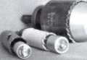

TURfl tO

WHOLESALE SERVICE

In-Stock... **SAFES** FREE Freight Program Fax: 800-391-4553

800**-**848-9790

AMSEC RreKing Baidal HAYMAN MEILINK \/lCTOK

Keynotes • July/Aug 2003



**associate**

members

Distributor

ADI Inc

Phone: 631-692-1000 Fax: 631-692-3011

Accredited Lock Supply Co

Phone: 201-865-5015 Fax: 201-865-0030 [www.acclock.com](http://www.acclock.com)

Ace Lock & Security Supply

Phone: 908-688-7666 Fax: 908-688-2442 [www.acelock.com](http://www.acelock.com)

Action Hardware Inc

Phone: 800-662-6695 Fax: 800-930-2329

Andrews Wholesale Lock Supply

Phone: 717-272-7422 Fax: 717-274-8659 [www.andrewslock.com](http://www.andrewslock.com)

Boyle & Chase Inc

Phone: 800-325-2530 Fax: 800-205-3500 [www.boyleandchase.com](http://www.boyleandchase.com)

Chinrose International

Phone: 503-357-7553 Fax: 503-357-5522 [www.chinrose.com](http://www.chinrose.com)

Clark Security Products

Phone: 800-854-2088 Fax: 619-974-5284 [www.clarksecurity.com](http://www.clarksecurity.com)

Cook's Building Specialties

Phone: 505-883-5701 Fax: 505-883-5704

Dire's Lock & Key Company

Phone: 303-294-0176 Fax: 303-294-0198

Direct Security Supply Inc.

Phone: 800-252-5757 Fax: 800-452-8600

Doyle Security Products

Phone: 800-333-6953 Fax: 612-521-0166 [www.doylesecurity.com](http://www.doylesecurity.com)

Dugmore and Duncan, Inc.

Phone: 888-384-6673 Fax: 888-329-3846

E. L. Reinhardt Co., Inc.

Phone: 800-328-131 1 Fax: 651-481-0166 [www.elreinhardt.com](http://www.elreinhardt.com)

Ewert Wholesale Hardware

Phone: 800-451-0200 Fax: 708-597-0881

Fairway Supply, Inc.

Phone: 214-350-0021 Fax: 214-352-4299 [www.fairwaysupply.com](http://www.fairwaysupply.com)

Foley-Belsaw Company

Phone: 800-821-3452 Fax: 816-483-5010 [www.foley-belsaw.com](http://www.foley-belsaw.com)

Fried Brothers Inc.

Phone: 800-523-2924 Fax: 215-592-1255

[www.fbisecurity.com](http://www.fbisecurity.com)

H L Flake Co

Phone: 800-231-4105 Fax: 713-926-3399 [www.hlflake.com](http://www.hlflake.com)

H.S. & S. Wholesale Distrib.

Phone: 313-342-6777 Fax: 313-342-7580

Hans Johnsen Company

Phone: 214-879-1550 Fax: 214-879-1530 [www.hjc.com](http://www.hjc.com)

Hardware Agencies, Ltd.

Phone: 416-462-1921 [www.hardwareagencies.com](http://www.hardwareagencies.com)

IDN Incorporated

Phone: 817-421-5470 Fax: 817-421-5468 [www.idn-inc.com](http://www.idn-inc.com)

Intermountain Lock & Supply

Phone: 800-453-5386 Fax: 801-485-7205 [www.intermountainlock.com](http://www.intermountainlock.com)

Jo Van Distributors

Phone: 416-752-2238 Fax: 416-752-7282 www. j ova n loc k. co m

KeylessRide

Phone: 877-619-3136 Fax: 409-216-5058 [www.keylessride.com](http://www.keylessride.com)

Lockmasters, Inc.

Phone: 859-885-6041 Fax: 859-885-7093 [www.lockmasters.com](http://www.lockmasters.com)

Locks Company

Phone: 800-288-0801 Fax: 305-949-3619

Locksmith Ledger International

Phone: 770-886-0800 Fax: 770-889-7703 [www.lledger.com](http://www.lledger.com)

M. Zion Company

Phone: 212-349-8677 Fax: 212-964-0495 [www.mzion.com](http://www.mzion.com)

McDonald Dash Locksmith Supp

Phone: 800-238-7541 Fax: 901-366-0005 [www.mcdonalddash.com](http://www.mcdonalddash.com)

McManus Locksmith Supply, In

Phone: 704-333-9112 Fax: 704-332-8664

Monaco Lock Co.

Phone: 800-526-6094 Fax: 800-845-5625 [www.monacolock.com](http://www.monacolock.com)

Omaha Wholesale Hardware

Phone: 800-238-4566 Fax: 402-444-1664 [www.omahawh.com](http://www.omahawh.com)

Phoenix Safe International LLC

Phone: 765-483-0954 Fax: 765-483-0962 [www.phoenixsafeusa.com](http://www.phoenixsafeusa.com)

Professional Business Products

Phone: 248-360-3979

Fax: 248-360-3982

[www.professionalbusinessproducts](http://www.professionalbusinessproducts).

RA-Lock Company

Phone: 972-775-6301 Fax: 972-775-6316 [www.ralock.com](http://www.ralock.com)

S J Hope Products

Phone: 702-260-7645 Fax: 702-837-1465

SNA Inc.

Phone: 678-206-0381 Fax: 678-206-0382 [www.sungil-safe.com](http://www.sungil-safe.com)

SecureRite.Com

Phone: 800-241-3930 Fax: 858-974-5269 [www.SecureRite.Corn](http://www.SecureRite.Corn)

Security House

Phone: 905-669-5300 Fax: 905-660-6313 [www.securityhouselock.com](http://www.securityhouselock.com)

Security Lock Distributors

Phone: 800-847-5625 Fax: 800-878-6400 [www.securadealer.com](http://www.securadealer.com)

Sentry Security Fasteners

Phone: 309-693-2800 Fax: 800-693-2872

Somerset Security Products

Phone: 800-881-5206 Fax: 800-206-9949

Southern Lock and Supply Co.

Phone: 727-541-5536 Fax: 727-544-8278 [www.southernlock.com](http://www.southernlock.com)

Stone & Berg Wholesale

Phone: 800-225-7405 Fax: 800-535-5625

The Locksmith Store Inc.

Phone: 847-364-511 1 Fax: 847-364-5125 [www.locksmithstore.com](http://www.locksmithstore.com)

Timemaster Inc

Phone: 859-259-1878 Fax: 859-255-0298 [www.time-master.com](http://www.time-master.com)

Top Notch Distributors, Inc.

Phone: 800-233-4210 Fax: 800-854-4146 [www.4topnotch.com](http://www.4topnotch.com)

Turn 10 Wholesale

Phone: 800-848-9790 Fax: 800-391-4553

U.S. Lock Corp.

Phone: 800-925-5000 Fax: 800-338-5625 [www.uslock.com](http://www.uslock.com)

Wilco Supply

Phone: 800-745-5450 Fax: 510-653-5397 [www.wilcosupply.com](http://www.wilcosupply.com)

Manufacturer

A & B Safe Corporation Phone: 800-253-1267

Fax: 856-863-1208 [www.a-bsafecorp.com](http://www.a-bsafecorp.com)

ABUS Lock Company

Phone: 800-352-2287 Fax: 602-516-9934 [www.abus.com](http://www.abus.com)

Abloy Door Security

Phone: 800-465-5761 Fax: 514-335-0430 [www.abloy.com](http://www.abloy.com)

Adams Rite Mfg Company

Phone: 800-872-3267 Fax: 800-232-7329 [www.adamsrite.com](http://www.adamsrite.com)

Adesco Safe Mfg. Company

Phone: 800-694-9340 Fax: 562-408-6427 [www.adesco.com](http://www.adesco.com)

Adrian Steel Company

Phone: 800-677-2726 Fax: 517-265-5834 [www.adriansteel.com](http://www.adriansteel.com)

Alarm Lock Systems Inc.

Phone: 800-252-5625 Fax: 516-789-3383 [www.alarmlock.com](http://www.alarmlock.com)

All Five Tool Company, Inc.

Phone: 860-583-1691 Fax: 860-583-4516 [www.all5tool.com](http://www.all5tool.com)

American Lock Company

Phone: 708-534-2000 Fax: 708-534-0531 [www.armericanlock.com](http://www.armericanlock.com)

American Security Products

Phone: 909-685-9680X1083 Fax: 909-685-9685 [www.amsecusa.com](http://www.amsecusa.com)

BWD Automotive

Phone: 334-872-6524 Fax: 334-874-6011 [www.bwdautomotive.com](http://www.bwdautomotive.com)

Baldwin Hardware

Phone: 610-796-4012 Fax: 610-796-4493 [www.baldwinhardware.com](http://www.baldwinhardware.com)

Be-Tech Security Systems Ltd

Phone: 852-231-67447 www. be-tec h. com. h k

Bianchi USA, Inc.

Phone: 800-891-2118 Fax: 216-803-0202

Buddy Products

Phone: 800-886-8688 Fax: 312-733-8356 [www.buddyproducts.com](http://www.buddyproducts.com)

COMPX Security Products

Phone: 864-297-6655 Fax: 864-297-9987 [www.nclnet.com](http://www.nclnet.com)

Curtis Industries, A Barnes Distr

Phone: 800-555-5397 Fax: 800-867-6020 [www.curtisindustries.com](http://www.curtisindustries.com)

D&D Technologies (USA), Inc

Phone: 714-677-1300X292

Keynotes • July/August 2003

associate

members

Fax: 714-677-1299 [www.ddtechusa.com](http://www.ddtechusa.com)

DETEX Corporation

Phone: 800-729-3839 Fax: 830-620-6711 [www.detex.com](http://www.detex.com)

DORMA Architectural Hardware

Phone: 717-336-3881 Fax: 717-336-3500 [www.dorma-usa.com](http://www.dorma-usa.com)

Don-Jo Manufacturing, Inc.

Phone: 978-422-3213 Fax: 978-422-3467 [www.don-jo.com](http://www.don-jo.com)

Door Controls International

Phone: 800-742-3634 Fax: 800-742-0410 [www.doorcontrols.com](http://www.doorcontrols.com)

ESP Lock Products Inc.

Phone: 978-562-3481 Fax: 978-562-9859

FireKing Security Products

Phone: 800-457-2424 Fax: 800-896-6606 [www.fireking.com](http://www.fireking.com)

HES, Inc

Phone: 623-582-4626 Fax: 623-582-4641 [www.hesinnovations.com](http://www.hesinnovations.com)

HPC, Inc.

Phone: 847-671-6280 Fax: 847-671-6343 [www.hpcworld.com](http://www.hpcworld.com)

HY-KO Products Co.

Phone: 440-232-8223X3095 Fax: 440-232-8227

Hongtai Lock Co Ltd

Phone: 137-238-1414 Fax: 208-793-3856

INTELLIKEY Corp.

Phone: 800-226-0703 Fax: 321-724-0811 www. i ntel I i key.com

Jet Hardware Mfg., Co.

Phone: 718-257-9600 Fax: 718-257-0973 [www.jetkeys.com](http://www.jetkeys.com)

KABA High Security Locks

Phone: 860-621-3601 Fax: 860-621-9727 [www.kabausa.com](http://www.kabausa.com)

KABA ILCO Corp.

Phone: 252-446-3321 Fax: 252-446-4702 [www.kaba-ilco.com](http://www.kaba-ilco.com)

KEY-BAK/West Coast Chain Mfg

Phone: 909-923-7800 Fax: 909-923-0024 [www.keybak.com](http://www.keybak.com)

Keri Systems Inc

Phone: 408-451-2520 Fax: 408-441-0309 [www.kerisys.com](http://www.kerisys.com)

Knaack Manufacturing Co.

Phone: 800-456-7865 Fax: 815-459-9097 [www.weatherguard.com](http://www.weatherguard.com)

LAB Security

Phone: 800-243-8242 Fax: 860-583-7838 [www.labpins.com](http://www.labpins.com)

LCN Closers/Div of Ingersoll

Phone: 815-875-3311 Fax: 815-879-1497 [www.lcnclosers.com](http://www.lcnclosers.com)

La Gard Inc.

Phone: 310-325-5670 Fax: 310-325-5615 [www.lagard.com](http://www.lagard.com)

Lock America, Inc. Dba L.A.I. Gro

Phone: 714-373-2993 Fax: 714-373-2998 [www.laigroup.com](http://www.laigroup.com)

Lucky Line Products, Inc.

Phone: 858-549-6699 Fax: 858-549-3241 [www.luckyline.com](http://www.luckyline.com)

M.A.G. Security

Phone: 714-891-5100 Fax: 714-892-6845 [www.magsecurity.com](http://www.magsecurity.com)

MARKS, U.S.A.

Phone: 516-225-5400 Fax: 516-225-6136 [www.marksusa.com](http://www.marksusa.com)

MARRAY ENTERPRISES

Phone: 408-970-0213 Fax: 408-970-8767 [www.marray.com](http://www.marray.com)

MCS Communication Systems

Phone: 450-444-2040X225 Fax: 450-444-4856 [www.mcscommunication.com](http://www.mcscommunication.com)

MMD, Inc.

Phone: 865-428-3611 Fax: 865-453-4136

MUL-T-LOCK USA, Inc

Phone: 800-562-3511 Fax: 973-778-4007 [www.mul-t-lock.com](http://www.mul-t-lock.com)

Master Lock Company

Phone: 414-444-2800 Fax: 414-444-0322 [www.masterlock.com](http://www.masterlock.com)

Medeco Security Locks

Phone: 540-380-5000 Fax: 540-380-5010 [www.medeco.com](http://www.medeco.com)

Mustang Company

Phone: 574-674-0053 Fax: 574-675-9603

NKL Industries Inc

Phone: 800-528-9900

Fax: 757-485-0271

[www.nklindustries.com/products_NK](http://www.nklindustries.com/products_NK)

OSI Security Devices

Phone: 619-628-1000 Fax: 619-628-1001 [www.omnilock.com](http://www.omnilock.com)

Pro Steel

Phone: 801-373-2385 Fax: 801-373-2399 [www.prosteel.us](http://www.prosteel.us)

ROFU International Corp

Phone: 800-255-7638 Fax: 253-922-1728 [www.rofu.com](http://www.rofu.com)

Rutherford Controls Int'l Co

Phone: 757-427-1230 Fax: 757-427-9549 [www.rutherfordcontrols.com](http://www.rutherfordcontrols.com)

STRATTEC Security Corp.

Phone: 414-247-3415

Fax:414-247-3692

[www.strattec.com](http://www.strattec.com)

Sargent & Greenleaf, Inc.

Phone: 859-885-9411 Fax: 859-885-3063 [www.sargentandgreenleaf.com](http://www.sargentandgreenleaf.com)

Sargent Manufacturing Co

Phone: 203-562-2151 Fax: 203-776-5992 [www.sargentlock.com](http://www.sargentlock.com)

Schlage Lock Co

Phone: 719-264-5300

Fax:719-264-5382

[www.schlagelock.com](http://www.schlagelock.com)

Schwab Corp

Phone: 765-447-9470 Fax: 765-447-8278 [www.schwabcorp.com](http://www.schwabcorp.com)

Secure-UR-Home

Phone: 905-771-7300 Fax: 905-771-7304

Securitron Magnalock Corp.

Phone: 775-355-5625 Fax: 775-355-5636 [www.securitron.com](http://www.securitron.com)

Security Door Controls

Phone: 805-494-0622 Fax: 805-494-8861 [www.sdcsecurity.com](http://www.sdcsecurity.com)

Security Solutions

Phone: 405-376-1600 Fax: 405-376-6870 [www.securitysolutions-usa.com](http://www.securitysolutions-usa.com)

Sully Tools Inc

Phone: 703-689-3416 Fax: 703-787-0869 [www.sullytools.com](http://www.sullytools.com)

Sun Safes Manufacturing Co.

Phone: 823-194-59300 Fax: 823-194-59400 [www.eaglesafes.com](http://www.eaglesafes.com)

Taylor Security & Lock

Phone: 301-948-7670 Fax: 301-948-1029 [www.taylorsecurity.com](http://www.taylorsecurity.com)

Taymor Industries, Inc.

Phone: 800-388-9887 Fax: 800-288-8133

Townsteel, Inc.

Phone: 626-858-5080 Fax: 626-858-3393

Trine Access Technology

Phone: 718-829-2332 Fax: 718-829-6405 [www.trineonline.com](http://www.trineonline.com)

Victor E-lok, Inc

Phone: 949-916-1200 Fax: 949-916-1300 [www.victorelok.com](http://www.victorelok.com)

Videx Inc

Phone: 541-758-0521 Fax: 541-752-5285 [www.videx.com](http://www.videx.com)

W-LOK Corporation

Phone: 616-355-4015 Fax: 616-355-4295 [www.wlokcorp.com](http://www.wlokcorp.com)

YSG Door Security Consultants, Inc.

Phone: 800-438-1951 Fax: 800-338-0965

Service Organization

1-800 Locksmith 1994 Inc

Phone: 800-562-5764 Fax: 718-236-4504 www. 1 800locksmith.net

Allstate Insurance Company

Phone: 800-859-0247 Fax: 847-326-7509 [www.allstate.com](http://www.allstate.com)

Cross Country Automotive Ser­vices

Phone: 800-541-2262 Fax: 781-393-0256 [www.argosi.com](http://www.argosi.com)

Emergency Road Service Inc

Phone: 888-839-5386 Fax: 678-277-8105

Massglass & Door Service

Phone: 888-742-8837 Fax: 805-497-2255

[www.massglass.com](http://www.massglass.com)

The National Locksmith

Phone: 630-837-2044 Fax: 630-837-1210 [www.thenationallocksmith.com](http://www.thenationallocksmith.com)

The Security Professionals

Phone: 866-486-1938 Fax: 856-486-0401

[www.thesecurityprofessionals.com](http://www.thesecurityprofessionals.com)

Webster Safe & Lock Co., Inc

Phone: 901-332-2911 Fax: 901-332-2878 [www.webstersinc.com](http://www.webstersinc.com)

Keynotes • July/August 2003



**back**

About the Authors

Brian Costley is a Certified Master Locksmith and Certified Master Safe Technician whc serves as Director of Training for Sargent & Greenleaf. Brian received the ALOA Lifetime Achievement Award in 1995 and the Philadelphia Award in 1997. He was inducted into the Safe & Vault Technicians Hall of Fame in 1997. Brian has conducted lock classes in the U.S. and internationally, including South America, China, Greece, and Africa. He is the author of Dialing Diagnostics and Logical Lock Diagnostics, as well as numerous articles in a vari­ety of industry publications.

Eric Costley, CRL, has been active in the locksmith industry since 1980. He has a bachelor's degree from Gardner-Webb University, and has worked in shops in Arizona, North Carolina, and New York. He is currently employed by Bill's Locksmithing in Elmira, New York. Eric's hobbies include music and raising tarantulas.

Jim DeSimone is editor of Keynotes.

Jim Hancock, CRL, began his locksmithing career at the age of 8 in his grandfa­thers lock shop in Gulfport, Mississippi. He has been working as a locksmith since 1974. He currently is the manager of Cothron's Lock & Safe and the lead instructor of Cothron's School of Professional Locksmithing in Austin, Texas. Jim has taught for many regional associations and is an ALOA Certified

Instructor who teaches at ALOA conventions and at ACE classes throughout the country.

Frank Markisello Jr., CRL, owns and operates Aable Locksmith in Ozone Park,

NY.

Greg Perry, CML, CPS, has been in the locksmith indus­try for 20 years. He's spent half of that time as a field technician for Security Engineering in Ridgecrest, CA. Greg is also a past president of the Desert Counties Chapter of the California Locksmiths Association. He has also won the 2002 Keynotes Author of the Year Award. You can e-mail him at [glm- perry@iwvisp.com](mailto:glm-perry@iwvisp.com).

Marc Weber Tobias is an investigative attorney and security specialist. He is the author of Locks, Safes, and Security, and LSS+. He has written a total of five police textbooks dealing with law, security, and police commu­nications. He is a member of ALOA, SAVTA, and ASIS, and a technical advisor to the Association of Firearms and Toolmarks examiners (AFTE], Marc will be an instructor at ALOA in Las Vegas and can be contacted at [mwtobias@security.org](mailto:mwtobias@security.org) <[mailto: mwtobias@securi- ty.org](mailto:_mwtobias@securi-ty.org)>. He welcomes feed­back from readers.

Jeff Trepanier, RL, owns and operates Interstate Lock Masters in Racine,

Wl. He has been published in several trade magazines and is widely recognized as an automotive locksmithing guru.

**page**



|  |  |  |  |
| --- | --- | --- | --- |
| Strattec Inside Front Cover | | Kaba Mas | 39 |
| Aable Locksmiths | 3 | CIA | 43 |
| Stam | 7 | Hinge Doctor | 45 |
| Inkas | 9 | Assa | 47 |
| PLA | 9 | D&D Technologies | 49 |
| DHI | 11 | Medeco | 59 |
| SNA | 15 | HES | 65 |
| Pearl Technical Sales/ |  | Turn 10 | 73 |
| Accurate Accessories | 19 | Tri-City Lock Co | 73 |
| Professional  Business Products | 27 | Kaba llco . ..Inside Back Cover | |
| A&B Safe 37, Back Page | | Hickok | Back Cover |

**Ad Index**



SAFE CORPORATION

Viking Stainless

Fire & Burglary Protection  
State of the Art Composite Fill

Strong • Functional * Attractive

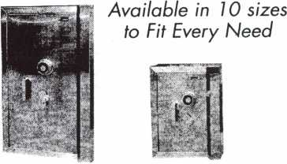

See us at [www.a-bsafecorp.com](http://www.a-bsafecorp.com)

*]-*800*-*253-1*267*

Fax 856-863-1208

CALL FOR YOUR CATALOG TODAY

Keynotes • July/August2003

***Keyed To Quality And Locked Into Service***

*This One Will Surprise You!*

liriiiij sins

si jo *ALOA Show.*

coupon so Uooif] ;id01 us

9 Soo -j ciojno os our slow product.

One entry per person

Name: _ Address:

City:

State:

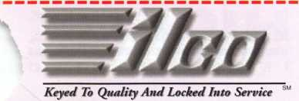

1-800-334-1381

[www.kaba-ilco.com](http://www.kaba-ilco.com)

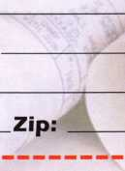

Prajwlnjfi @pTte **Ibecfespitfis Qmlty**



t/AITA

A Member of the KABA Group



**Your**

**Key to Unlocking Ford/Mazda**

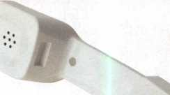

"I've lost my Taurus keys...  
can you make a new set?"

How much of your money

have you sent to the  
local Ford dealer?

8008LA New Generation STAR

Use the Ford factory tool to  
program transponder keys for  
ALL Ford/Mazda vehicles.

Keep the money in your pocket!

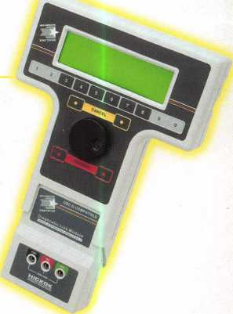

NGS

Complete  
Ford/Mazda  
transponder  
coverage

PLUS the

ability to  
clear ALL  
Diagnostic

Service Codes

Say "YES" to  
$100 phone calls



HICKOK

